Hollow Using Species List & Nest Box Designs

For the Sydney to Greater Blue Mountains

World Heritage Area Bushfire Zone
Hollow Using Species List & Nest Box Designs

For the Sydney to Greater Blue Mountains World Heritage Area Bushfire Zone

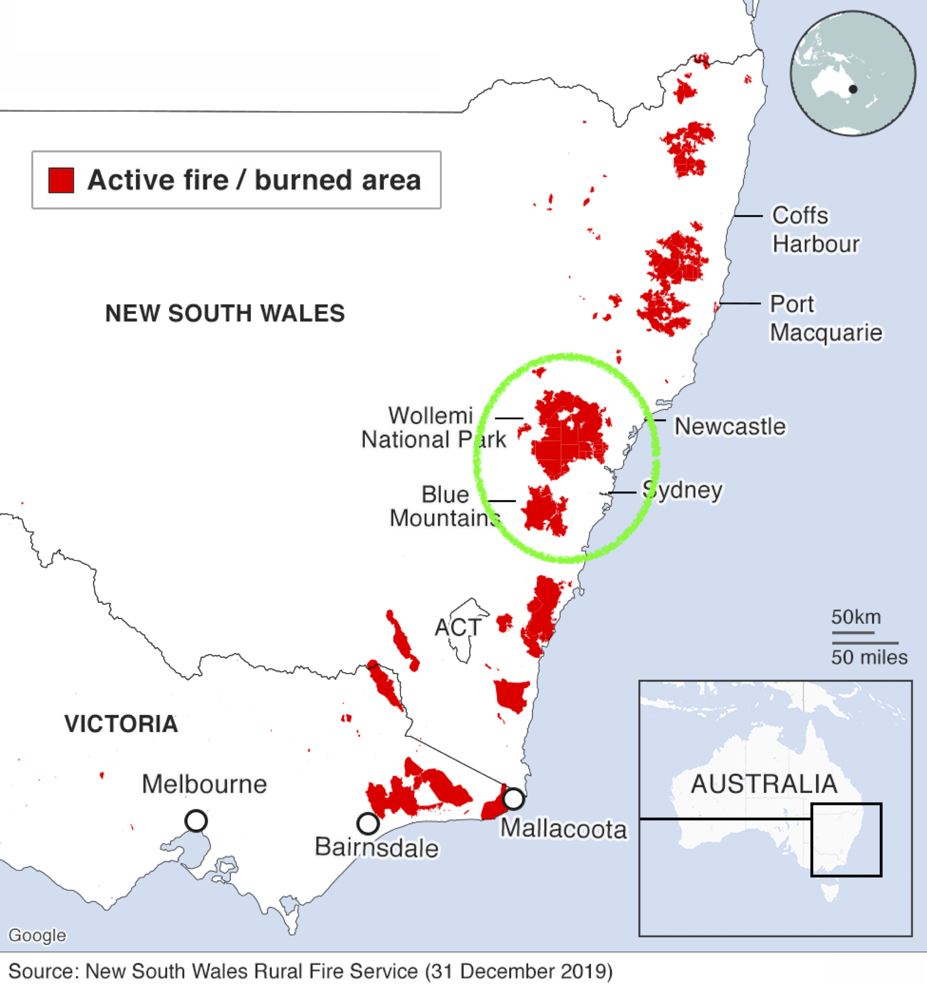

Written and Compiled by Alice McGlashan
Facebook: https://www.facebook.com/groups/nestboxtales/
Website: www.nestboxtales.com
Sharing stories and knowledge about nest boxes for Australian native animals to encourage everyone to improve habitat for wildlife.

Graphic design assistance gratefully received from Springwood Printing



Background

Studies of all different vegetation types across Australia have found that fire tends to reduce the number of hollows in an ecosystem for the short to medium (0-50+++) term. The hotter and more damaging the fire, the greater the loss of tree hollows. Think of an old, large, wizened, partially dead tree with many small to large sized hollow, somewhat of an apartment block for hollow using wildlife. Trees such as these don’t stand a chance in this year’s infernos.
These same studies have found that hollow using species don’t initially return to badly burnt areas, and when they do, the numbers are extremely low compared to before the fire. Other non-hollow using species generally bounce back relatively quickly and in a few years are similar in numbers to those pre-fire.
Aside: the studies to date have been on smaller patch burns or areas that are dwarfed in size by the vast expanses of forests burnt particularly in the Eastern states of Australia during the bushfire season of 2019-20.
There are a large number of Australian animals - birds and mammals that need to use tree hollows for shelter, or to breed. There are about 114 bird species, and about 83 mammal species that use tree hollows in these ways, and also many lizards, snakes, and frogs.
Without tree hollows, those birds that only use hollows to nest, simply won’t breed. Some birds are territorial, including Kookaburras, and Crimson Rosellas. Where there are no suitable tree hollows within a Kookaburra pair’s territory, they simply will never breed.
Those birds and mammals that need hollows to sleep by day such as sugar gliders, owls and many possum species, will likely either be taken by predators, not survive the cold winter months, or perish in search of a tree hollow elsewhere.
We can give any hollow using bushfire survivors, and future residents of the ecosystems scorched in this season’s expansive bushfires a helping hand, by adding artificial hollows for them to use.

This booklet series has been compiled from existing online resources to enable volunteer nest box makers to quickly learn how to make nest boxes, for the species that occur within their region.

I have collated the information in this booklet from the following organisations and resources:

Birdlife Australia: https://birdlife.org.au/images/uploads/education_sheets/INFO-Nestbox-technical.pdf

Birds in Backyards:
http://www.birdsinbackyards.net/Nest-Box-Plans

Greater Sydney Local Land Services:
https://www.wires.org.au/wildlife-info/wildlife-factsheets/Wildlife-Nest-Boxes-LLS.pdf

East Gippsland & Maffra and Districts Landcare Networks:
https://egln.org.au/wp-content/uploads/2013/07/Nest-box-booklet.pdf

A bit about me

I studied geomatic engineering and geology for my undergraduate Bachelor Degree quite a few years ago now, and worked as a geologist and GIS Analyst during my first career. More recently I returned to university, completing a Graduate Diploma of Psychology, and Master of Environmental Science and Law, specialising in ecosystem and wildlife management, biodiversity law, water law, and climate change law.

I have enjoyed exploring wilderness areas since a very young age, bird watching, frog spotting, and observing the complex interactions within Australia’s diverse ecosystems. I used my 7th year birthday money to purchase a Slater’s Field Guide to Australian Birds.

More recently I have worked in natural resource management paid and volunteer roles, and spend any free time working to improve the habitat on my degraded woodland property just outside Canberra.

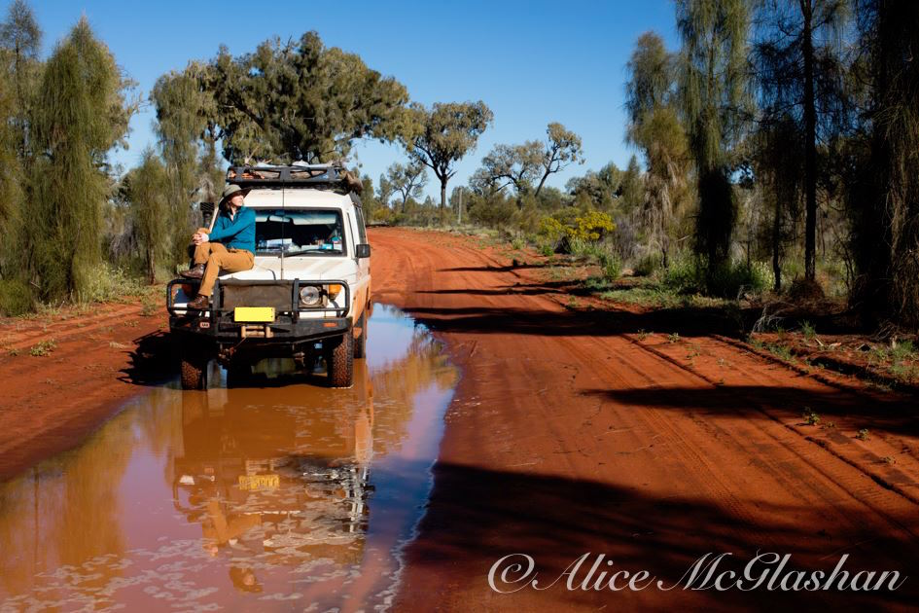

Compiled by Alice McGlashan
Facebook: https://www.facebook.com/groups/nestboxtales/
Website: www.nestboxtales.com
Sharing stories and knowledge about nest boxes for Australian native animals to encourage everyone to improve habitat for wildlife.

Sydney to Blue Mountains World Heritage Area
Bushfire Zone Species List

For the bird list go to the next page
Mammals | Entrance diameter | Nest box height
Brown Antechinus | 30mm | 2-4m
Dusky Antechinus | 30mm | 2-4m
Feathertail Glider | 30mm | 2m
Greater Glider (southern subspecies) | 130mm | 6-10m
Squirrel Glider (V) | 50mm | 4-8m
Sugar Glider | 50mm | 4-8m
Yellow-bellied Glider (V) | 80mm | 6-8m
Microbats (V) | 30mm hole, 20mm slot | 3-5m
Mountain Brushtail Possum | 90-150mm | 4-8m
Common Brushtail Possum | 90-150mm | 4-8m
Eastern Pygmy-possum (V) | 25mmm
Ringtail Possum | 60-80mm | 4-8m
Spotted-tailed Quoll (V)

Sydney to Blue Mountains World Heritage Area
Bushfire Zone Species List Contd.
Birds | Entrance diameter | Nest box height
Barking Owl (V) | 150mm | 5m
Barn Owl | 400mm | 5m
Masked Owl (V) | 400mm | 5m
Powerful Owl (V) |  | 10m +
Sooty Owl (V) | 400mm | 5m
Southern Boobook | 150mm | 5m
Australian Owlet-nightjar | 65mm | 3-6m
Grey Teal | 80-120mm | 1.5m
Pacific Black Duck | 120mm | 3m
Wood Duck | 120mm | 5-6m
Azure Kingfisher | 75mm | 5-10m
Sacred Kingfisher | 75mm | 5-10m
Laughing Kookaburra | 180mm arch | 5-10m
Gang-gang Cockatoo (V) | 110-140mm | 6m +
Glossy Black Cockatoo (V) | 200mm | 8-10m
Yellow-tailed Black-cockatoo | 200mm | 8-10m
Red-tailed Black-cockatoo (V) | 200mm | 8-10m
Sulphur-crested Cockatoo | 150mm | 5m +
Galah | 120-150mm | 6m
Little Lorikeet | 25-30mm
Musk Lorikeet | 25-30mm
Rainbow Lorikeet | 60mm | 5m
King Parrot | 100-120mm protruding entrance | 6m +
Red-rumped Parrot | 50-60mm | 5m
Turquoise Parrot (V) | 80mm | 0-3m
Crimson Rosella | 70-100mm | 5-6m
Eastern Rosella | 65-80mm | 5-6m
Spotted Pardalote | 30mm tube | 5m
Striated Pardalote | 30mm tube | 5m
Brown Treecreeper (V) | 50-70mm | 3-5m
Red-browed Treecreeper | 50-70mm | 3-5m
White-throated Treecreeper | 50-70mm | 3-5m
Tree Martin | 30mm | 2m +

Materials and Tools for Making Nest boxes

Tools and materials

- Untreated hardwood timber, marine ply or exterior ply.
- Stainless steel or galvanised screws.
- Stainless steel or brass hinge, and external hinge screws for the lid.
- Hole saw or jig saw for making entrance holes.
- Hand saw or power saw to cut the panels.
- Screwdriver or power drill (best to use screws, not nails).
- Ruler/tape measure.
- Pencil for marking out design.
- Sandpaper to smooth rough edges.
- One to two inches of sawdust or wood shavings (from untreated wood), or untreated fine wood or bark chip for bedding, to emulate a decaying hollow.
- Paint the nest box with at least two coats of a water-based (non-toxic) external quality paint to significantly increase the durability of the nest box. Choose a pale colour such as Flooded Gum (Dulux colour), to prevent overheating of occupants on hot sunny days.

Installing Nest Boxes

- Place the nest box away from human disturbance, busy roads, and driveways, and also out of reach of non-native predators such as cats, dogs and foxes.
- Install in a location that is protected from direct sunlight during hot summer afternoons (east to south-east side of tree).
- The installation height sweet spot is 4-5m. Most species will use nest boxes at this height range, and a tall ladder will enable easy installation and access for monitoring and maintenance.
- Installation within the cover of leafy branches is preferred by many species, but some species do prefer open aspects for easy access such as microbats.
- Tall ladder, ladder holder and person installing the nest box.

Monitoring and Maintaining Nest Boxes

- Monitoring is important to enable removal of feral pest species, such as European bees, Indian Mynas and Starlings.
- Annually or bi-annual nest boxes checks enables problems such as feral species invasion to be rectified, and repairs to be made so that native animals can continue to use the nest box.

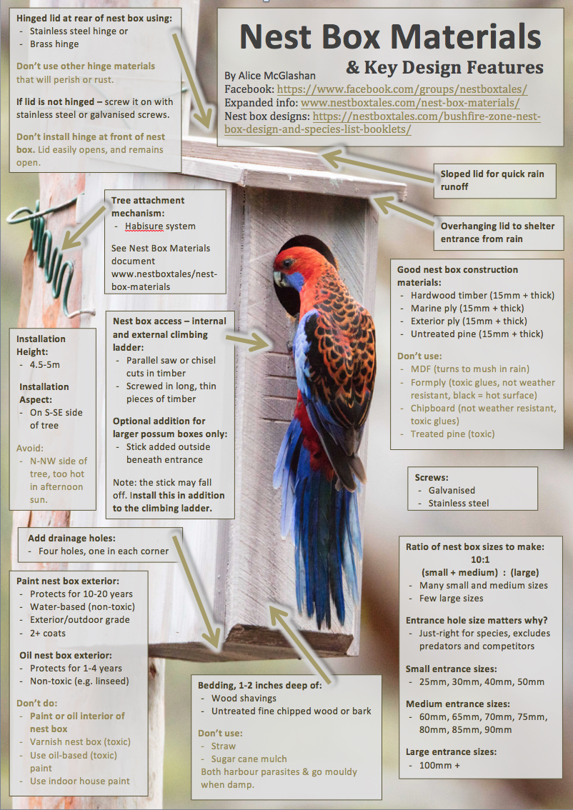

Nest box making choose your own adventure:

2 options

- Use the same nest box design

Make a series in the same nest box dimensions and vary the entrance size for different species, using Birdlife Australia’s Crimson Rosella, and Red-rumped Parrot nest box designs. See the following page for instructions.

- Make a range of different nest boxes from the included designs.

See the page after the next, for list of nest box designs included.

Three Nest Box Sizes for Many Species

Make a series in the same nest box dimensions and vary the entrance size for different species.

Please make a ratio of 10 small & medium nest boxes : 1 large nest boxes.
10:1

 |  | Small Nest Box Dimensions (Birdlife Red-rumped Parrot nest box)
Width |  |  | Length | Height
200mm |  |  | 200mm | 500
Entrance Diameter |  |  | Species
25mm |  |  | Mountain & Eastern Pygmy Possum, Little Lorikeet, Musk Lorikeet
30mm |  |  | Feathertail Glider, Antechinus, Tree Martin, Thornbill species, Little Lorikeet, Musk Lorikeet
40mm |  |  | Sugar Glider, Thornbill species, Pardalote species
50mm |  |  | Sugar Glider, Squirrel Glider, Thornbill species, Treecreeper species
60mm |  |  | Red-rumped Parrot, Treecreeper species, Rainbow Lorikeet

 | Medium Nest Box Dimensions (Birdlife Crimson Rosella nest box)
Width |  | Length | Height
230mm |  | 260mm | 500mm
Entrance Diameter |  | Species
40mm |  | Sugar Glider, Musk Lorikeet, Little Lorikeet
50mm |  | Squirrel Glider, Sugar Glider
65mm |  | Ringtail Possum, Eastern Rosella, Rainbow Lorikeet, Australian Owlet-nightjar
75mm |  | Ringtail Possum, Crimson Rosella, Eastern Rosella, Dollarbird, Rainbow Lorikeet, Australian Owlet-nightjar

 | Large Nest Box Dimensions (Scaled up Birdlife Crimson Rosella nest box)
Width |  | Length |  | Height
250mm |  | 300mm |  | 500mm
Entrance Diameter |  | Species
80mm |  | Yellow-bellied Glider, Ringtail Possum, Crimson Rosella
90mm |  | Brushtail Possum, Ringtail Possum, Crimson Rosella
100mm |  | Brushtail Possum, Owl species, King Parrot, Galah
130mm |  | Greater Glider (southern sub-species), Brushtail Possum, Duck species, Owl species, Galah, Gang-gang Cockatoo, Corella species
150mm |  | Brushtail Possum, Duck species, Owl species, Galah, Sulphur-crested Cockatoo, Corella species

Nest box designs

I would strongly recommend making a ratio of about 10:1, small + medium nest boxes vs large nest boxes. There are many more smaller hollows, and small to medium sized animals, compared to large animals in any ecosystem, so it would be best to have the ratios of different sizes of installed artificial hollows to also reflect this difference.

The following nest box designs were found for species that occur within your bushfire-affected region:

- Feathertail/Antechinus/Pygmy Possum

- Greater Glider

- Sugar Glider

- Ringtail Possum

- Microbat

- Owlet Nightjar

- Boobook Owl

- Pacific Black Duck

- Grey Teal/Chestnut Teal

- Laughing Kookaburra

- Red-rumped Parrot

- Turquoise Parrot

- Eastern Rosella

- Crimson Rosella

- Grey Shrike-Thrush

- Spotted Pardalote

- Striated Pardalote

- Treecreeper

There are also nest box dimensions for other species (not all within your area) provided by Birdlife Australia – added after the nest box designs.

Happy making!

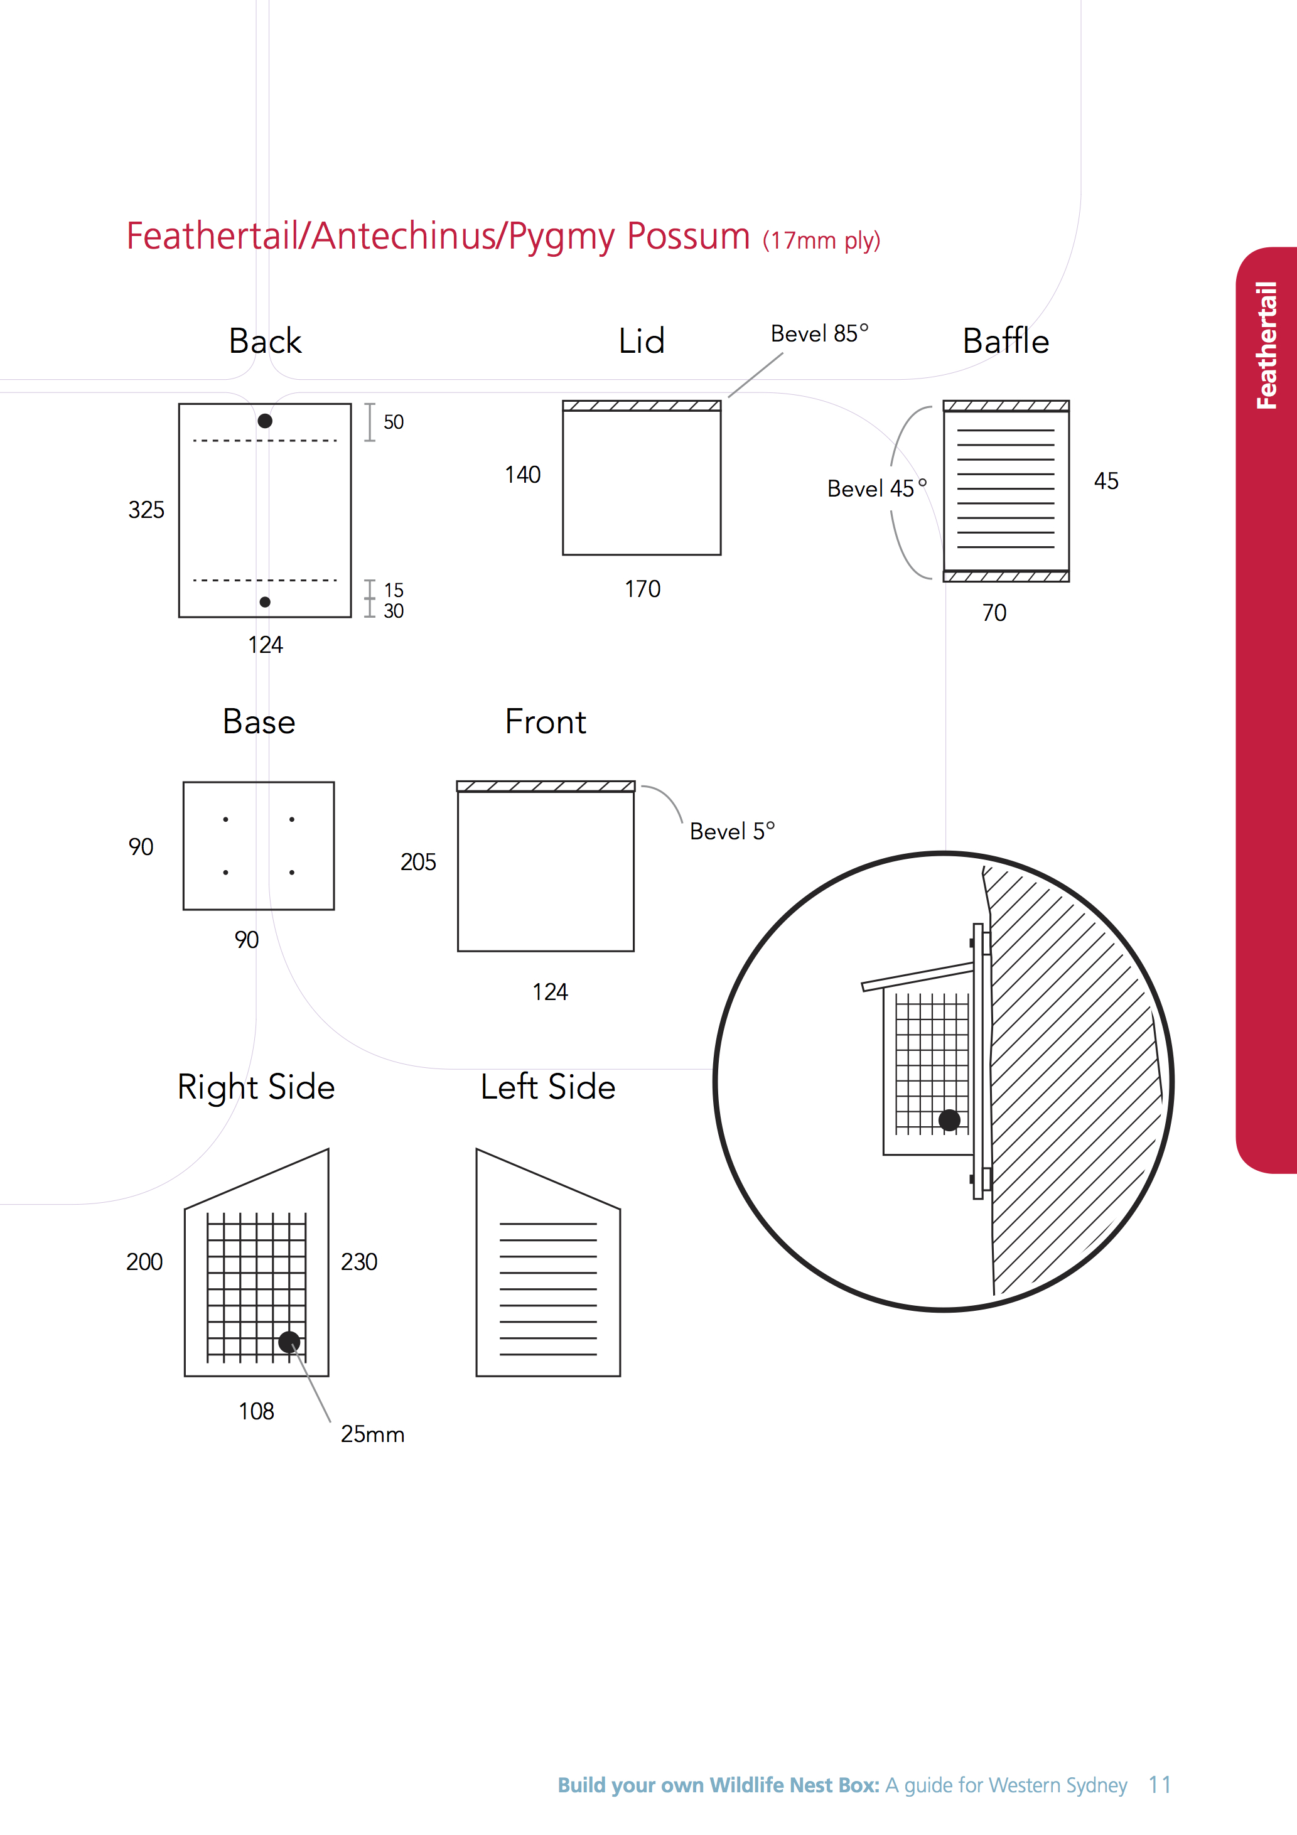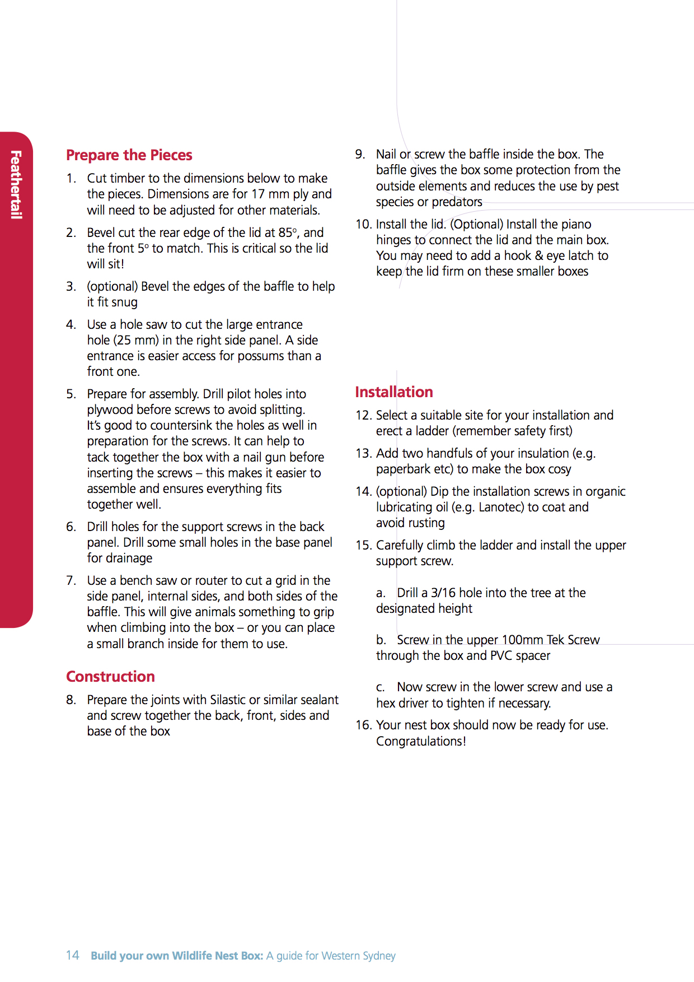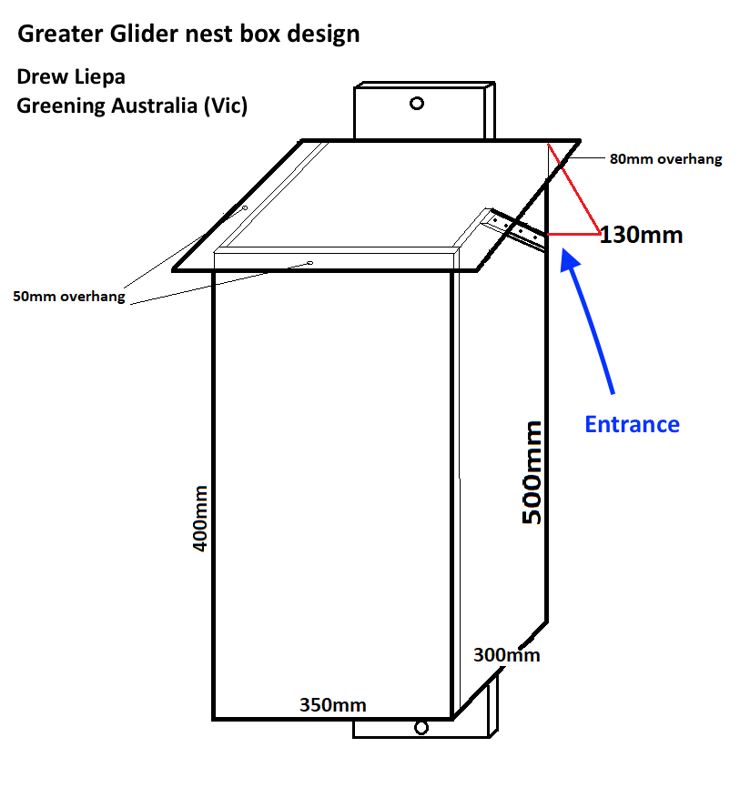
Greater Glider nest box design instructions (please contact Drew if you make this nest box – a project is underway):
Basic version is made with 18MM MARINE PLY.
We line the box with shredded bark and leaves before screwing the lid down.
We paint the outside with a light green to help prevent them deteriorating.
THE TRIANGLE 130MM IS THE ENTRY HOLE AND IS ALWAYS UP AGAINST THE TREE.
You can use a hole saw and cut round hole although we find the triangle works really well. One of the pics shows the triangle box being used.
NO DRAINAGE HOLES.
It’s important the box is well sealed. We did put a few bits of wood on top for grip but the GG’s have massive claws and don’t really need them. Easy to do though.
We installed all ours at A HEIGHT BETWEEN 15 AND 30M using tree climbers. This will depend on the tree species and the overall height of the trees in your landscape.
All our nest boxes are positioned on the SOUTH EASTERN side of the tree.
This is important to prevent over heating in summer.
The basic version has been shown to work without insulation
We install on average 10 PER HA.
NB. Consolidate the existing habitat that’s not burnt. GG’s don’t appear to use burnt out hollows for years.
Drew Liepa I Senior Program Officer | Greening Australia
PO Box 237, Leongatha, VIC 3953
| M 0439557304 | W www.greeningaustralia.org.au
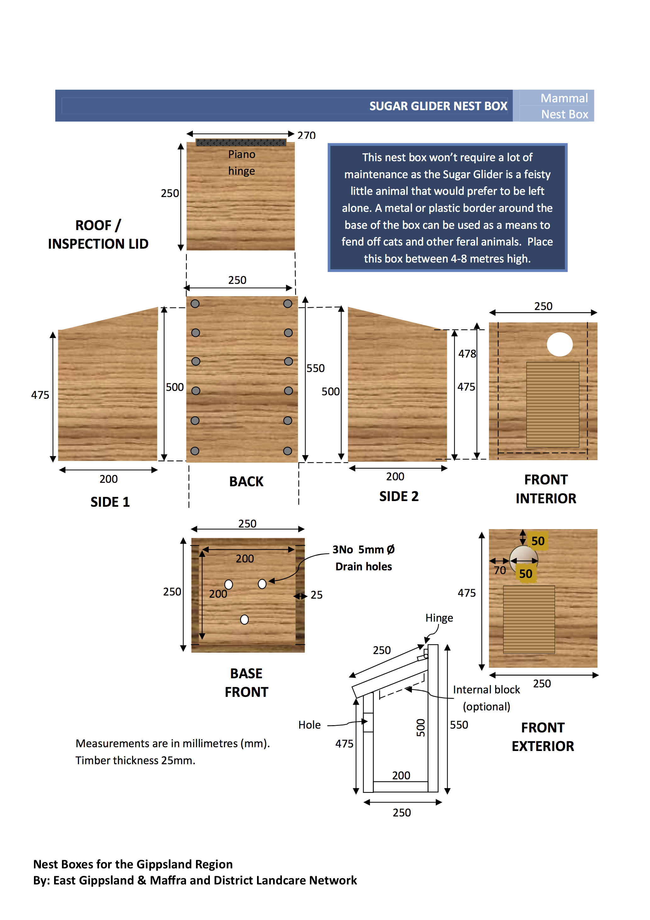
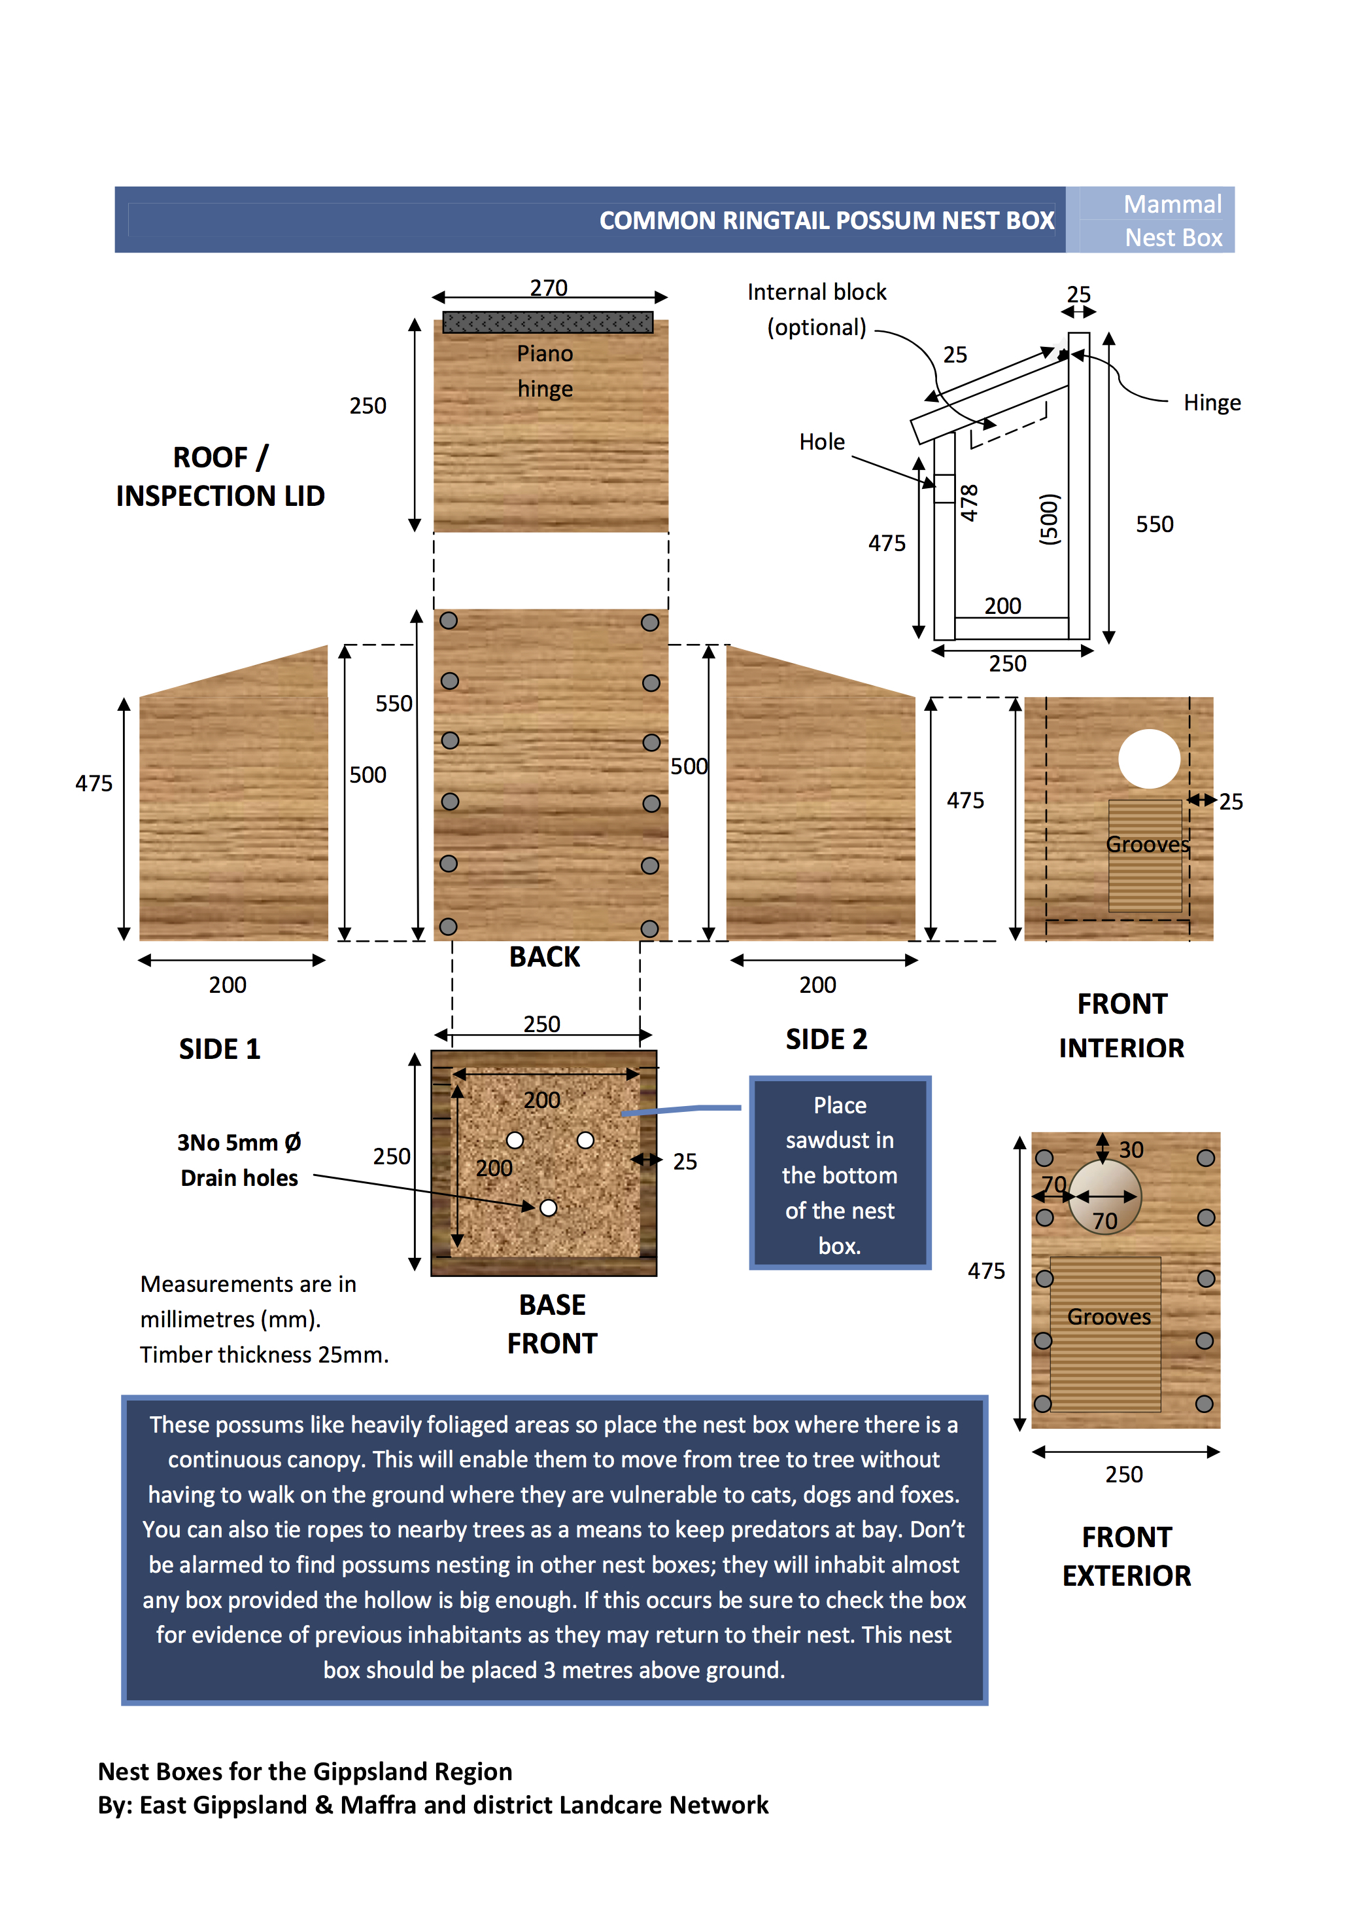

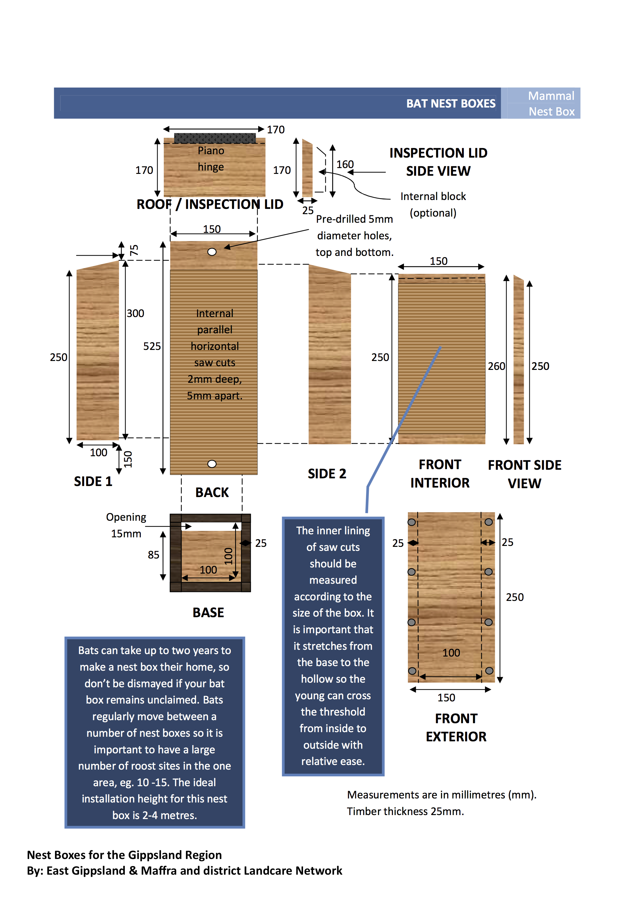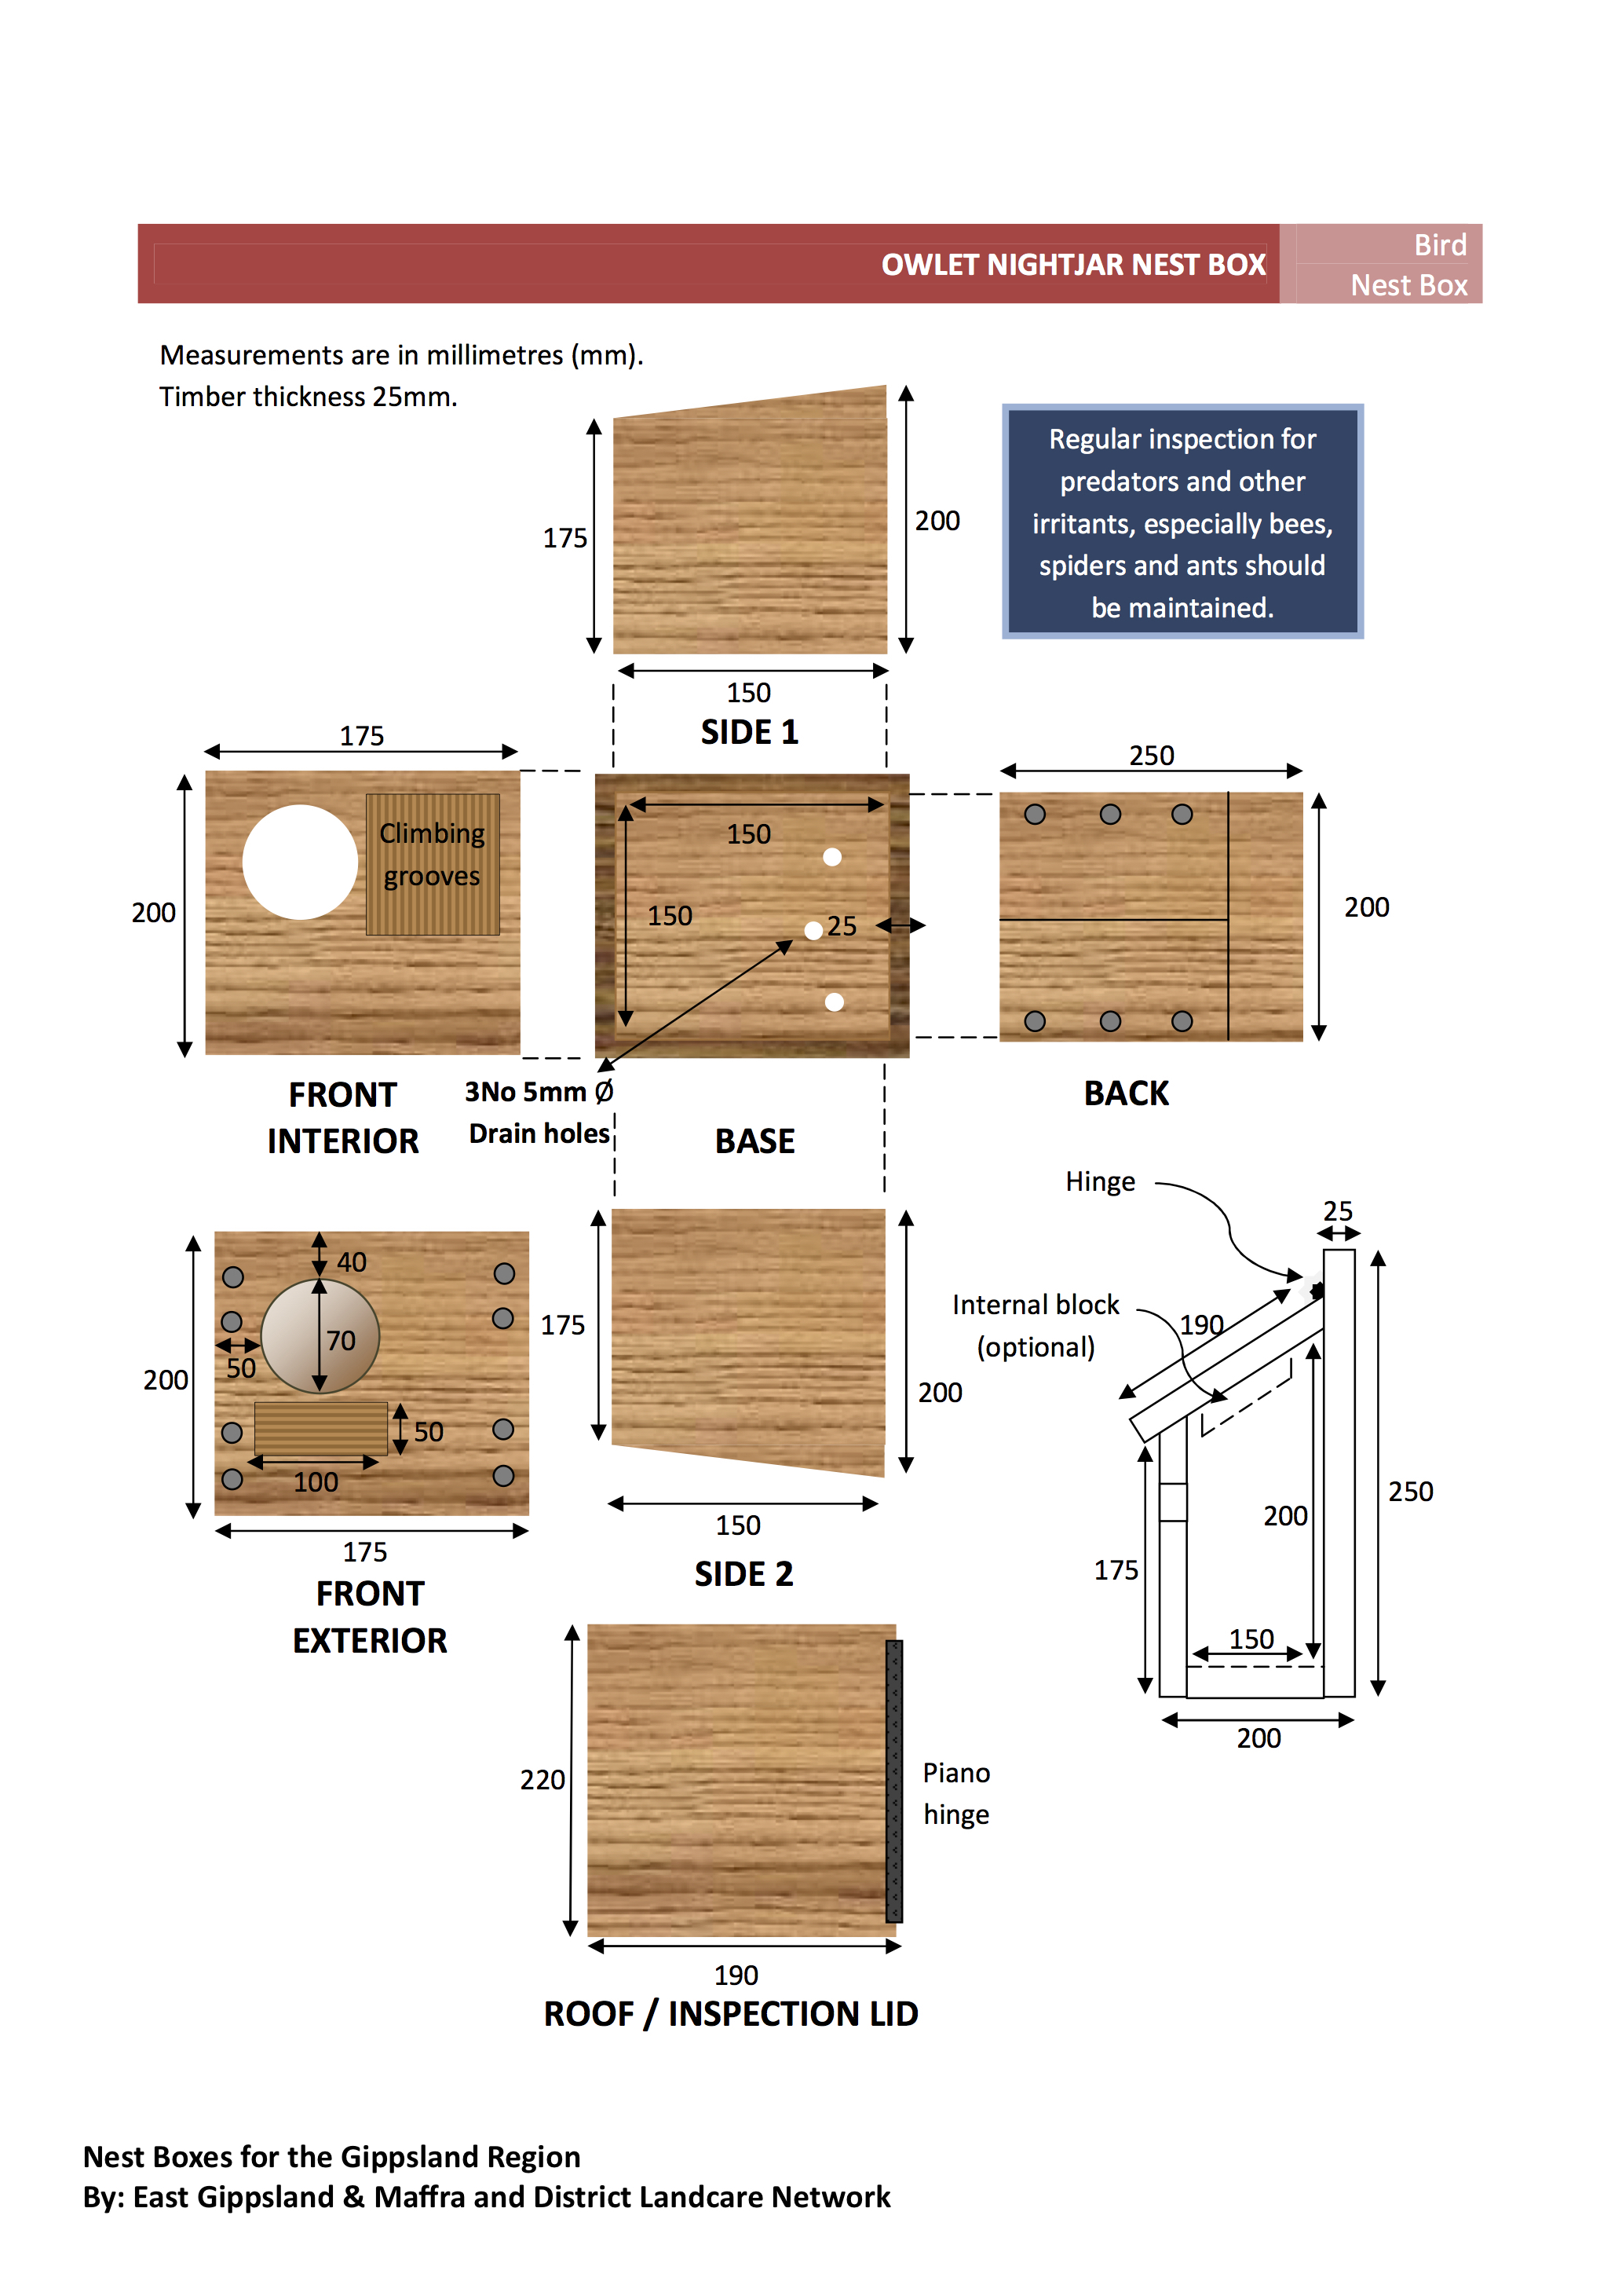
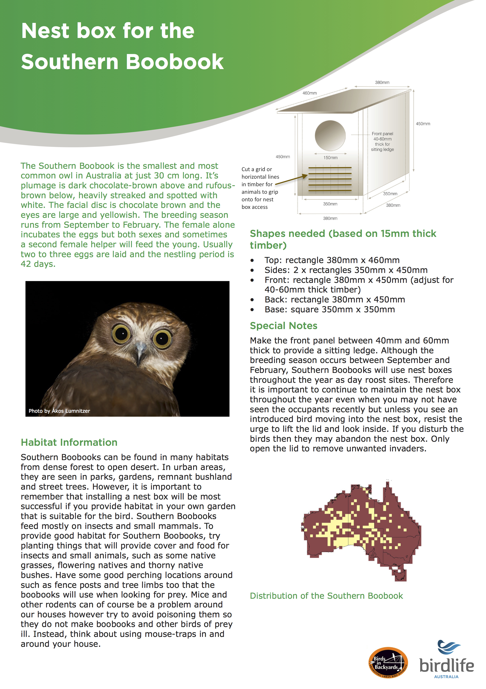
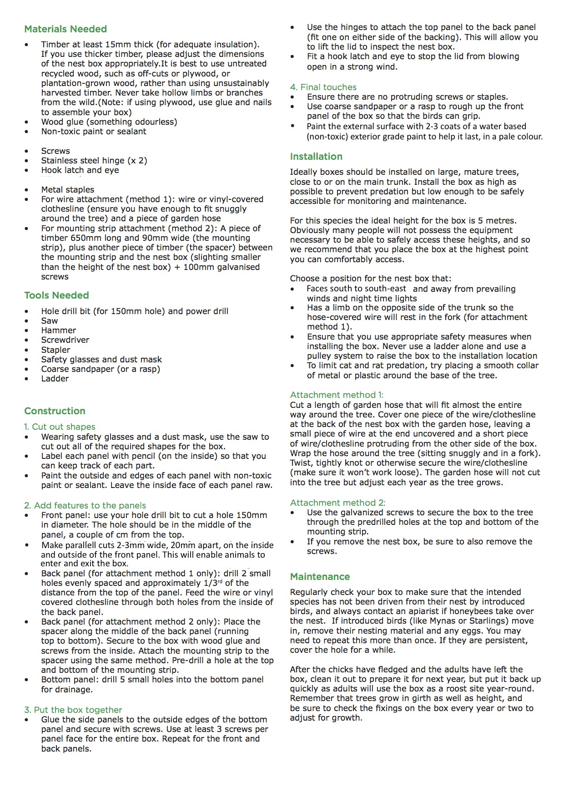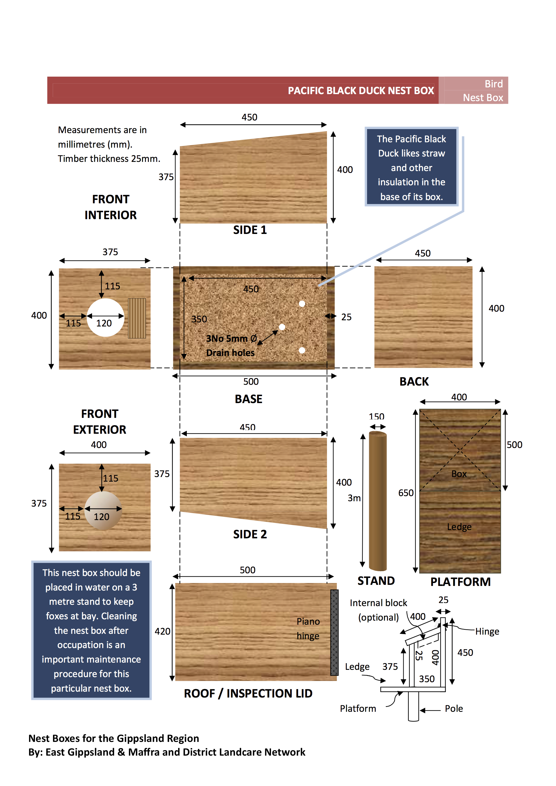
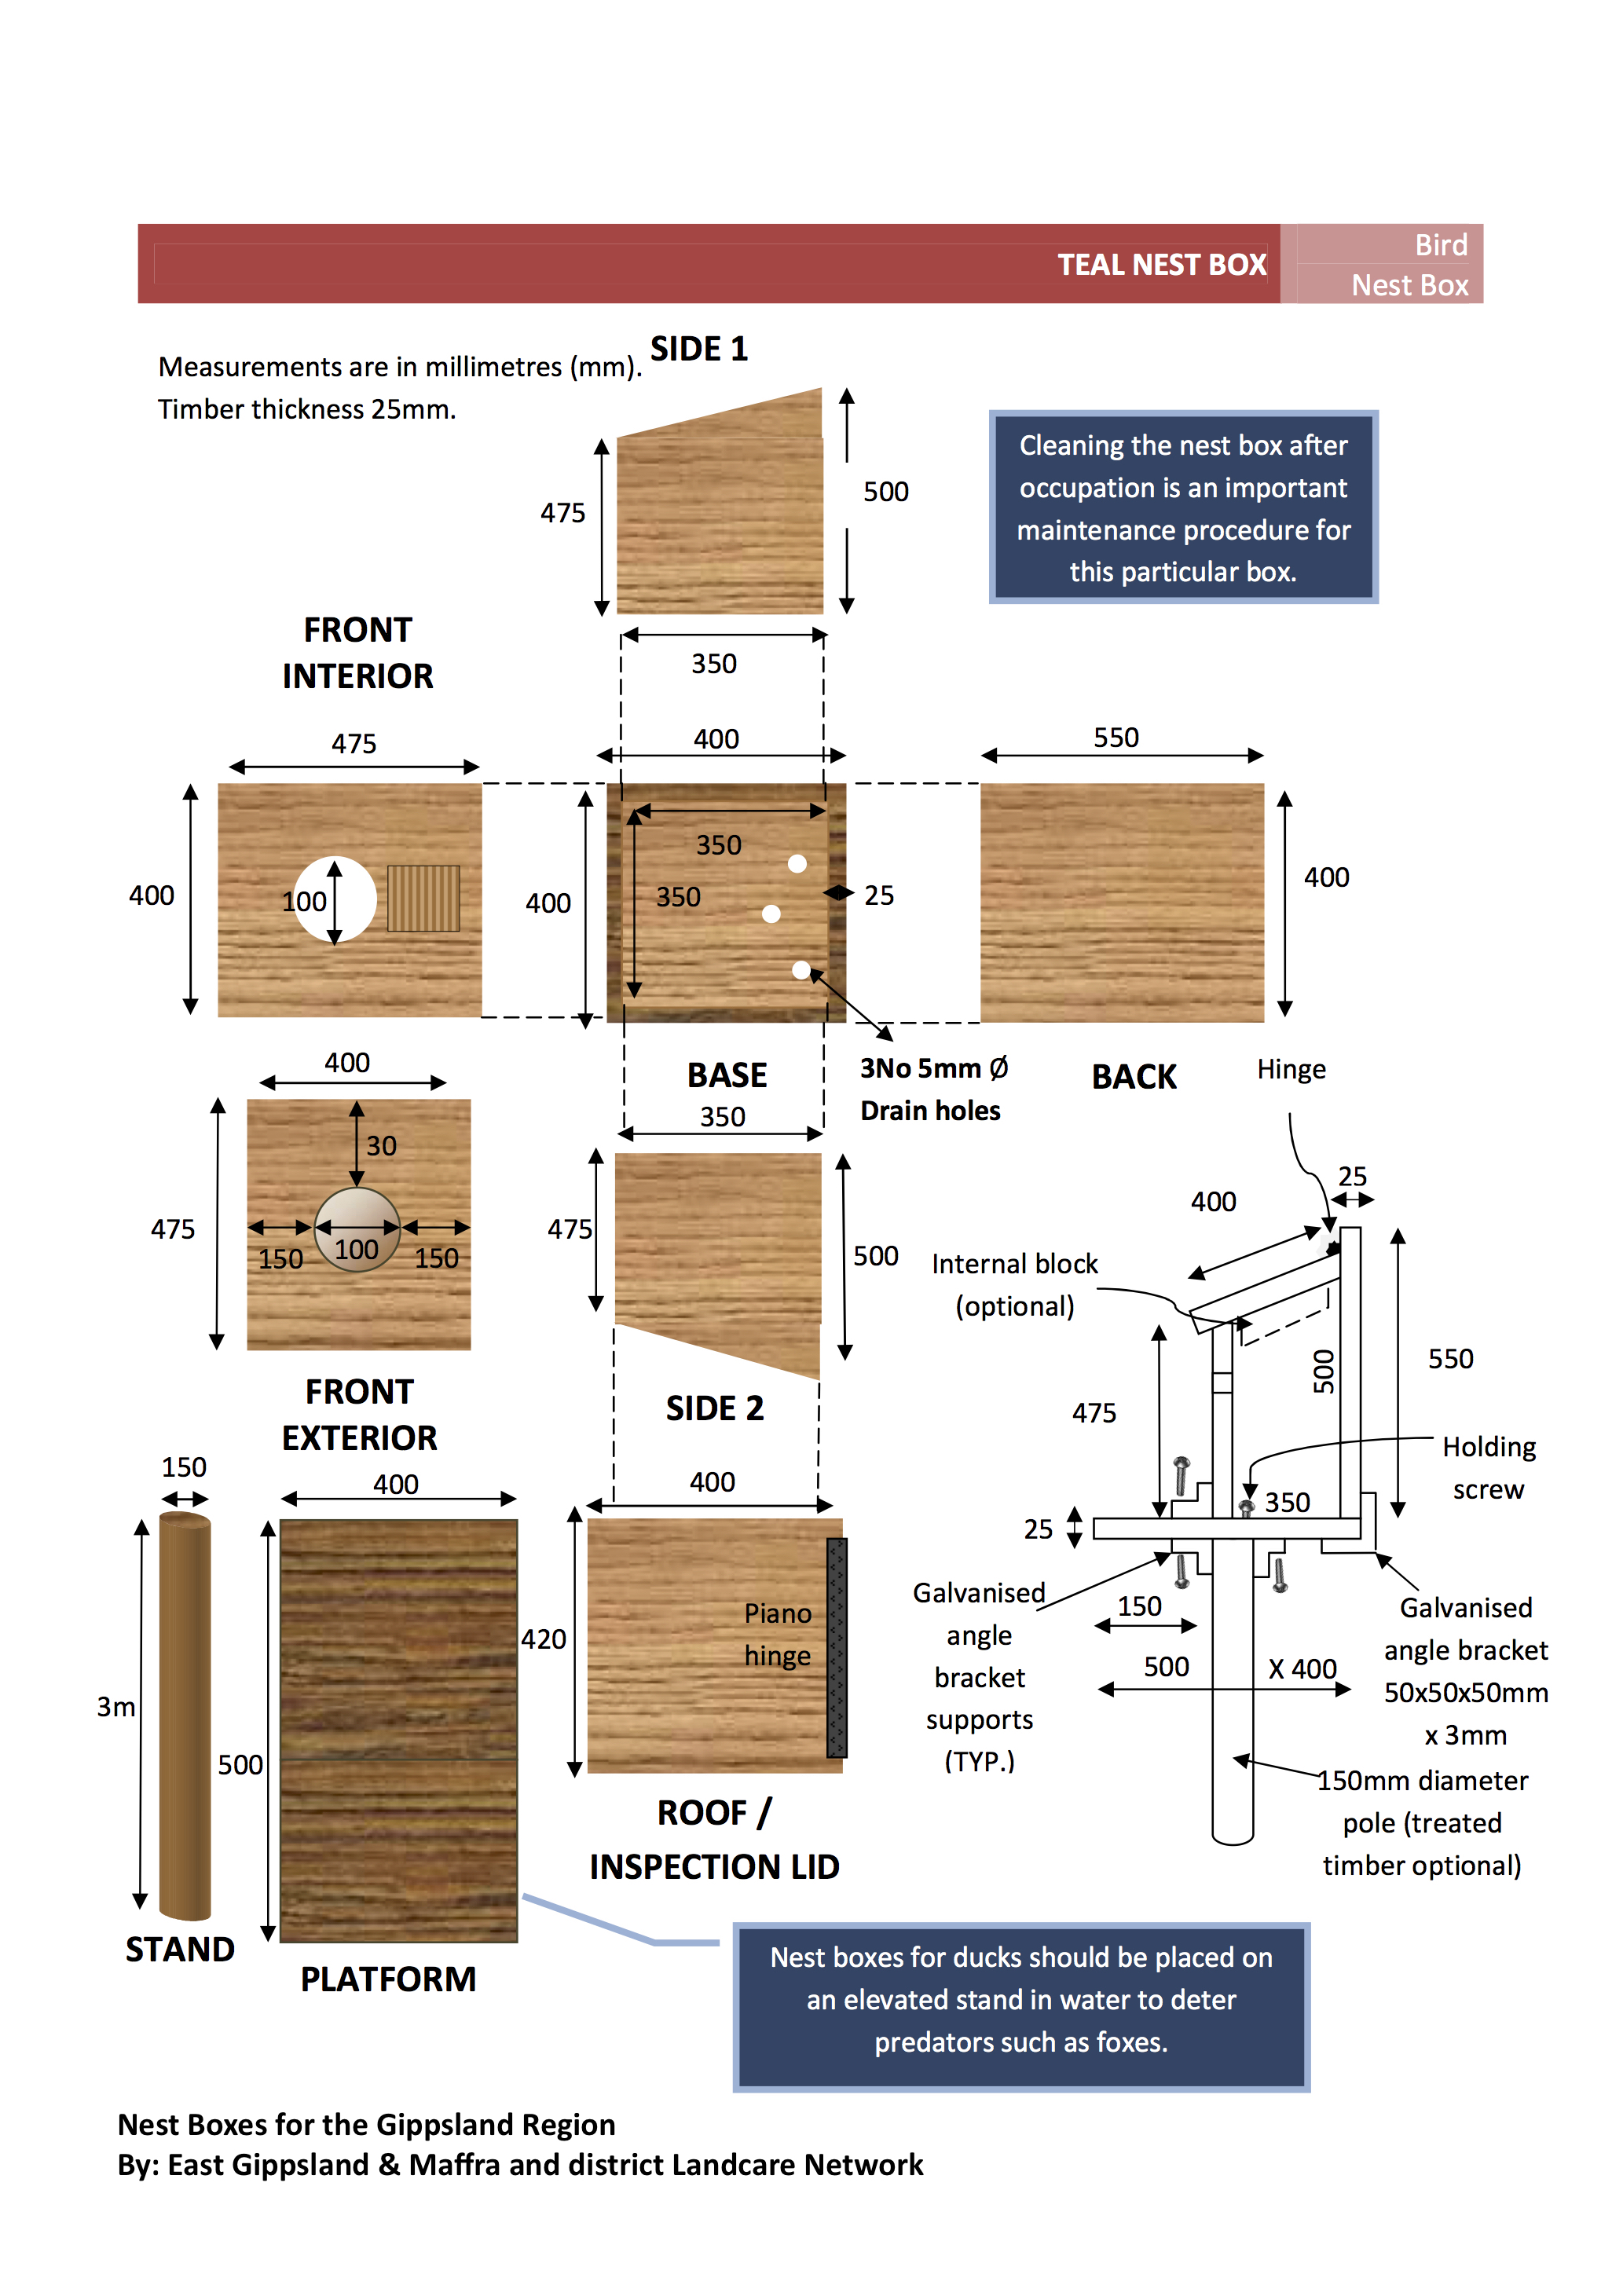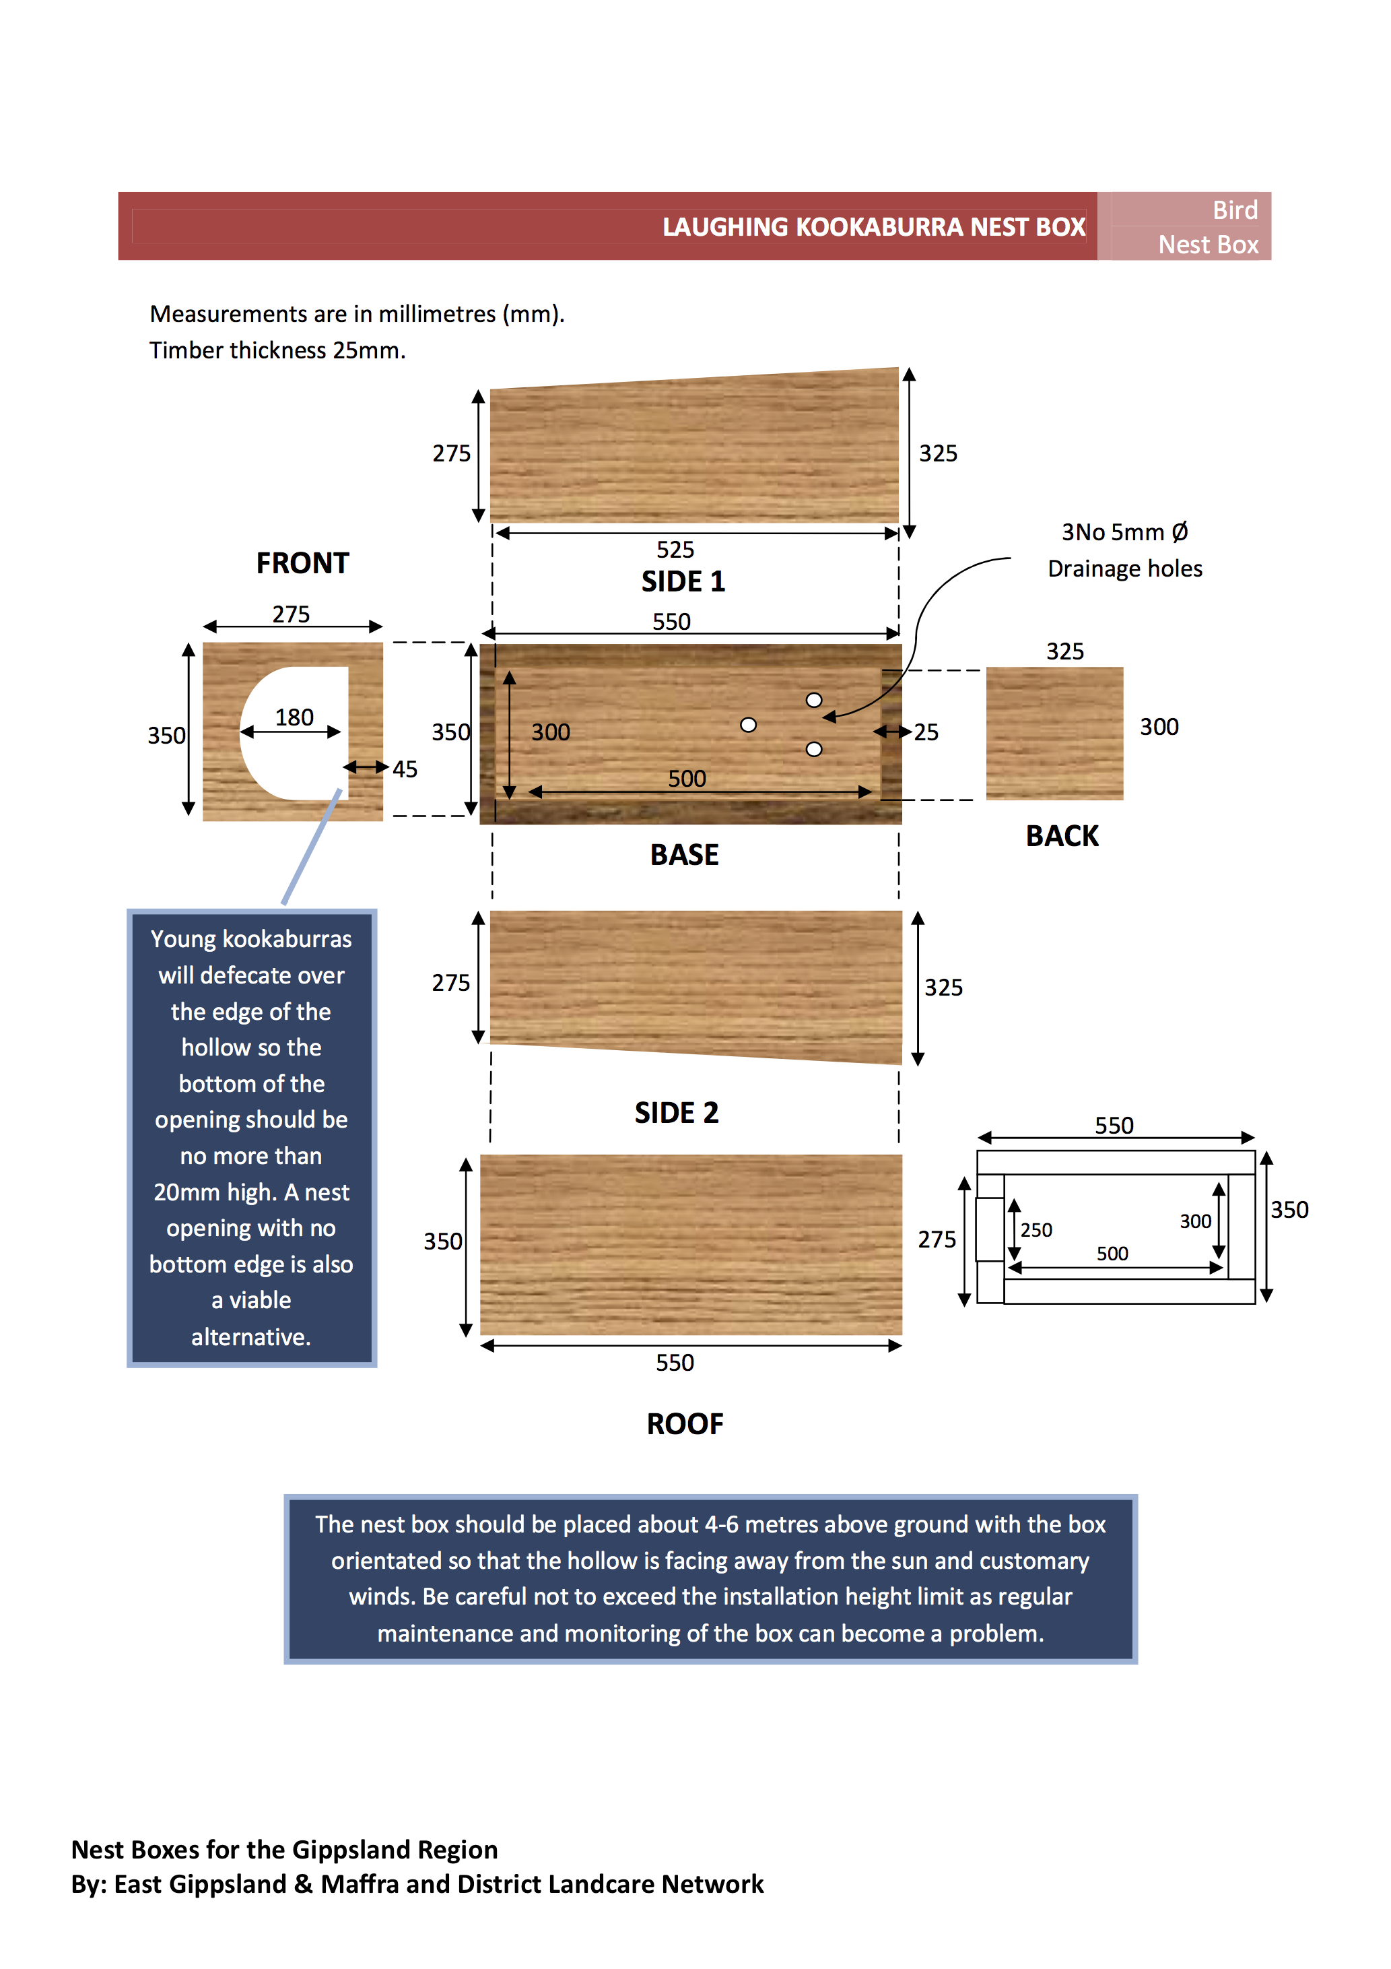
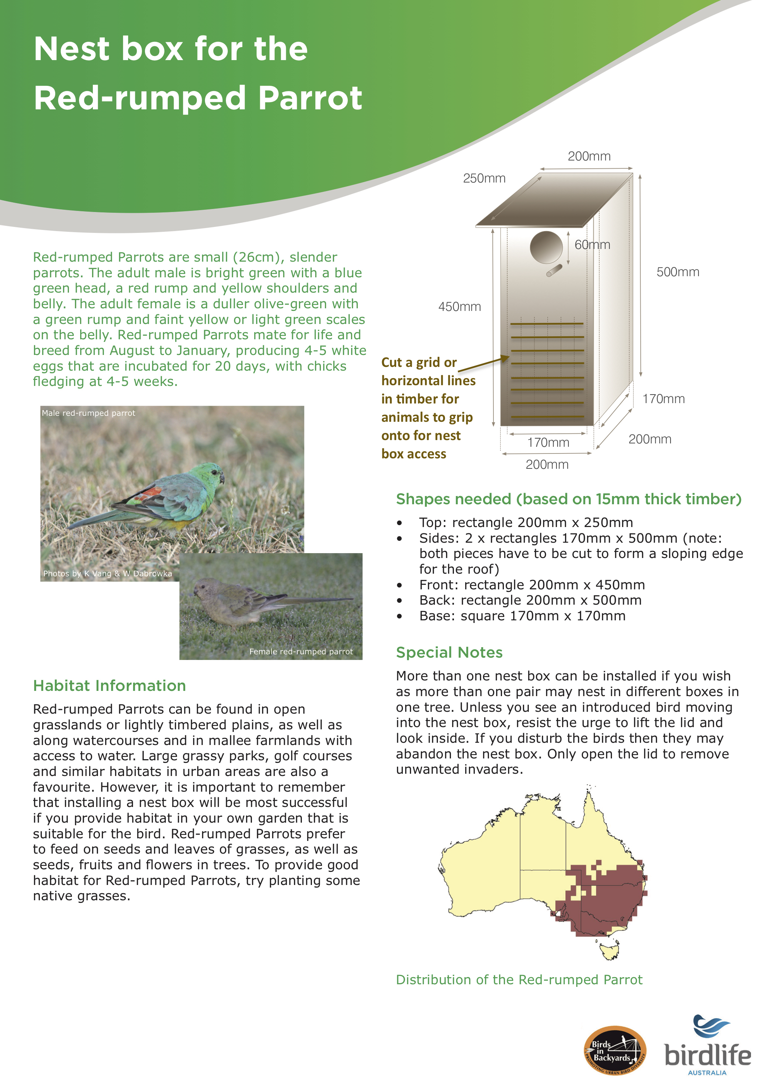

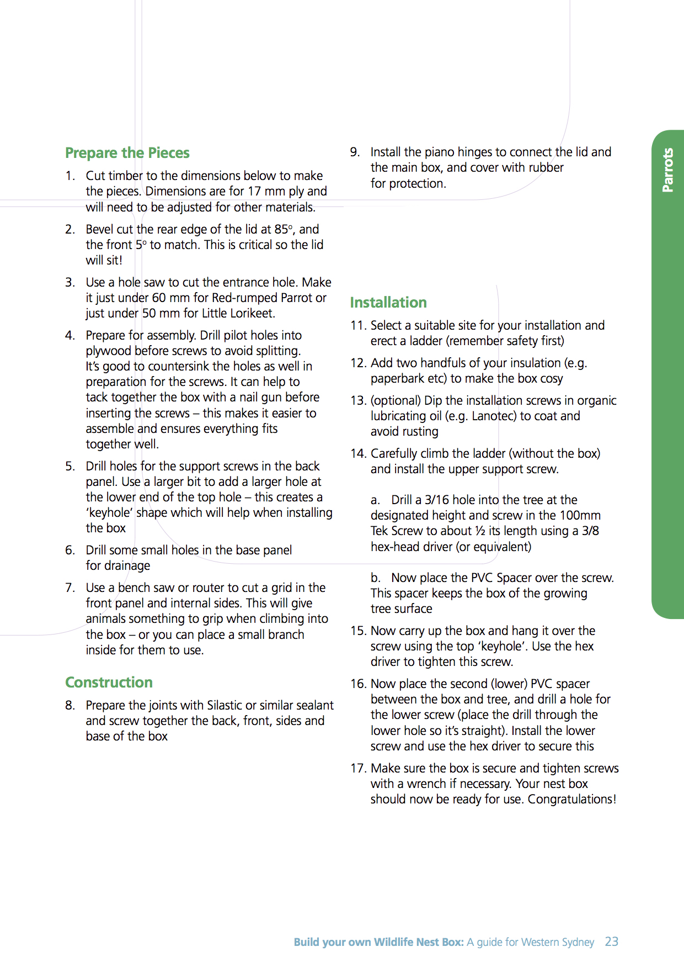

Turquoise Parrot nest box design
From ‘Turquoise Country, Communities caring for the threatened Turquoise Parrot’.
By the Goulburn Broken Catchment Management Authority

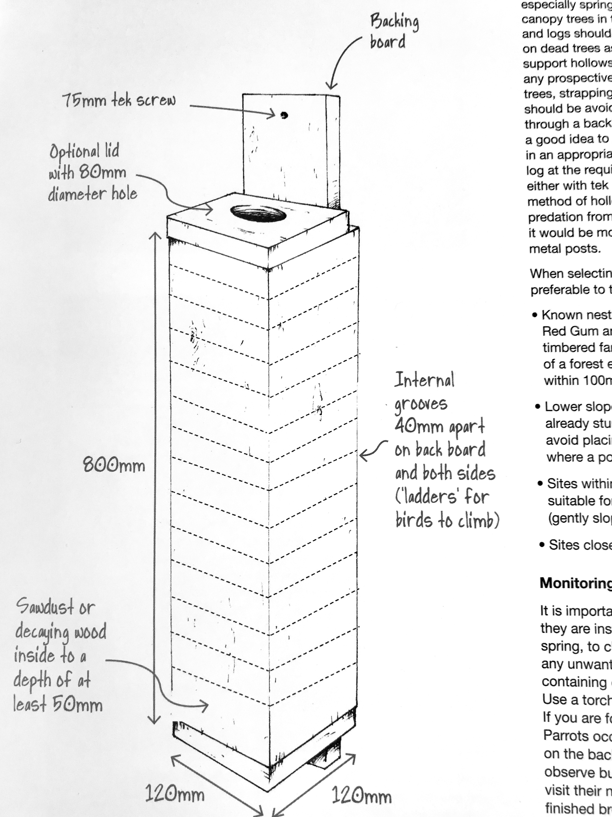

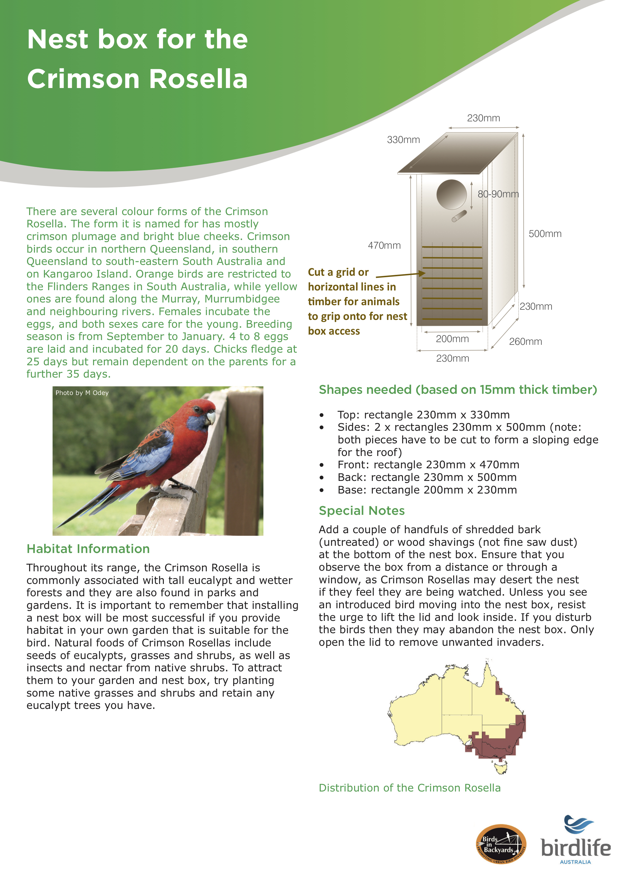
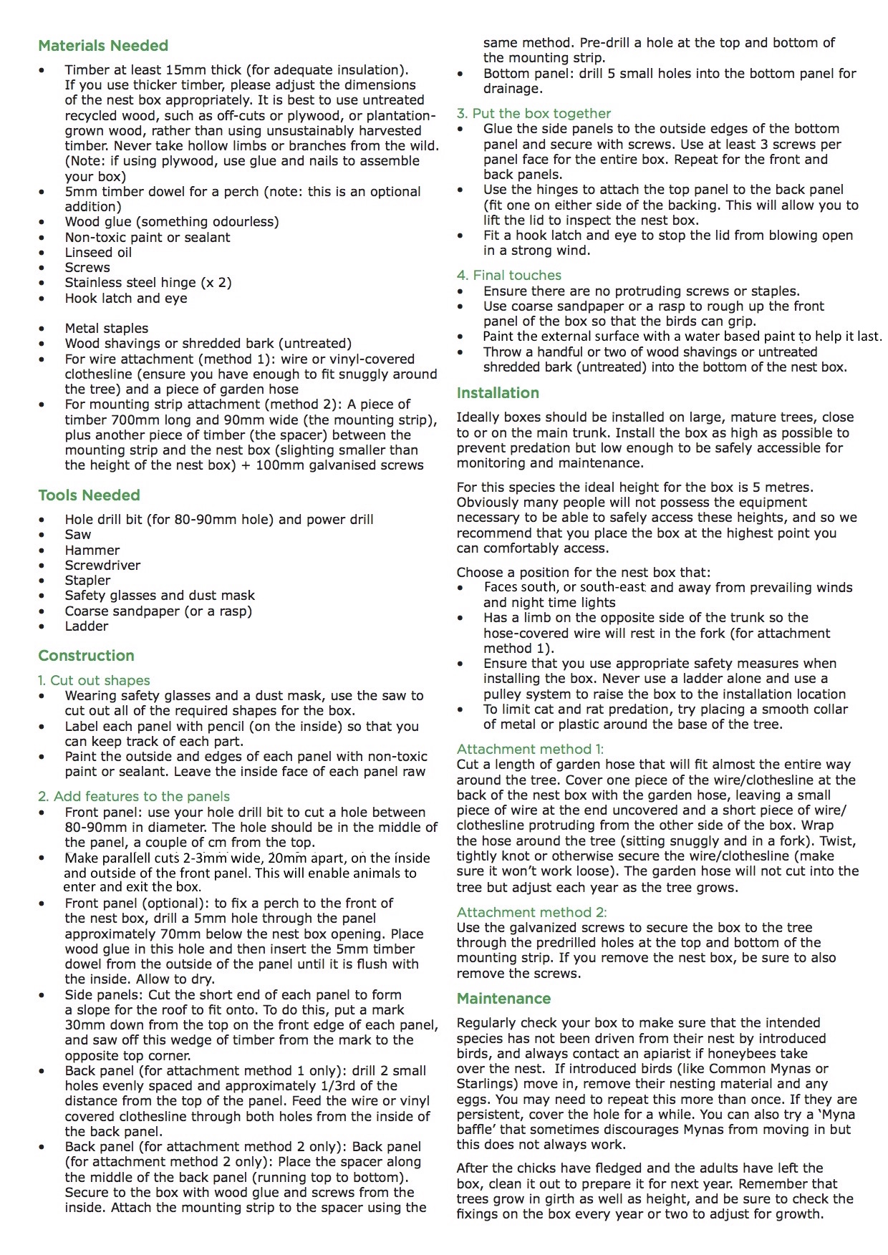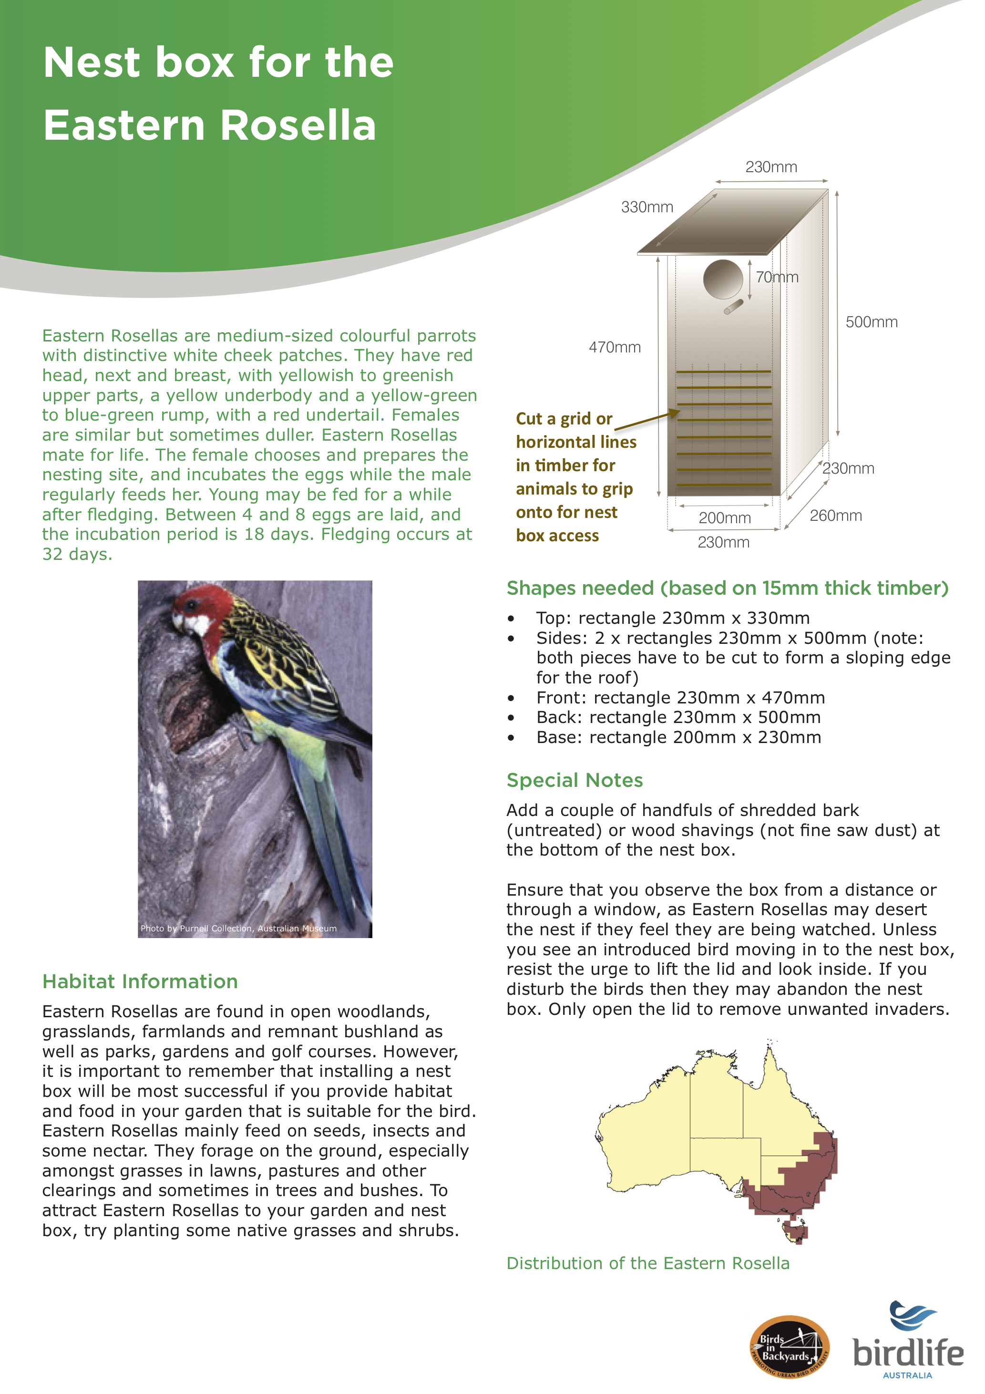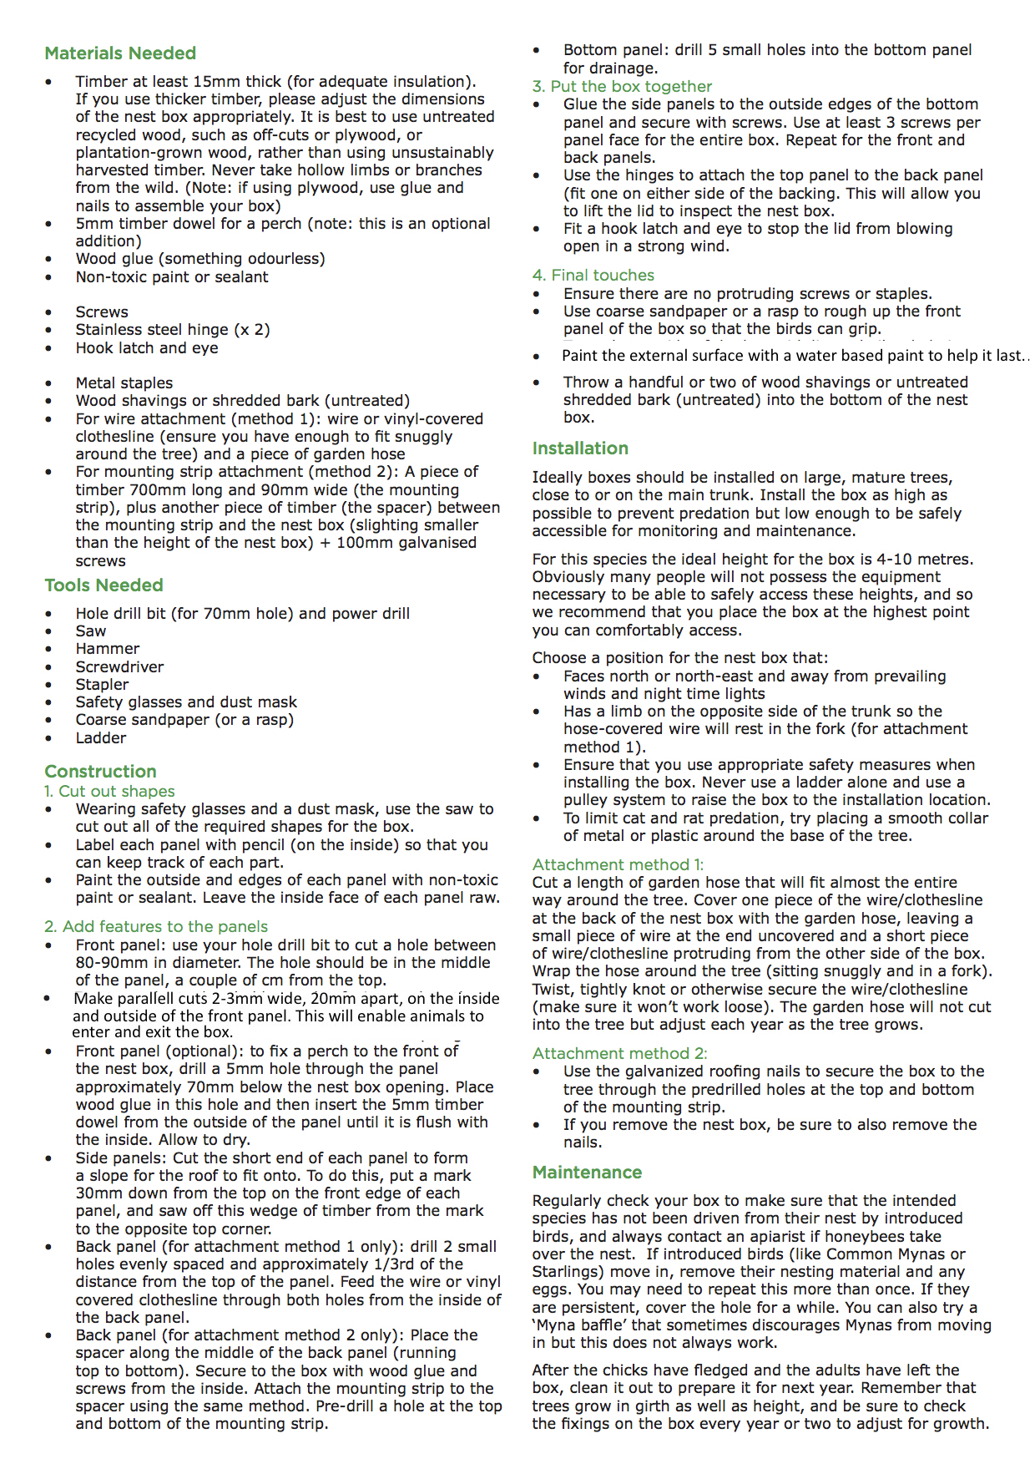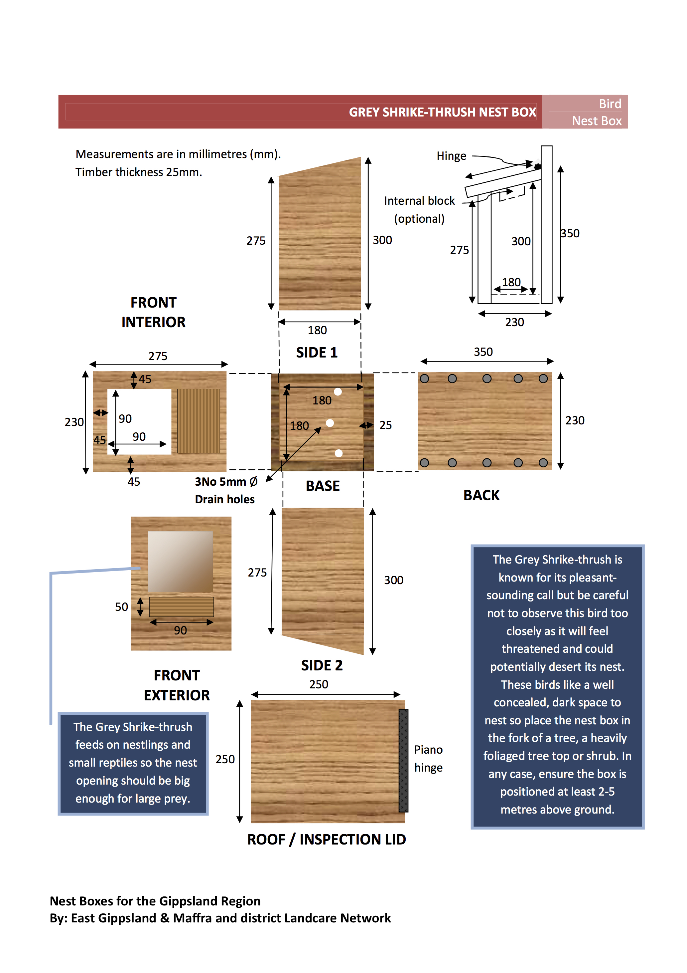

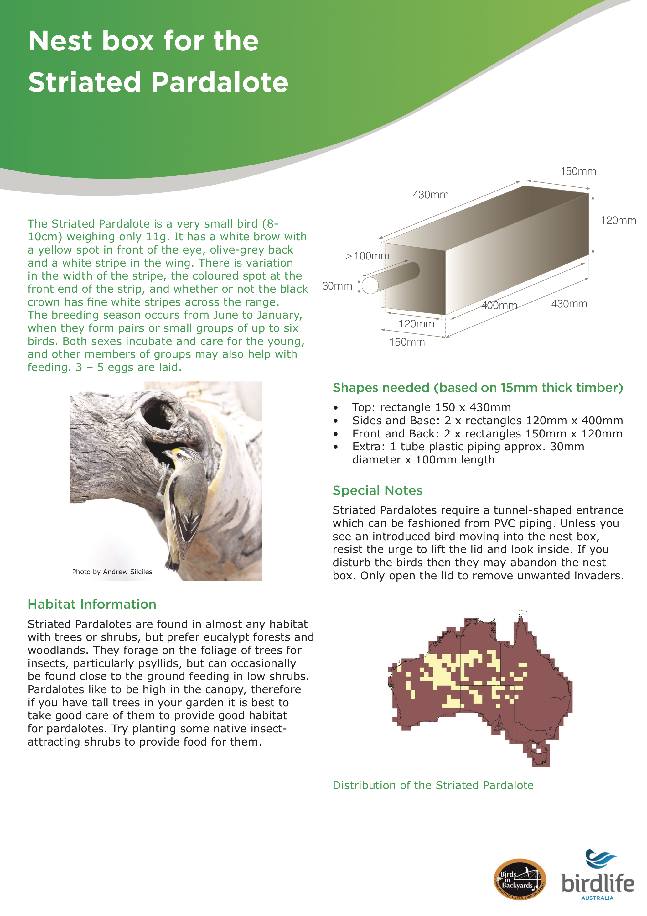
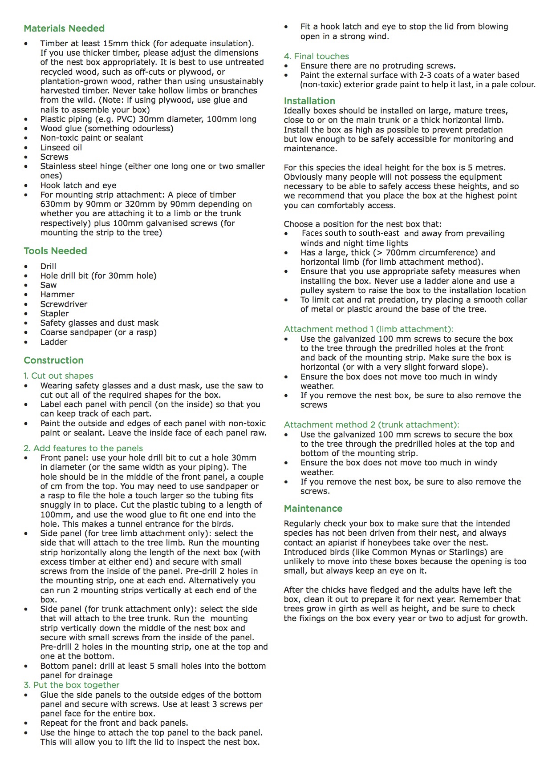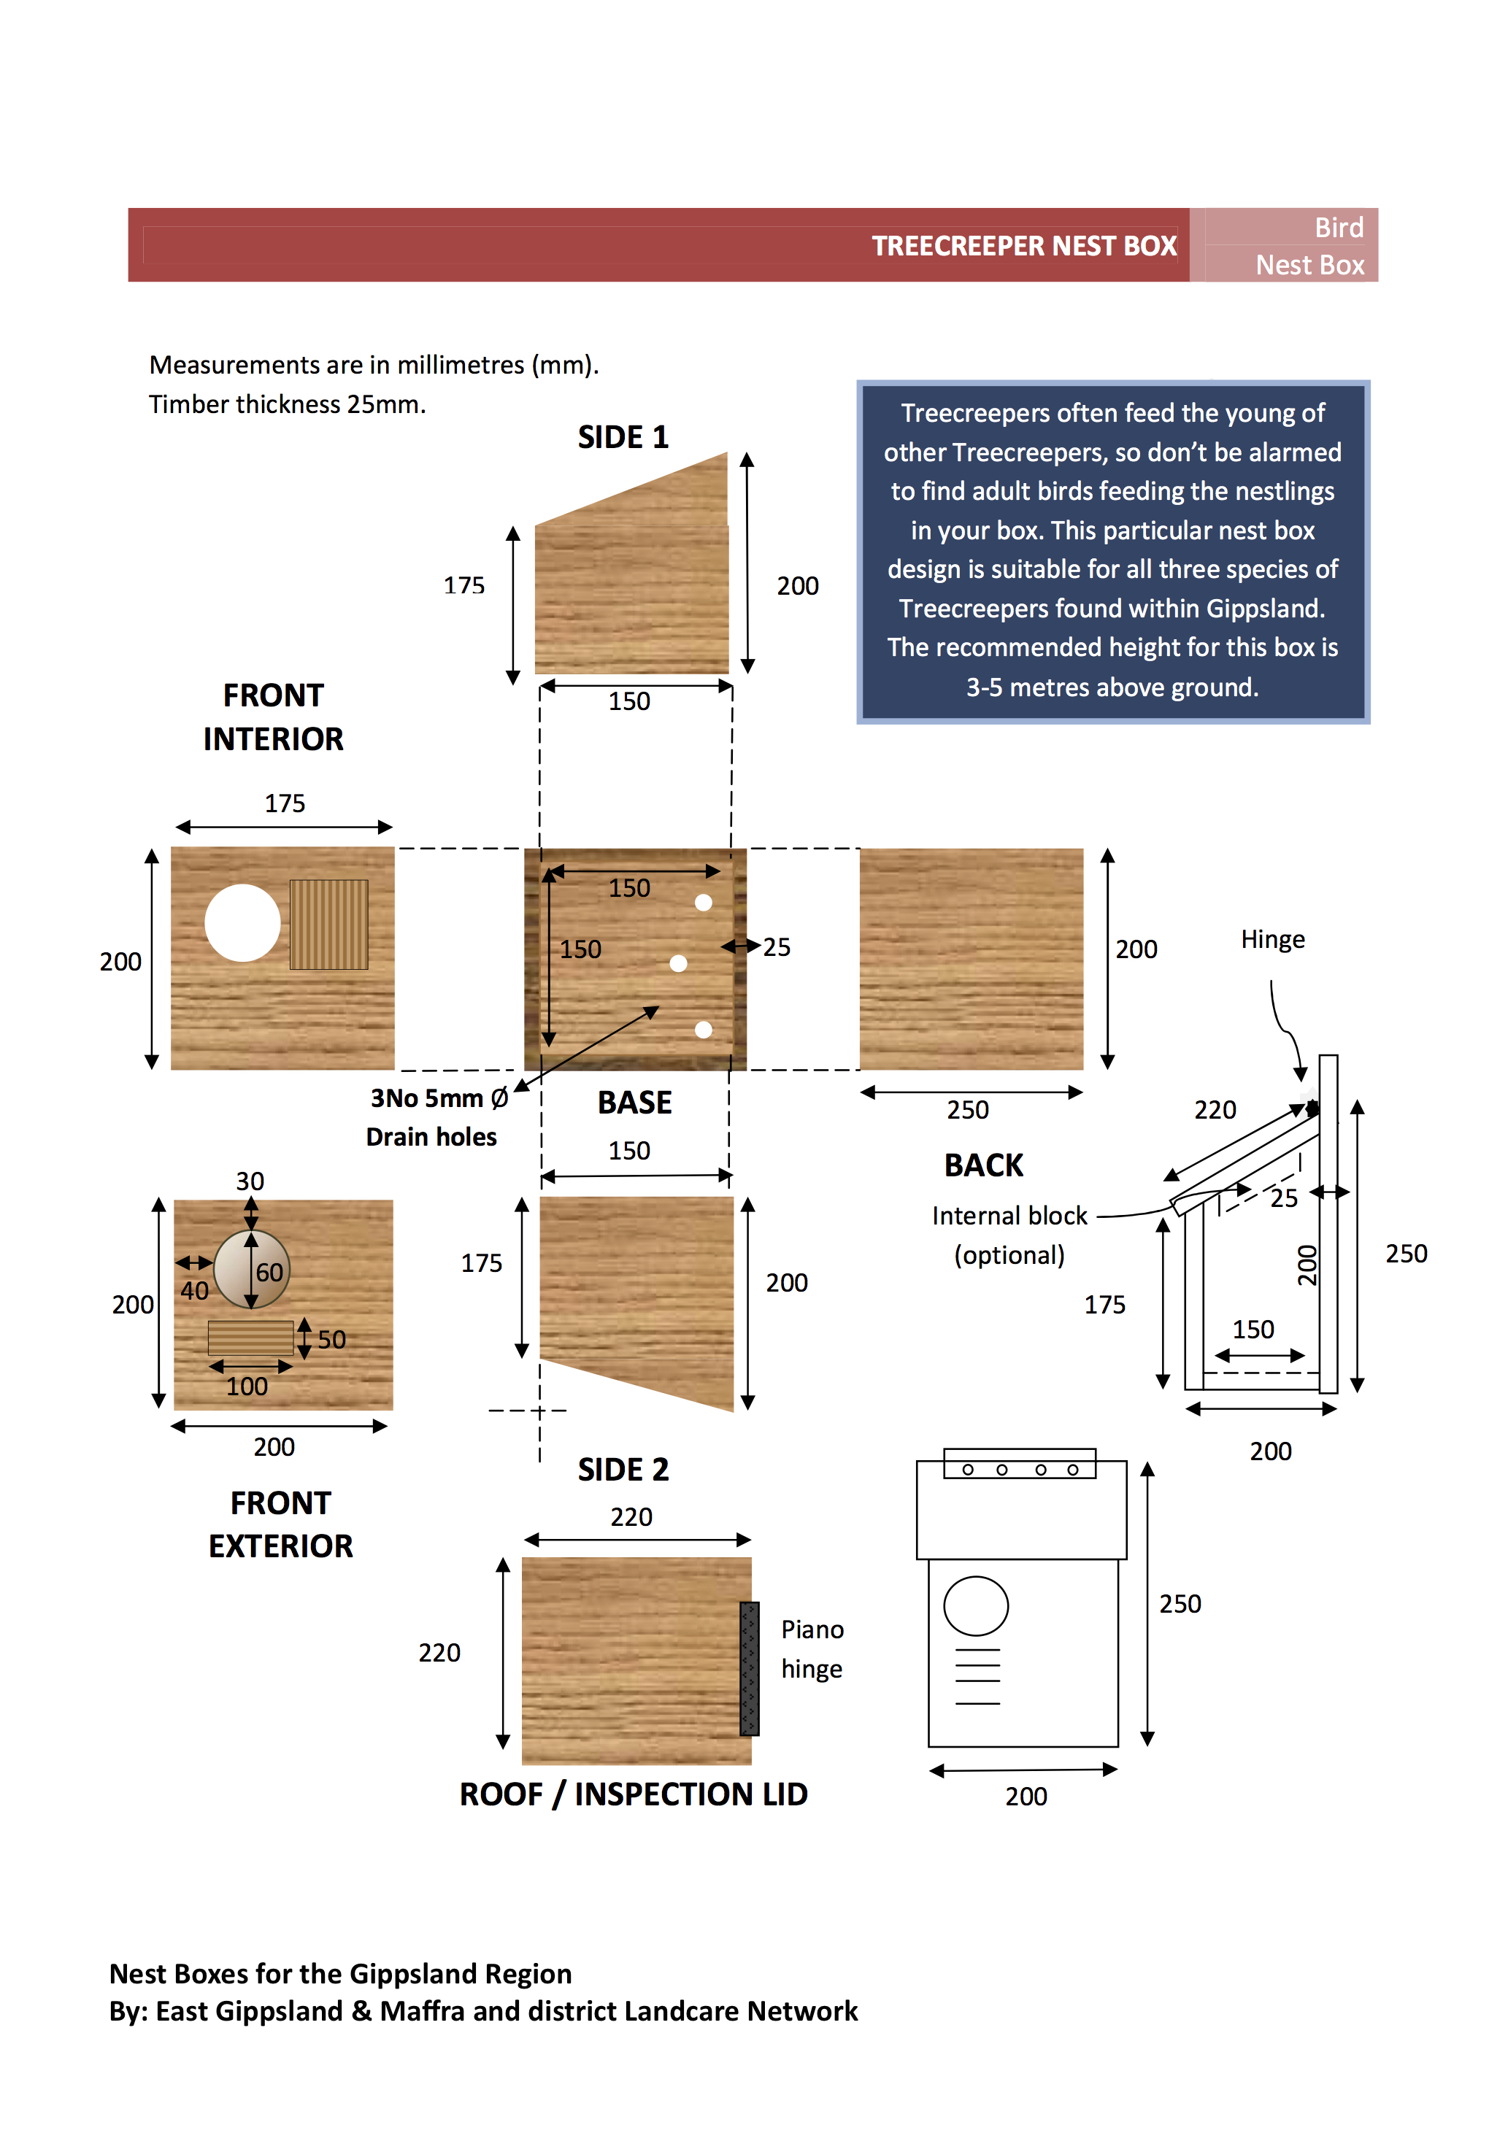
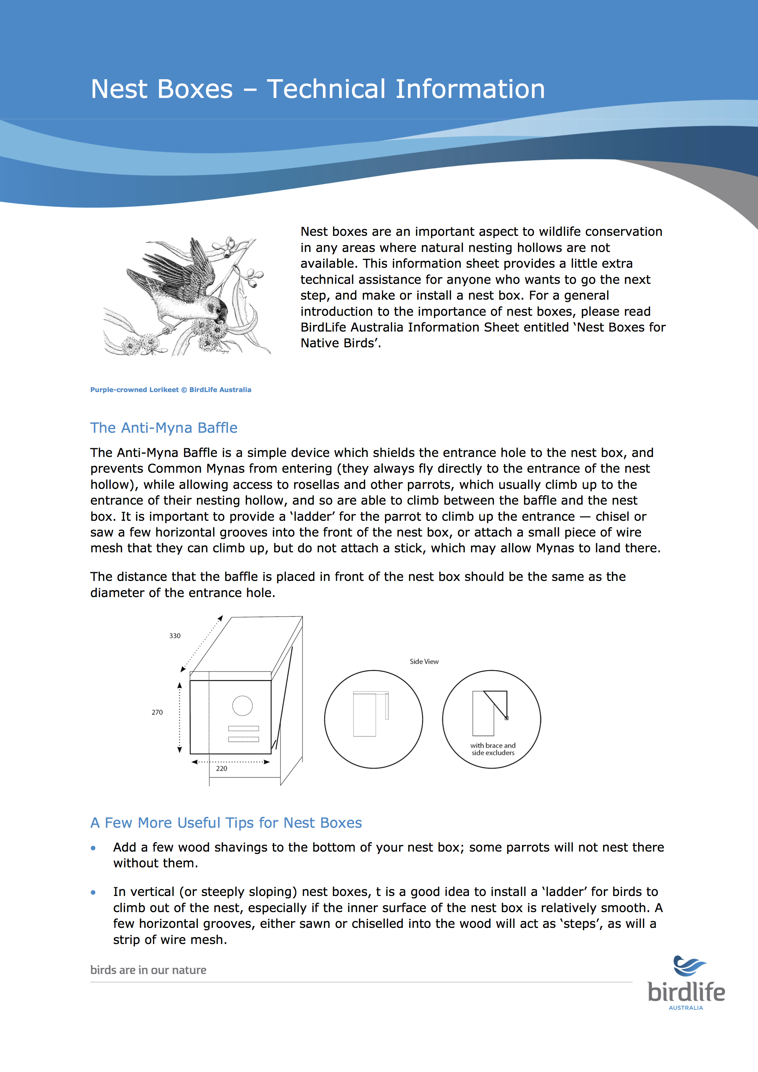
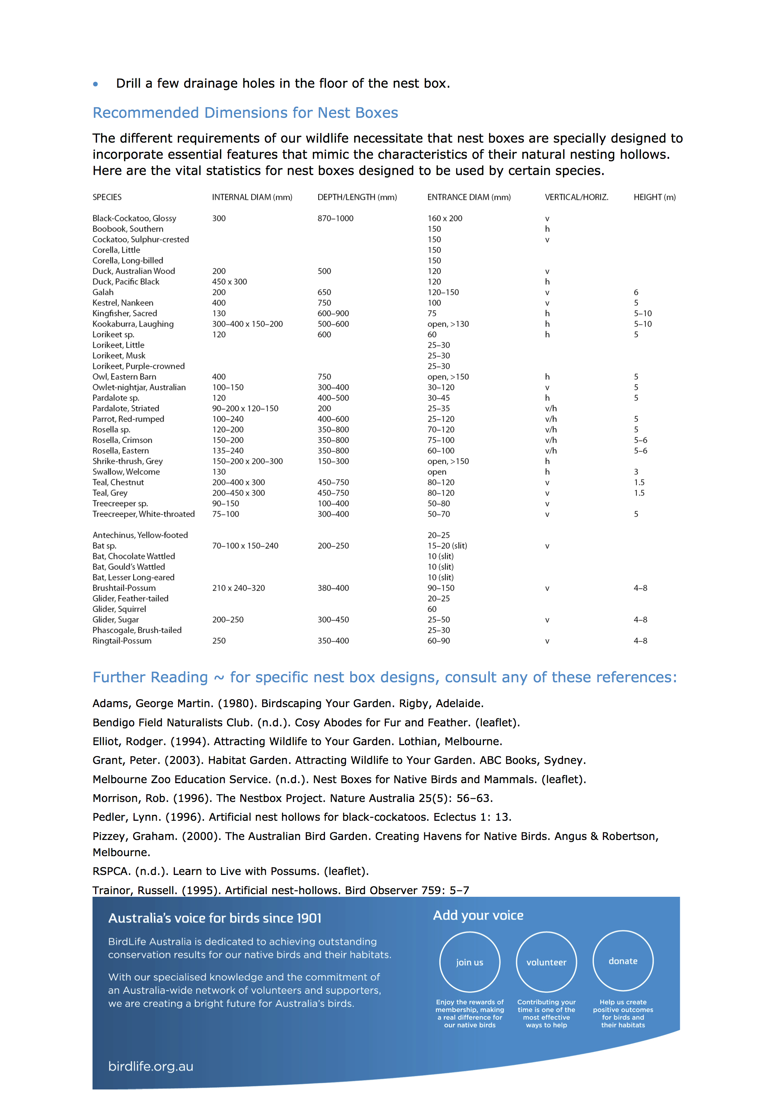

Tree installation materials

Now, there are a few different options for attaching a nest box to a tree. My preferred option is the Habisure system (and variations) by Hollow Log Homes, as this does no harm to the tree, is very durable, and makes installation a cinch. However, the materials for this and similar variations are more expensive than alternatives, and so may be not an option for some seeking to install nest boxes. That’s understandable!

The Habisure System (Nest Boxes for Wildlife, by Alan and Stacey Franks)

The Habisure system is a single piece of plastic coated 3.15-3.5mm galvanised wire (fencing wire is an alternative option), that goes through holes right at the back of the two side panels of the nest box. The wire is bent to a zigzag shape for the first 20-30cm, and then runs straight after. One end has a loop, the other is longer with a straight end that goes around the tree and through the loop.

One variation has a piece of garden hose on the part that hangs off the tree – this would be a good option if plain fencing wire (not plastic coated) were to be used.

The zig-zag shape allows for the growth of the tree, so the nest box stays secure, however prevents the wire from strangling the tree as it grows.

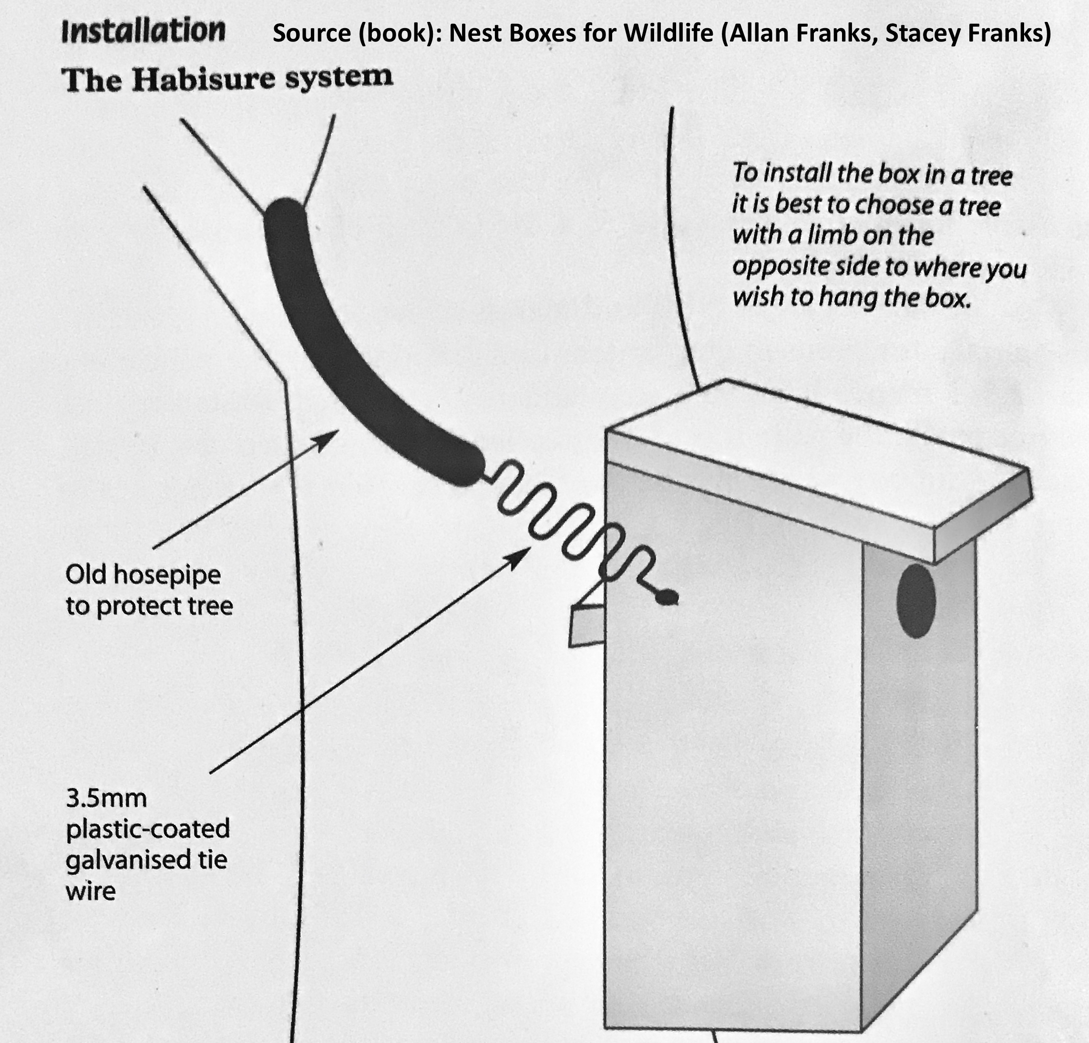

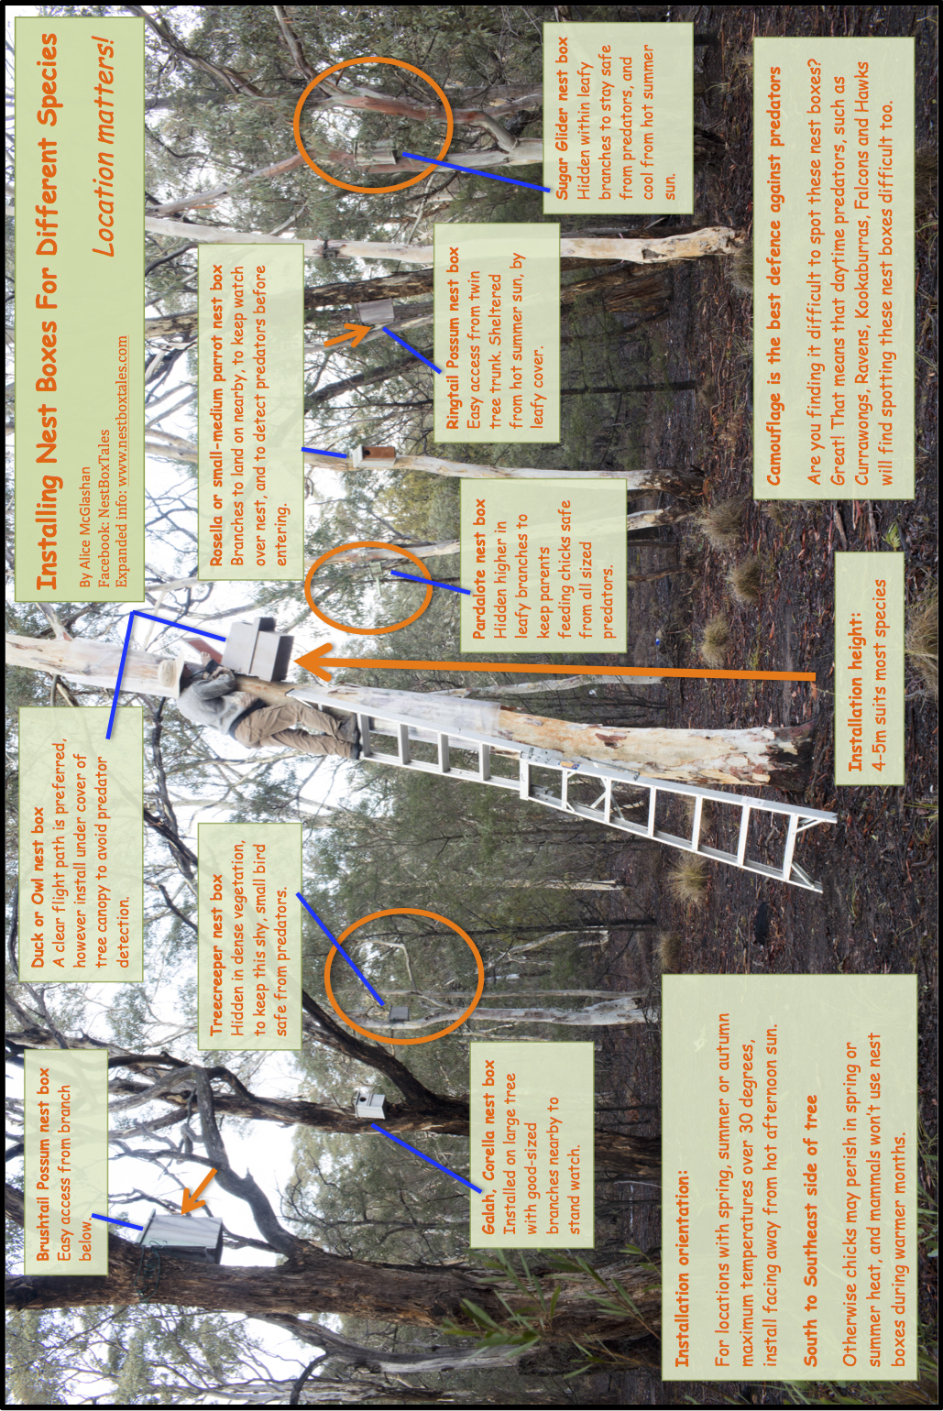

Good luck and enjoy!

Included are designs that I could find, for the species that occur in your region. There are not free online designs available for all species. However, don’t forget that at the start of this booklet, there is a species list that includes all the preferred entrance diameters for the native animals that occur in this region. Please do refer to these, and select a small, medium or large nest box design from above, however just make the entrance diameter that of the desired species from the list.

Studies have found that hollow using species are initially absent from badly burnt ecosystems (0-15yrs), and when they do return, are in very small numbers compared to pre-fire populations - studied from memory out to 50 years. Tree hollows take decades (tiny) to hundreds (large) of years to form. So, there is a very big need for artificial tree hollows to be added to the huge areas of bushfire-affected ecosystems

Most of our native hollow-using species are tiny, small or medium sized, with only a small number of large individuals and species for any location. So, nest boxes really need to be made to match this natural balance, for the bushfire affected ecosystems, where many of all sized tree hollows will have been lost.

There have already been hundreds of large brushtail nest boxes made across Australia for the bushfire recovery efforts.

An important consideration is the need for small to medium sized nest boxes to be made with a variety of entrance diameter sizes to keep all the slightly different hollow using species safe from slightly and much larger predators and predators. Most of our native animals compete with each other for scarce tree hollows. Slightly different hollow entrance sizes are important for enabling the different sized species to find a spot that is safe from slightly bigger predators and competitors, the difference often is only 5mm.

Thank you so much for making a difference.

Our native wildlife desperately need a helping hand to survive this current living hell of bushfire and drought. We really don’t want to lose more than we already have. Sure, we will probably lose some at-risk species because of this season’s bushfires and the ongoing drought. But don’t forget all the other wonderful native animals out there that we have the chance, right now to help survive. While we cannot undo the past, we can change the future to some extent depending on our choice of actions.

Every little tiny bit of difference made, cumulatively makes a big difference if many participate. Thank you so much for your contribution.

This is one of my contributions.
I hope you find this helpful.

Compiled by Alice McGlashan
Facebook: https://www.facebook.com/groups/nestboxtales/
Website: www.nestboxtales.com
Sharing stories and knowledge about nest boxes for Australian native animals to encourage everyone to improve habitat for wildlife.

