Nest Box Materials

&

Key Design Features

Booklet

For an online version of this document, or to download a copy, visit:

https://nestboxtales.com/nest-box-materials/

Written and Compiled by Alice McGlashan
Facebook: https://www.facebook.com/groups/nestboxtales/
Website: www.nestboxtales.com
Sharing stories and knowledge about nest boxes for Australian native animals to encourage everyone to improve habitat for wildlife.

Graphic design assistance gratefully received from Springwood Printing



A bit about me

I completed a Bachelor Degree of Geomatic Engineering and Science (geology) quite a few years ago now, and worked as a Geologist and GIS Analyst during my first career.

More recently I returned to university, completing a Graduate Diploma of Psychology, also a Master of Environmental Science and Law, specialising in ecosystem and wildlife management, biodiversity law, water law, and climate change law.

I have enjoyed exploring wilderness areas since a very young age, bird watching, frog spotting, and observing the complex interactions within Australia’s diverse ecosystems. I used all of my 7th year birthday money to purchase a Slater’s Field Guide to Australian Birds.

More recently, I purchased a small regenerating bushland property near Canberra. In 2016, I installed a first batch of 15 nest boxes for all the known local native hollow using species on my property, with several of them becoming occupied almost immediately. However there were also a number of unexplained failures.

After discovering that many of my questions about nest box utilisation and predation of occupants and eggs could not be answered by existing published research, I have purchased an ever expanding collection of wildlife cameras, temperature recording Thermocrons, polycarbonate plastic for possum guards, arborist (tree climbing) equipment, and more nest boxes, to figure out the causes of nesting failures, and to test different strategies to increase the occupancy of nest boxes by species that were struggling to use them successfully.

I have since learnt a lot about improving the occupation rates and bird nesting success of nest boxes for the different local native species, with key considerations discovered to be the predator and competitor species, bedding preferences, installation height, and installation aspect to avoid the hot afternoon sun. Late last year I created the NestBoxTales website and Facebook group to share what I had learnt, and to encourage other people across Australia to install nest boxes for hollow using wildlife. Install, and they absolutely will come!

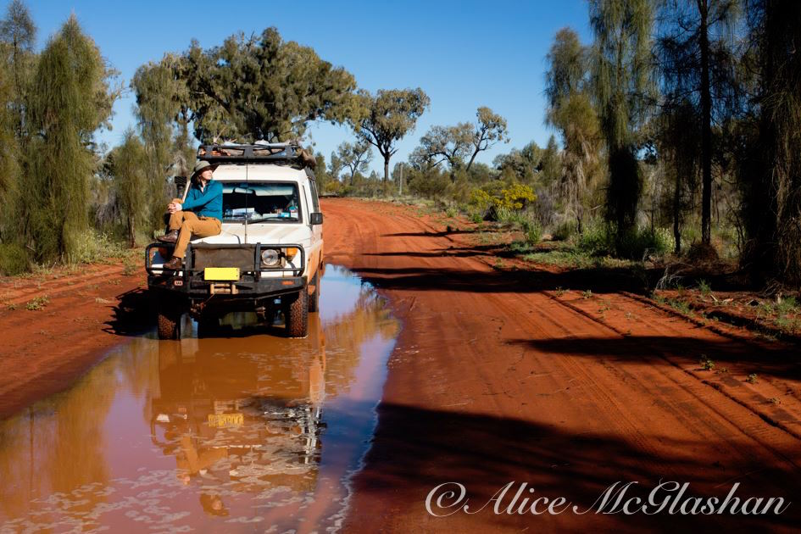
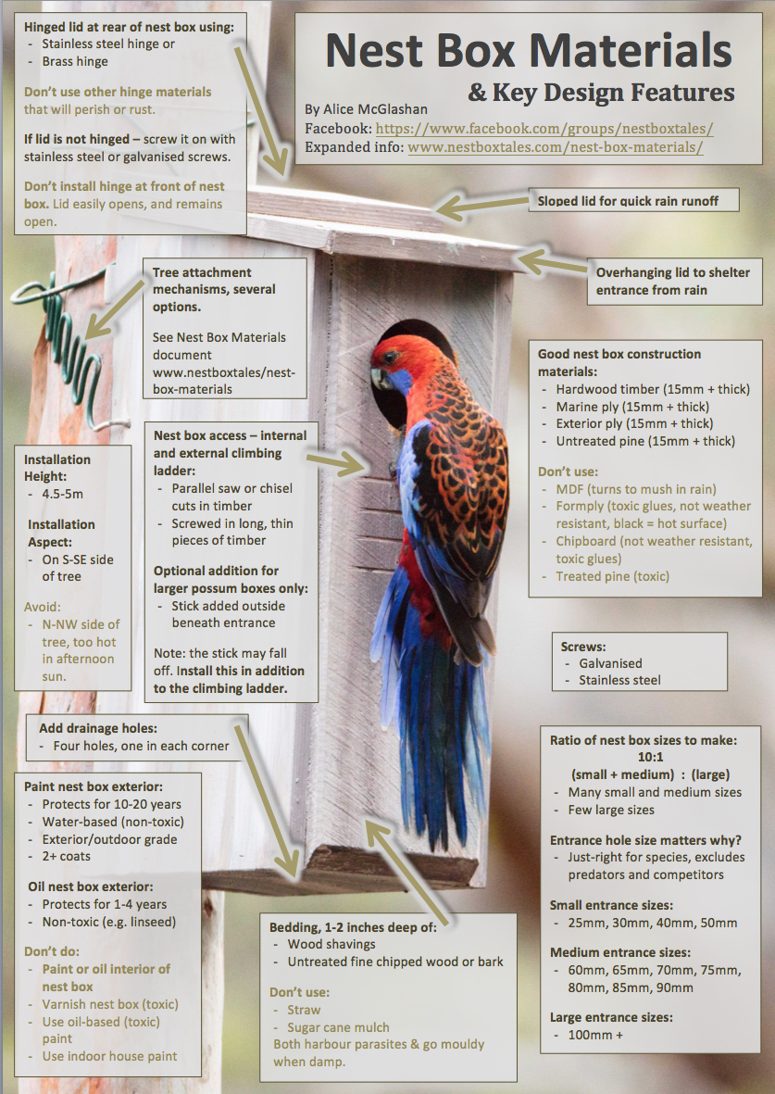

Nest Box Materials

Which wood to use?

Your choice of wood materials used to construct a nest box will affect the insulating properties (thermal mass) of a nest box, and also durability out in the elements.

Wood is a fantastic insulator and for nest box occupants.

During cold winter months, a nest box made from thick wood panels will retain the body heat of an occupant and protect against the outside cold temperatures.

During hot summer days, a thick-walled nest box will provide some protection against the hottest periods of the day, if installed out of direct sunlight.

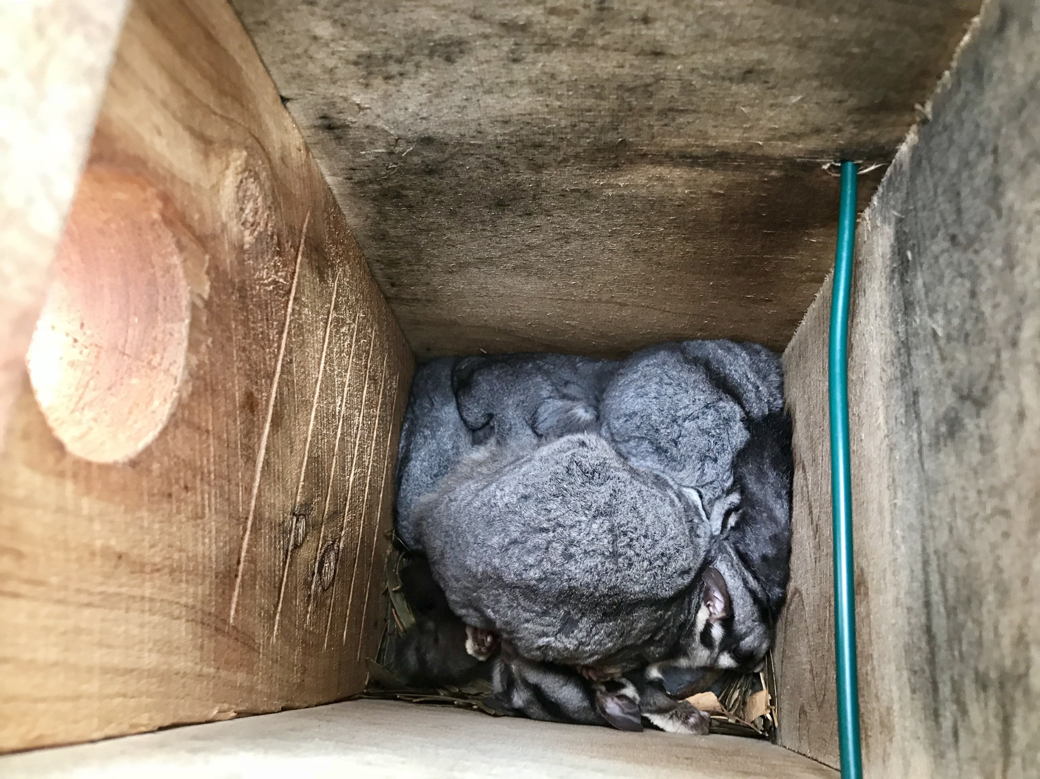
A winter snuggle of sugar gliders, staying warm in their thick-walled nest box.

A well-constructed hardwood or thick marine ply nest box, if painted with at least two coats of a good quality exterior grade paint, will potentially provide animals with a home for 20-30 years or more. By comparison, a pine, or thin plywood nest box may only last a few years.
- While (untreated) hardwood timber (15mm or more thick) is best (sawmill off cuts are an option). However this is a relatively scarce and expensive resource, so is not likely to be an option for most people to use.

- The second best option is thick marine ply, of at least 17mm thickness.

- The third best option is exterior ply, which should also be at least 17mm thick.

- The final option is untreated pine which is often readily available – from pallets etc (use HT = heat treated only). However just be aware that nest boxes made from pine may not last long in the environment. Painting of pine nest boxes is pretty much essential for them to last more than 2-3 years.

I would not recommend pine as a nest box making material for areas with high rainfall and humidity, and where termites are rampant. It won’t stand a chance against these! For my location near Canberra that has low rainfall, very low humidity, and few termites, pine nest boxes often last many years if painted well (outside only).

What about other wood products, like form ply, chipboard, MDF, treated pine?

If MDF is exposed to rain or water, it will rapidly turn to mush. This material is not designed for outdoor use. MDF will also absorb and retain urine and droppings even if kept out of the weather – such as in a garage or under your eaves. MDF is not an appropriate material to make nest boxes from.

Formply may, or may not be made using toxic glues that also let off fumes. The glues may, or may not be able to withstand being wet. Formply also has a thick black outer surface which would absorb heat and cannot be painted. Formply is not recommended as a material to make nest boxes from.

Chipboard is not designed for outdoor, rain, hail shine use. It will rapidly break down and may be bonded using glues that are toxic to eat. Chipboard is not recommended as a material to make nest boxes from.

Treated pine is a timber that has been permeated with a chemical solution to preserve it outdoors. It is not something that you’d want your child munch on, and so isn’t appropriate to use for making nest boxes. While your nest box may have a ringtail possum label on it, this size is also preferred by Crimson Rosellas, potentially Galahs and other parrot species that enjoy munching on things, especially if they are bored while sitting on eggs. You really don’t want to poison any nest box occupants! Treated pine is not an appropriate material to make nest boxes from.

Increasing the durability of nest boxes – to paint or oil?

The key question here is:

Would you like your nest box to last 1-10 years, or 20+ years?

It is very important that any coating put on your nest box is not toxic. Please do not varnish nest boxes, or paint them with oil based paints, or use other treatments that you would not want to eat.

No treatment should be applied to the interior of nest boxes. Occupants are more likely to consume or be exposed to the fumes of any internal treatments.

Treat the outside surfaces of a nest box only!

No treatment should be applied to the interior of nest boxes. Occupants are more likely to consume or be exposed to the fumes of any internal treatments. Treating the inside of a nest box is also unnecessary, as it is protected from the weather and will stay in a relatively pristine condition, depending on how messy the occupants are!

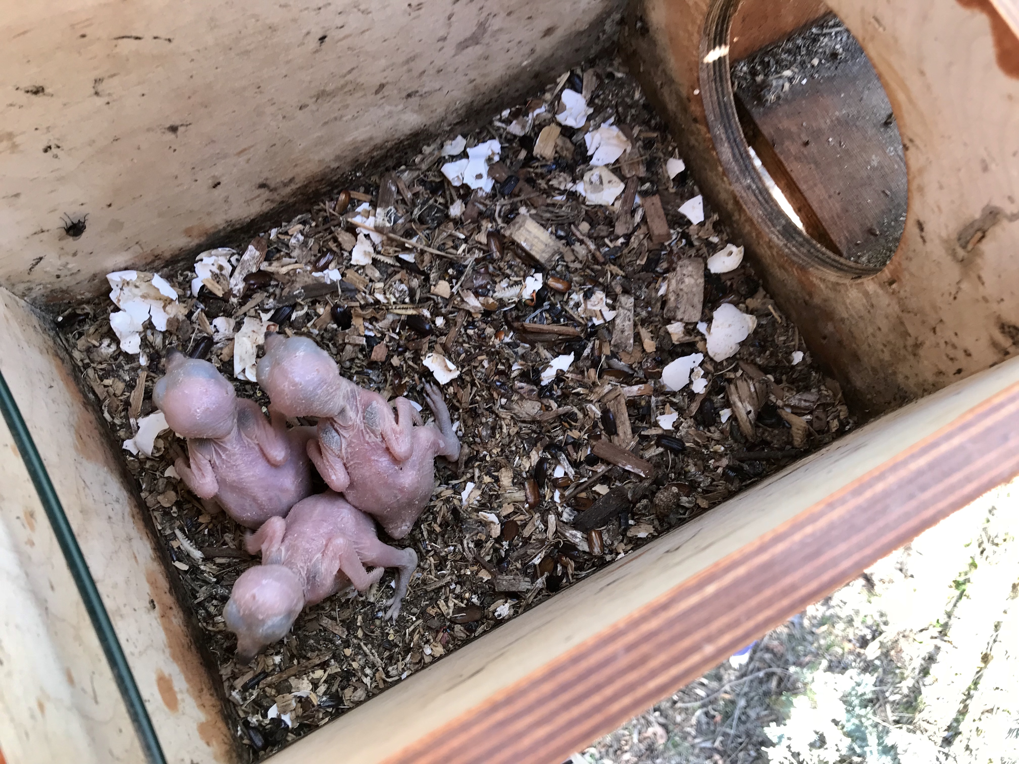
Third year of use by my resident kookaburra family. Note the good condition of the inside of the nest box, despite the gross kooka-chick poop layer at the bottom. Don’t worry, maggots are the nest box vacuum cleaners by consuming this goop, growing wings and flying away!

External nest box surfaces painted with an outdoor grade water-based paint

Painting the exterior of your nest box with a water-based under coat, and a good quality water-based exterior paint (2 + coats), such as Dulux Weathershield will extend the life of your nest box by a couple of decades at least.

Do ensure that the cut edges of your plywood and timber nest boxes are thoroughly coated, so you can't see the wood beneath.

Before painting sand all edges and around the opening of the nest box to remove sharp edges. A light sand between coats also helps the paint adhere to the timber or plywood.

Please use pale colours, as this will prevent the nest box from absorbing heat from the sun during warm weather. Dark coloured, hot nest boxes can be deadly for creatures that cannot escape, such as chicks and unhatched eggs.

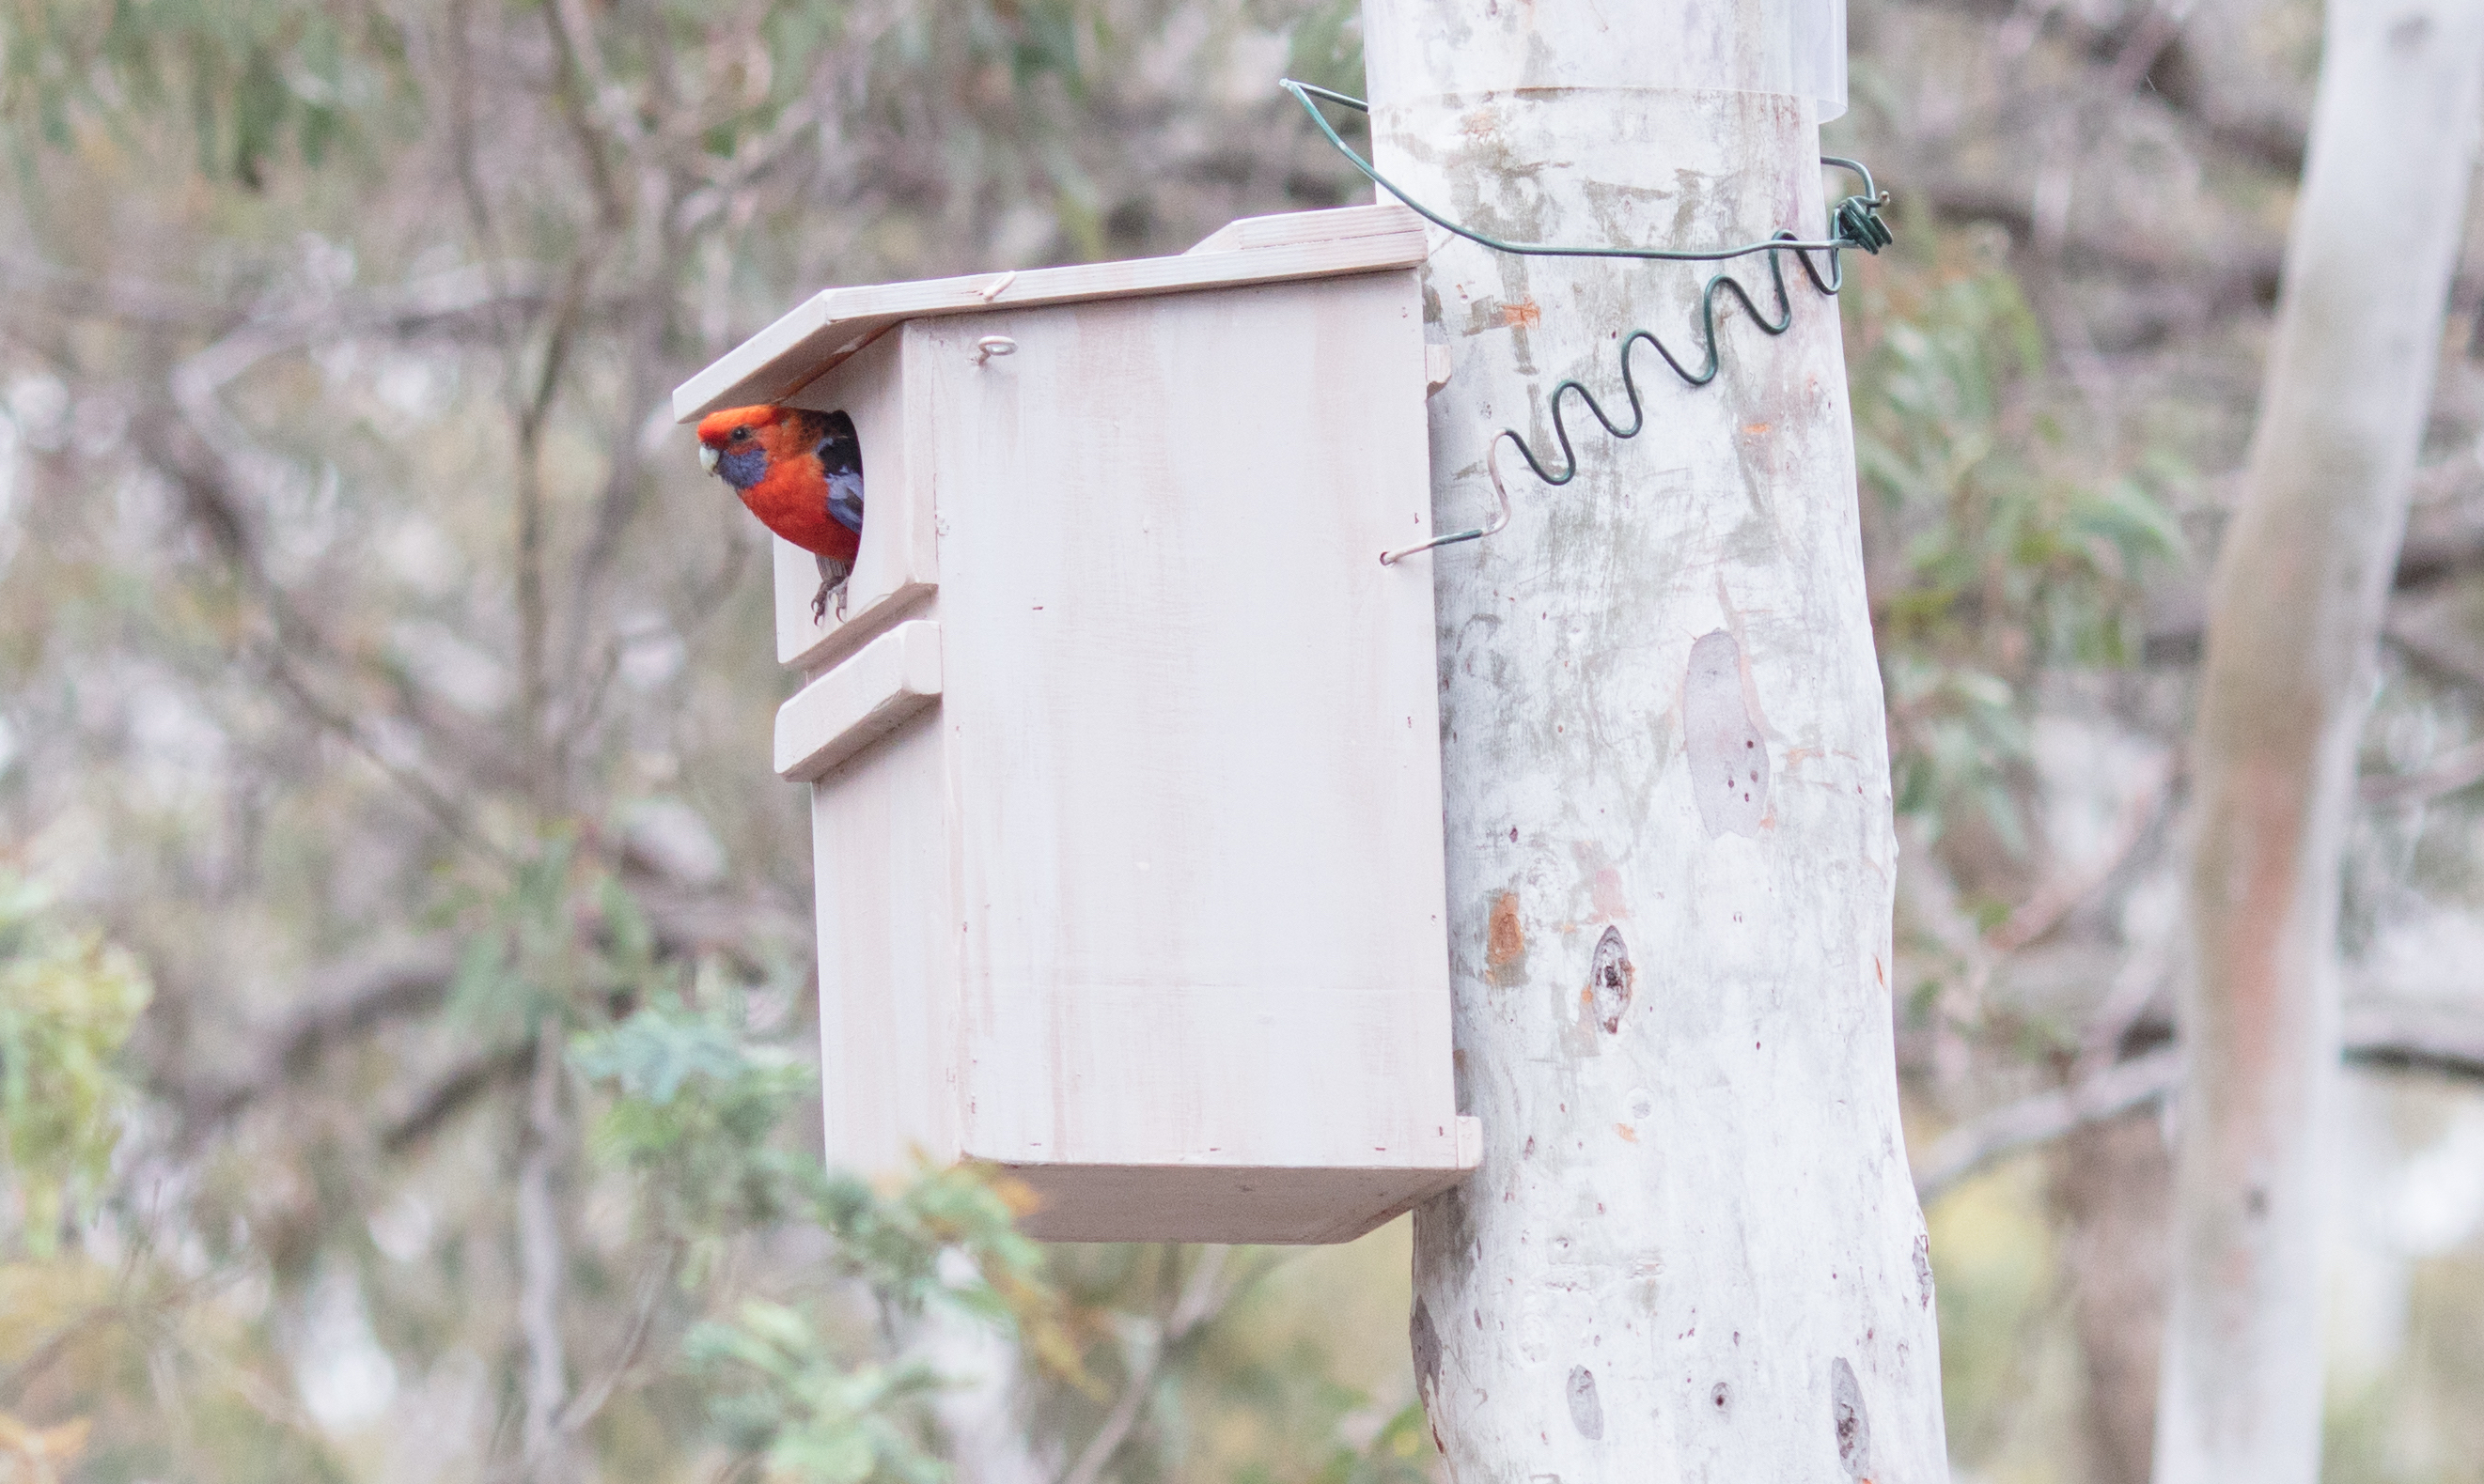
A nest box painted to match the colours of the scribbly gum trees on my property.

Also please choose colour/s that blend into the habitat where the nest box will be installed. This will reduce the risk that the nest box will be discovered by a predator of the occupants.

Birds prefer to nest in discrete, secret locations, so the colours of your nest box should emulate this.

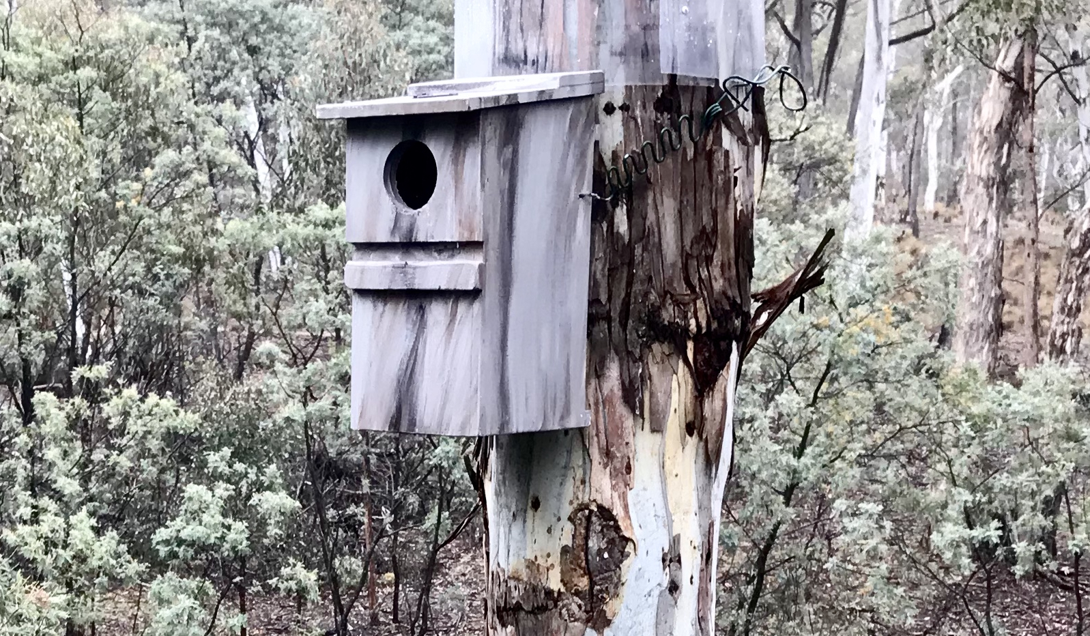
Feel free to have some fun with painting your nest boxes in bushland colours! I had some fun with this larger parrot nest box.

Sugar gliders and small possums also are at risk of being snacks for bigger daytime and night time predators, and so will benefit from a nest box that is invisible from hungry eyes.

For bushfire zones, some imagination will be required – imagine what the vegetation will look like once it regrows – pale ash grey is an option, it blends in with the sky too.

Black is not a suitable choice of colour to paint a nest box, given the ability to absorb heat during hot summer days and potentially cook occupants.

External nest box surface treatment with a non-toxic oil

A second treatment option for nest boxes, is a non-toxic oil such as linseed oil. However in the elements, the protective benefits of the oil for the wood will only last for 1-3 years, after which a new coat will need to be applied, or the nest box rapidly begin to degrade.

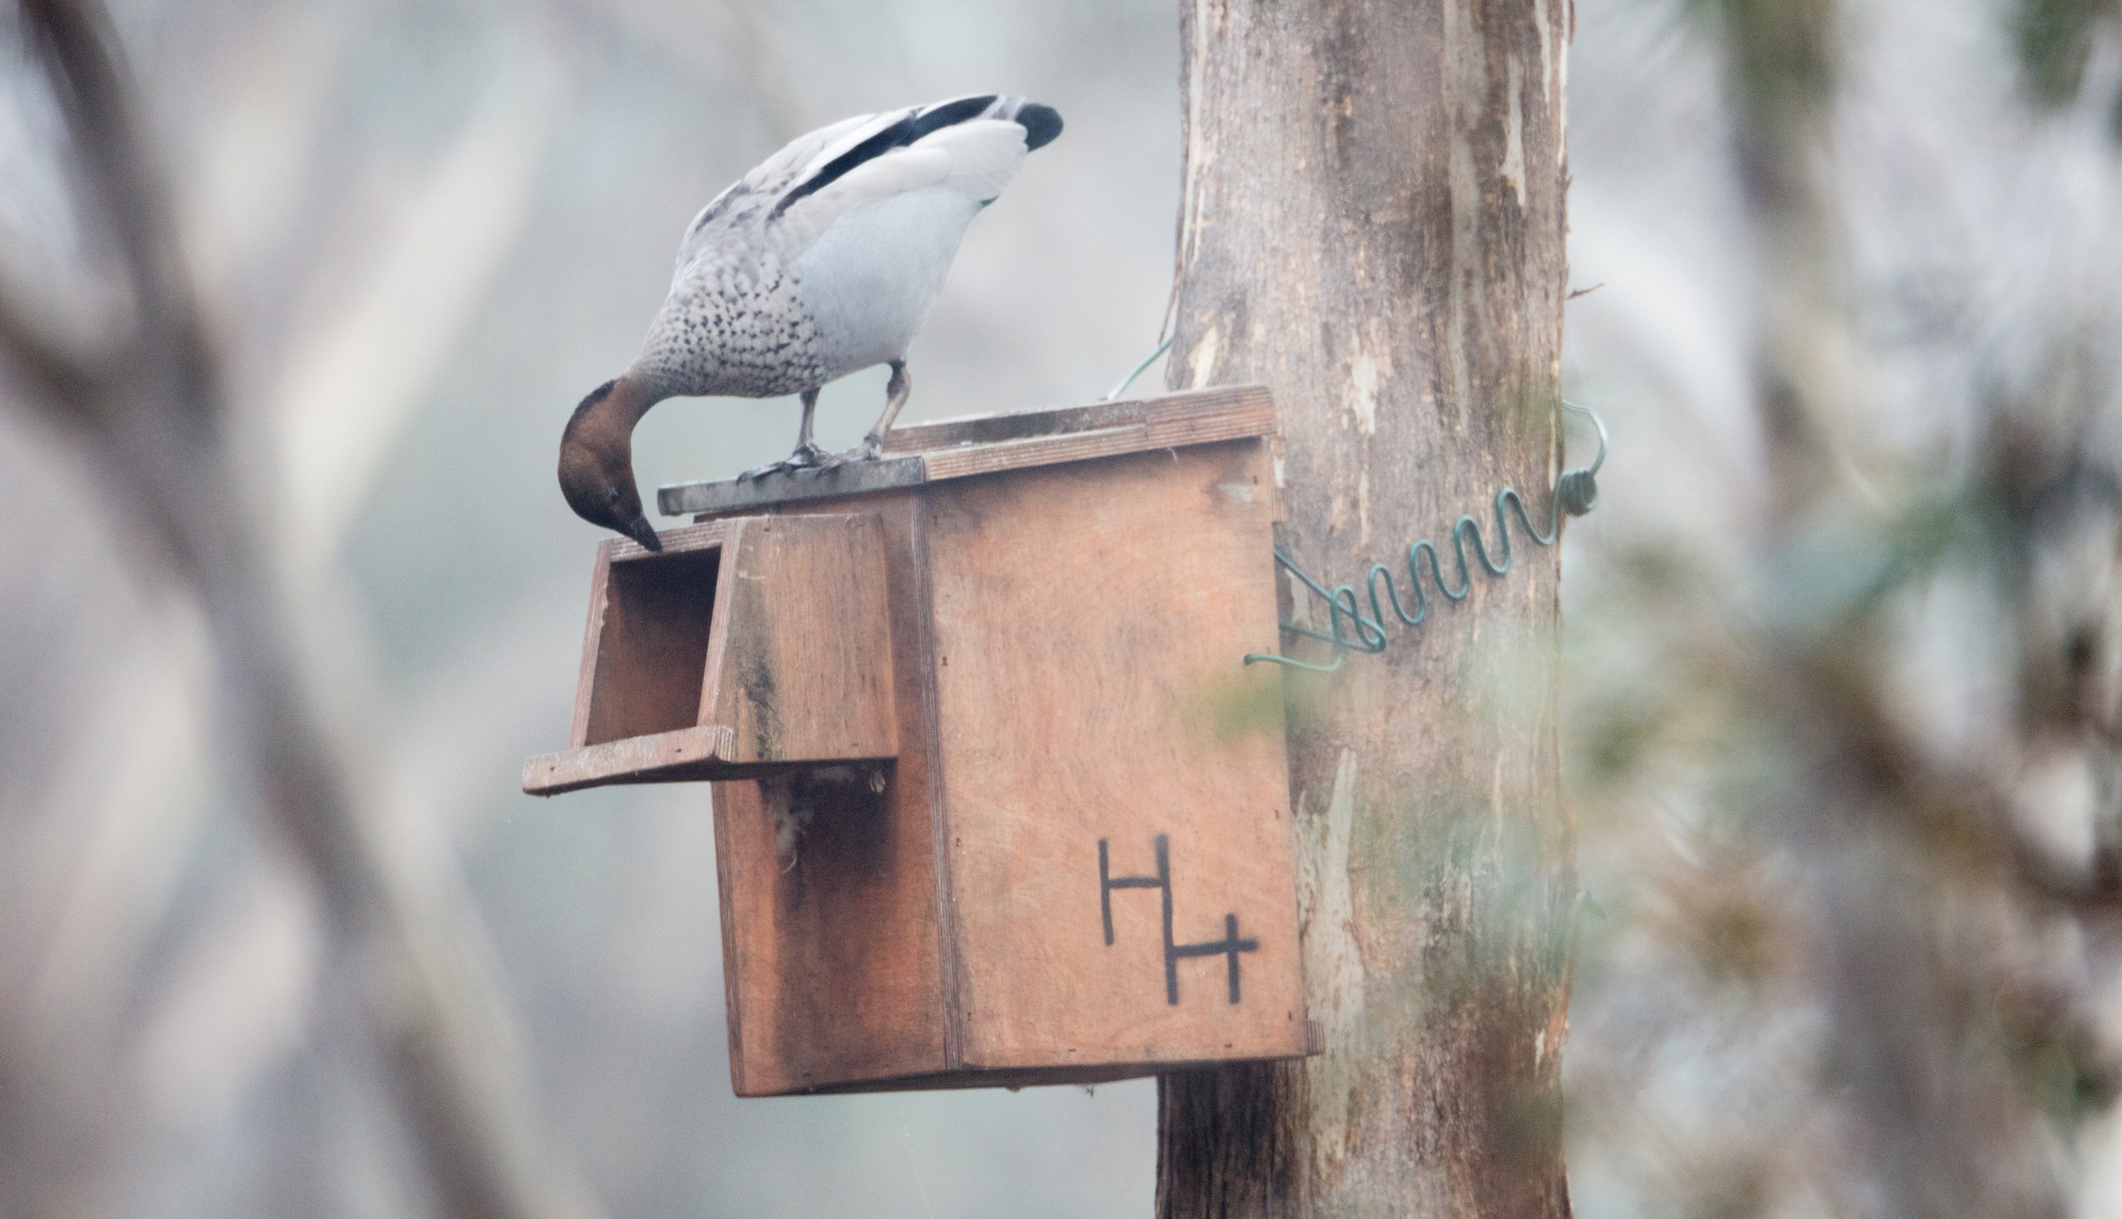
A Wood Duck checking out one of my for-Wood Duck nest boxes coated in linseed oil.

Unless you are installing your nest box at home and are willing to reapply the oil treatment every couple of years, I would recommend painting instead of oiling a nest box.

Nest boxes are a valuable resource for native animals that use them, have used expensive wood and metal materials, and someone’s time to construct. Increasing the length of time that a nest box will survive in an ecosystem I believe, is an important task for the nest box maker, or the nest box installer to complete.

Nest box bits and pieces

Nails, screws or staples?

Galvanised or stainless steel screws are recommended over nails or staples.

Of the greatest importance, is to use materials that will not rust with time. There may be salt in the air in coastal locations, or high rainfall. You really don’t want the rusting of a screw to cause the failure of an otherwise structurally sound nest box.

Drainage holes over creative “weather proofing”

Natural tree hollows often don’t keep occupants 100% dry during big storms. However the much loved, and successful hollow homes will enable any moisture entering to drain and so not causing flooding or fouling of bedding. A death trap of a hollow would be one that doesn’t permit water to drain, flooding any occupants that cannot escape such as chicks, during very wet conditions.

Just assume that your nest box may let some moisture in during a crazy big storm. That’s quite OK!

However to effectively drain this water out, a nest box needs to have drainage holes at each of the four corners. This is so that water can escape, no matter if the nest box is installed leaning forwards, backwards, angled to the left or to the right.

The lid needs a hinge (nice to have, not essential)

Stainless steel or brass hinges are recommended, as these will last for many years outdoors. As for the size, if you aren’t sure, just show your local hardware store the timber you are intending to use, and they will happily advise you on what size hinge to use.

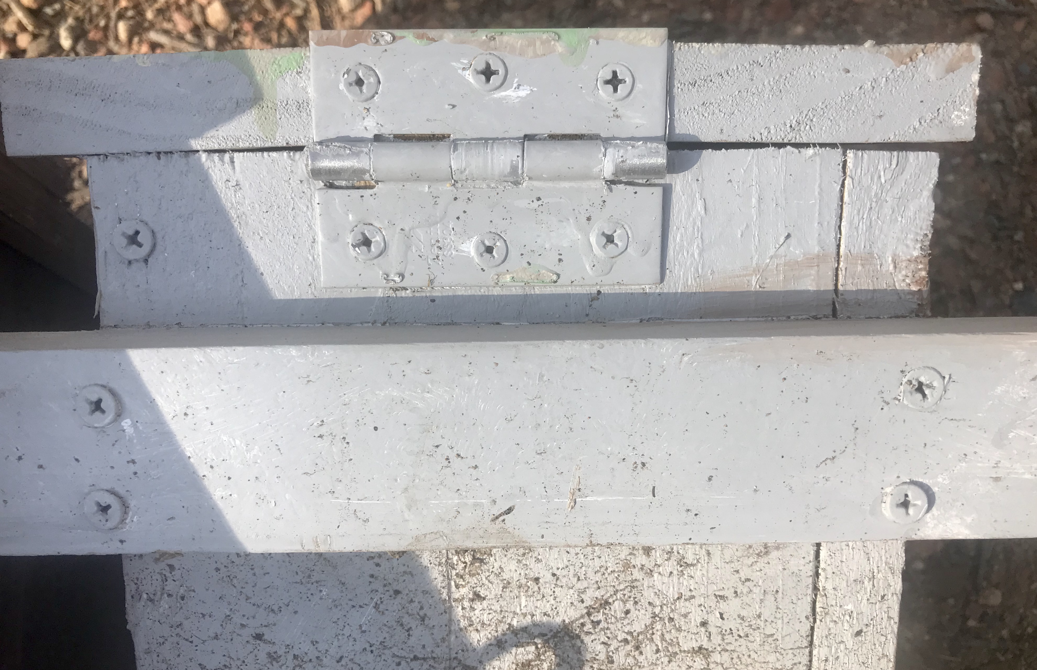
A stainless steel hinge purchased from a hardware store.

However if you can’t afford to purchase hinges, then attach the lid of the nest box to the body with good quality galvanised or stainless steel screws, so that these can be (relatively) easily removed if someone needs to gain access to the nest box.

Please don’t use other materials as substitute hinges, such as leather, bike tyres, or other materials, as these are unlikely to survive intact for 15-30 years in UV, rain, or withstand a curious parrot’s chomping.

The weakest part of the nest box is usually the lid/hinge. If the nest box lid comes ajar or falls off, the nest box will fail in its ability to provide shelter to wildlife.

Why is it nice to have a lid that can open?

It’s pretty much impossible to clean out a grotty nest box with a small entrance – that one can’t fit their hand into - or remove feral species such as European honey bees. I’ve scraped two-inch-deep Crimson Rosella chick poop out of my small-entranced rosella nest boxes, which would have been pretty difficult to do if the lid did not open. A lid that won’t open also severely limits the ability to monitor a nest box – which occupants are there, are there any egg shell fragments, what types of bedding is inside?

A latch to keep larger predators out (nice to have)

Predators such as brush tail possums (which eat eggs, chicks, kill small-large birds) and free ranging cats are quite able to push open nest box lids to gain access to a tasty nest box snack.

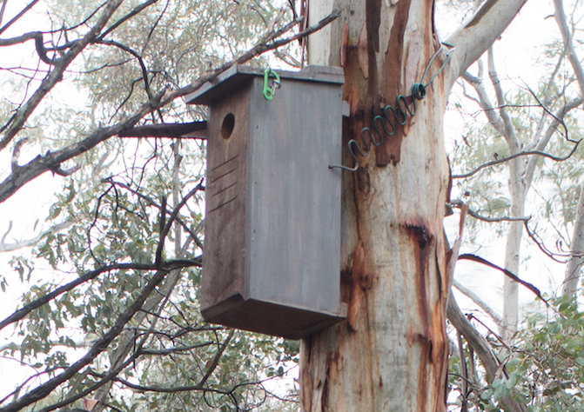
One of the sugar glider nest boxes on my property, with a latch to keep brushtail possums out.

Most predator individuals won't discover that they can open nest box lids, however this can be a problem. Adding a simple latch that prevents the nest box lid from being lifted up, is a good solution. Screwing in an eyelet on the front left or right side of the lid, and below on the side wall, and adding a small loop of twisted wire is one option, or adding a small screw in latch is another.

Nest box access

A smooth-surfaced nest box can be very difficult for animals to access or exit from the inside without adding some kind grip-able ladder. Older nest box designs and a couple of current designs suggest using wire mesh.

Don’t use: Wire mesh

Wire mesh can be problematic, with small feet of chicks and birds particularly at risk of being trapped, damaged and at worst, unable to be freed, causing a slow and quite horrible death.

However, if you've already made nest boxes with wire mesh added, don't stress. They will still be able to be used as the risk is very low. It's just best not to have all nest boxes installed out there with wire mesh attached!

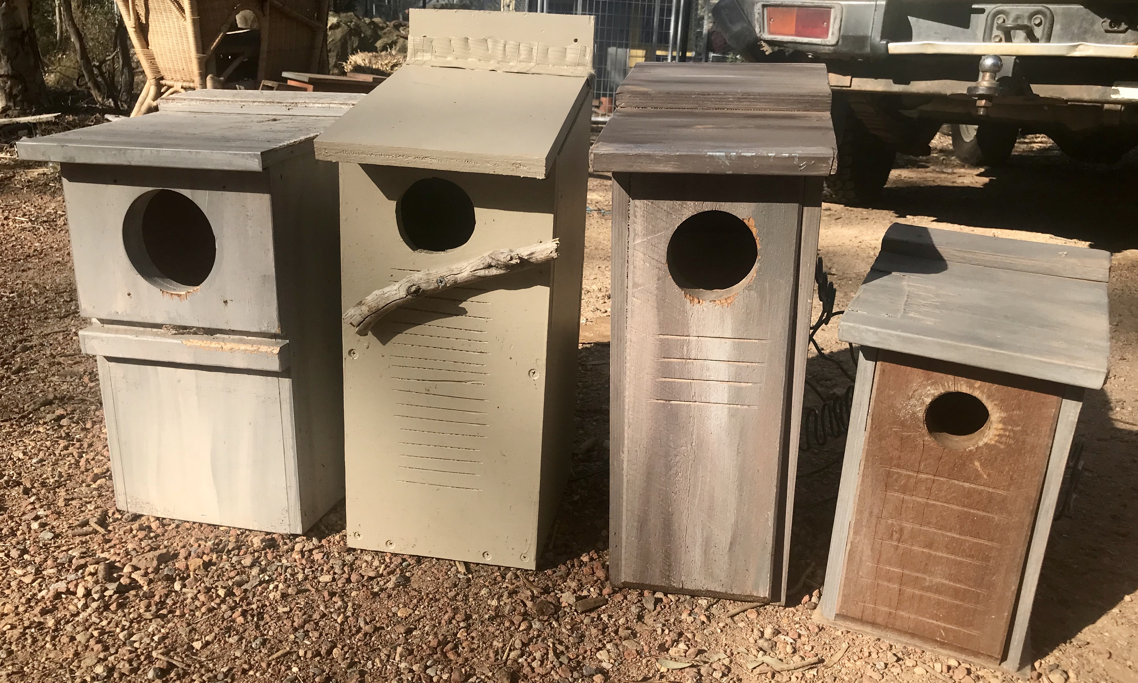
A selection of grip-able access options for nest boxes. Note the nest box with the stick also has the parallel cuts in the wood also, in case the stick breaks off or is chomped off by a parrot.

Option 1: Parallel saw or chisel cuts inside and outside of front panel

Two very durable options exist, which include making shallow parallel cuts in the front panel of the nest box below the entrance hole, both on the inside and outside face.

This can be done with a power saw, a hand saw, or even a chisel. Don’t stress about these being neat and symmetrical! Messy and uneven is fine. When was the last time you saw a symmetrical tree hollow?

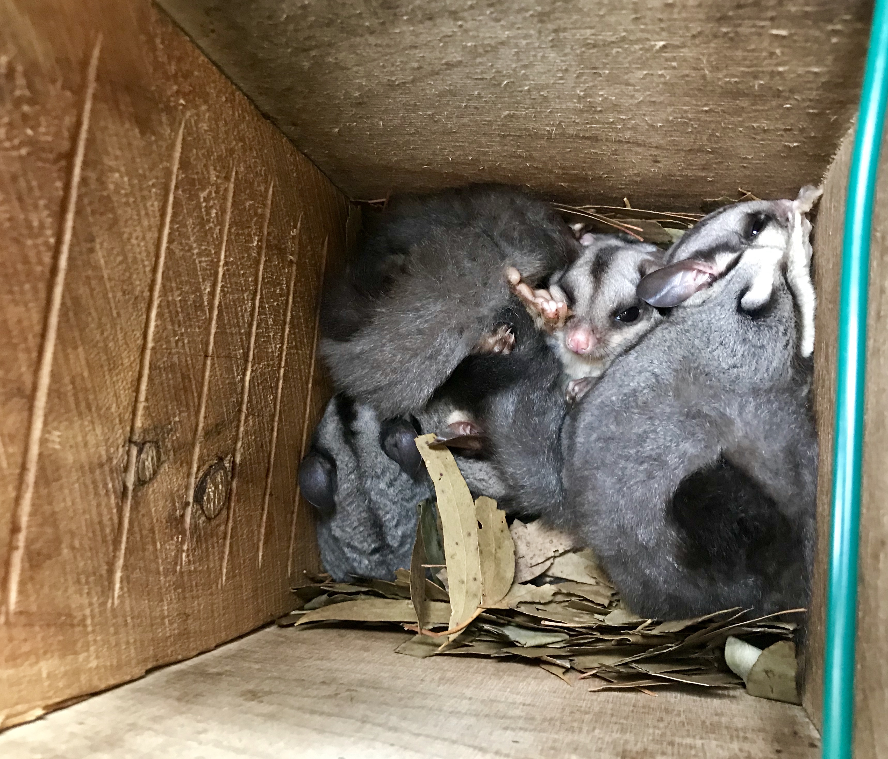
Note the internal climbing ladder for this sugar glider family to exit their nest box.

Option 2: Screw in long, thin piece/s of timber inside and outside of front panel

The second option is to add strong parallel thin cut pieces of wood to the outside and inside of nest boxes below the access hole.

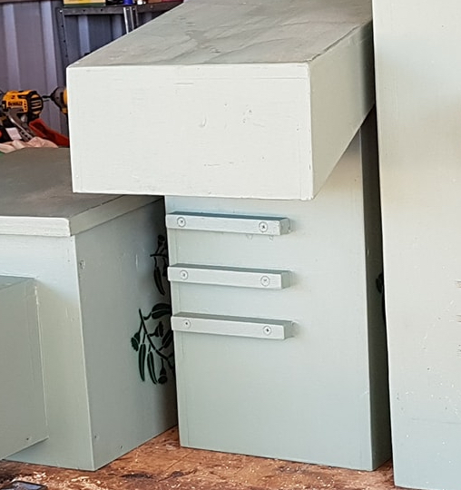
Image and nest boxes by Philip Dubbin, a good example of adding strips of wood as a climbing ladder, instead of the parallel saw or chisel cuts.

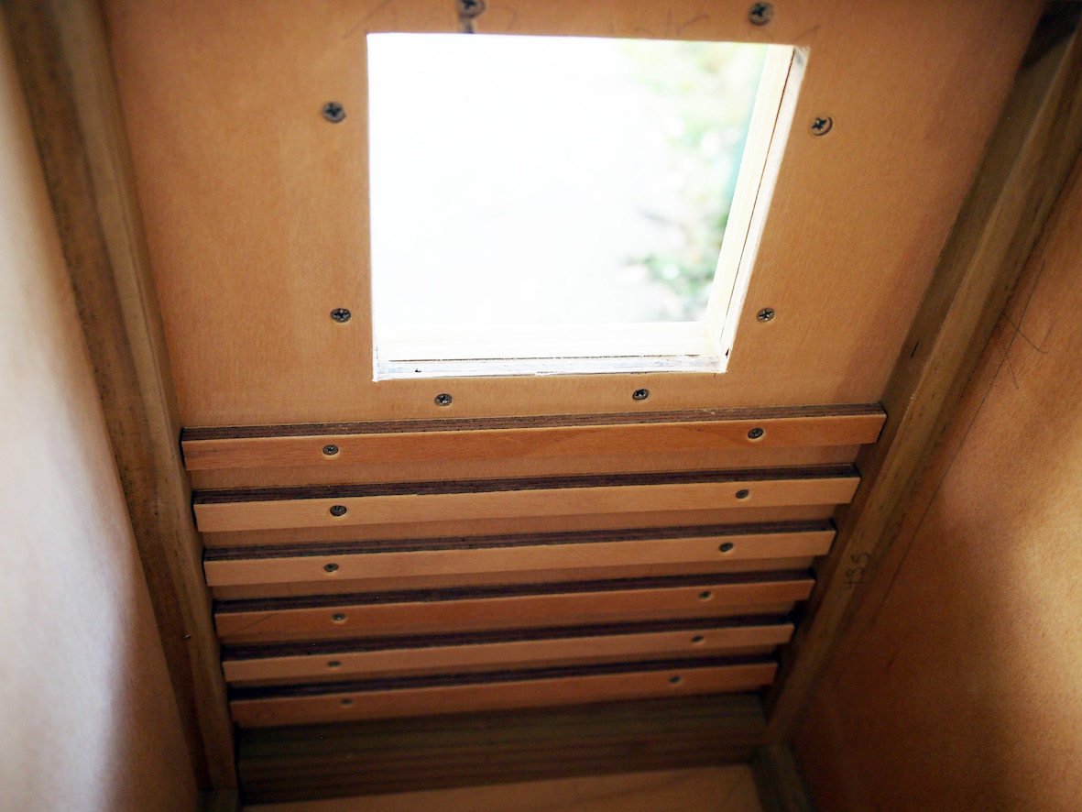

Image and nest box by Jenny Bigelow. Internal climbing ladder made from cut strips of timber, securely screwed onto the front wall of the nest box below the entrance.

Optional addition: attach a stick perch to nest box front

Adding a good-sized stick below the entrance hole is advised for brushtail possum nest boxes. However, this should be added in addition to the above two options.

This is because a stick may be chewed off by a curious parrot, leaving the nest box with no grip-able access to the entrance hollow.

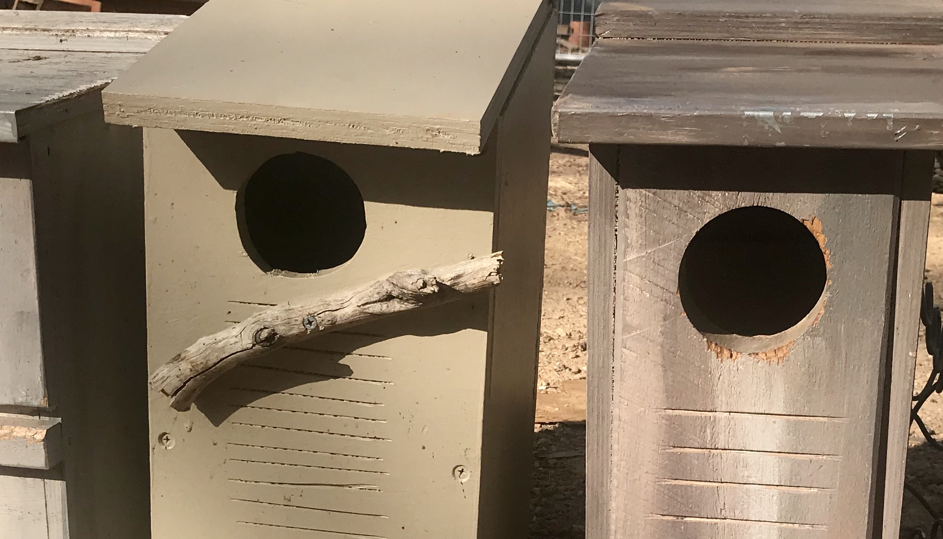
Note that this nest box with an added stick also has the parallel saw cut ladder in addition. It is likely that this stick will not survive as long as the nest box itself will, when used by all sorts of native animals. Some of which are quite destructive!

For bird nest boxes, I would recommend not adding the stick, as this will make access easier for possum species that are predators (e.g. brushtails, sugar gliders), or competitors for nesting hollows (e.g. ringtails, brushtails).

Nest box entrances: size matters!

But probably not in the way you’d expect.

Inexpensive nifty pieces of kit called hole saws that attach to power drills are used to make circular holes of a variety sizes in timber. You generally purchase them in a pack, that includes several sizes.

As you can see from the above image of the brush tail possum attacking a sitting wood duck, predation is an issue for nest box occupants. Competition is another problem, where a large animal will force a smaller animal out of a hollow home.

It is a misconception that a larger entrance will enable a greater number of species to use a nest box. Actually, the reverse is probably true. If a brushtail possum can access a tree hollow or nest box, then only those species of a similar size (that can’t fit into smaller hollows) will tend to use the hollow.

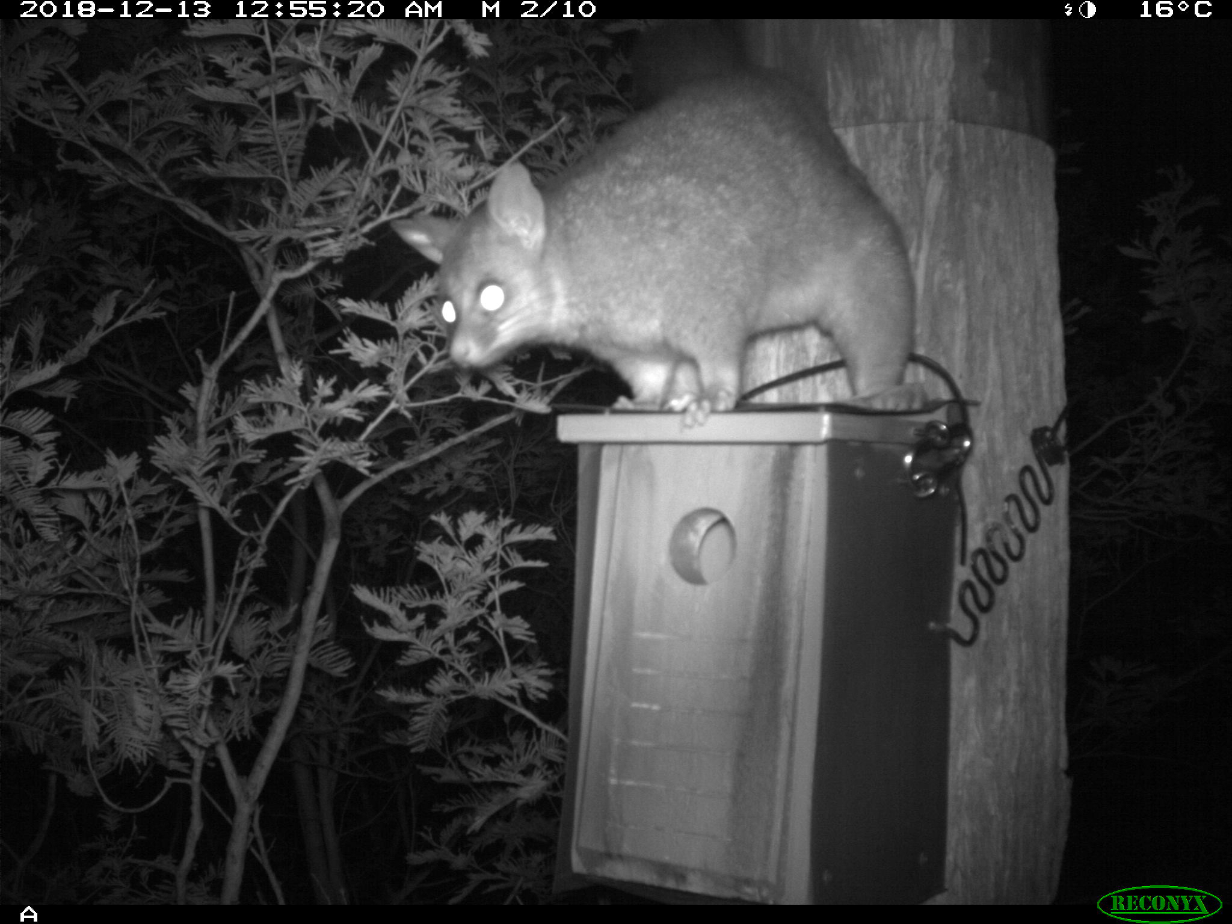
The occupants of this treecreeper nest box are safe from this hungry brushtail possum.

In Australian ecosystems, there is a greater number of species and individual animals that are small to medium, than are large. The same is true for naturally occurring tree hollows. Small tree hollows take fewer years to form, and so are more numerous than medium, large tree, and massive tree hollows.

When making and installing nest boxes to support ecosystem recovery after a catastrophic event causing the significant loss of tree hollows, or within regenerating habitat with few naturally occurring tree hollows (yet), it is really important to install nest boxes of the ratio of sizes that would naturally occur in an old-growth ecosystem.

Please make and install a ratio of 10 small + medium nest boxes, for every 1 large nest box (10:1).

Tiny to small entrances (25-50mm)

Many small brown undergrowth and tree-top birds use tiny tree hollows to nest, which provide protection against storms, and from predation by sugar gliders (tiny hollows), brushtail possums, kookaburras, goannas and owls.

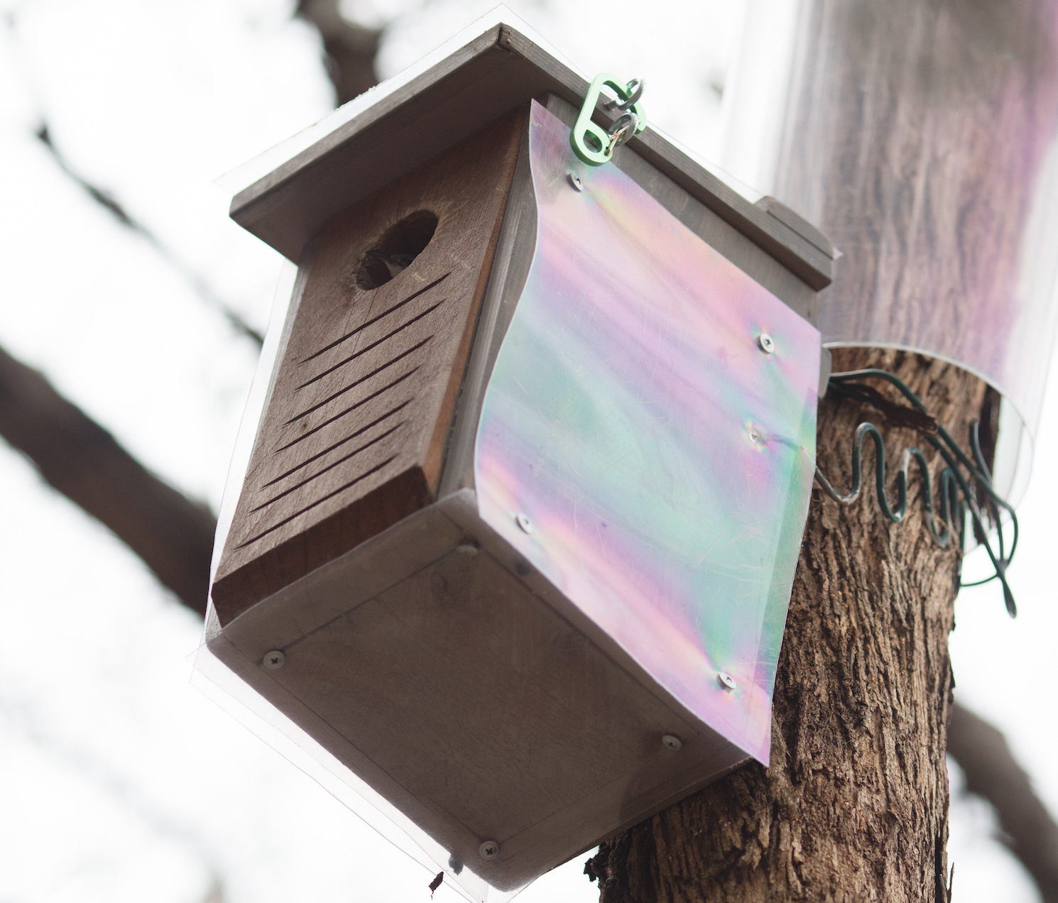
Can you see mother Treecreeper? She is sitting on two tiny eggs inside this little nest box.

Small birds also can’t compete for tree hollows that larger non-predator animals can access. These little birds provide valuable ecosystem services by reducing the sap-sucking insect burden on trees.

Small birds are very low on the food chain and are enjoyed as tasty snacks by many animals – and so provide a valuable food source within a balanced ecosystem.

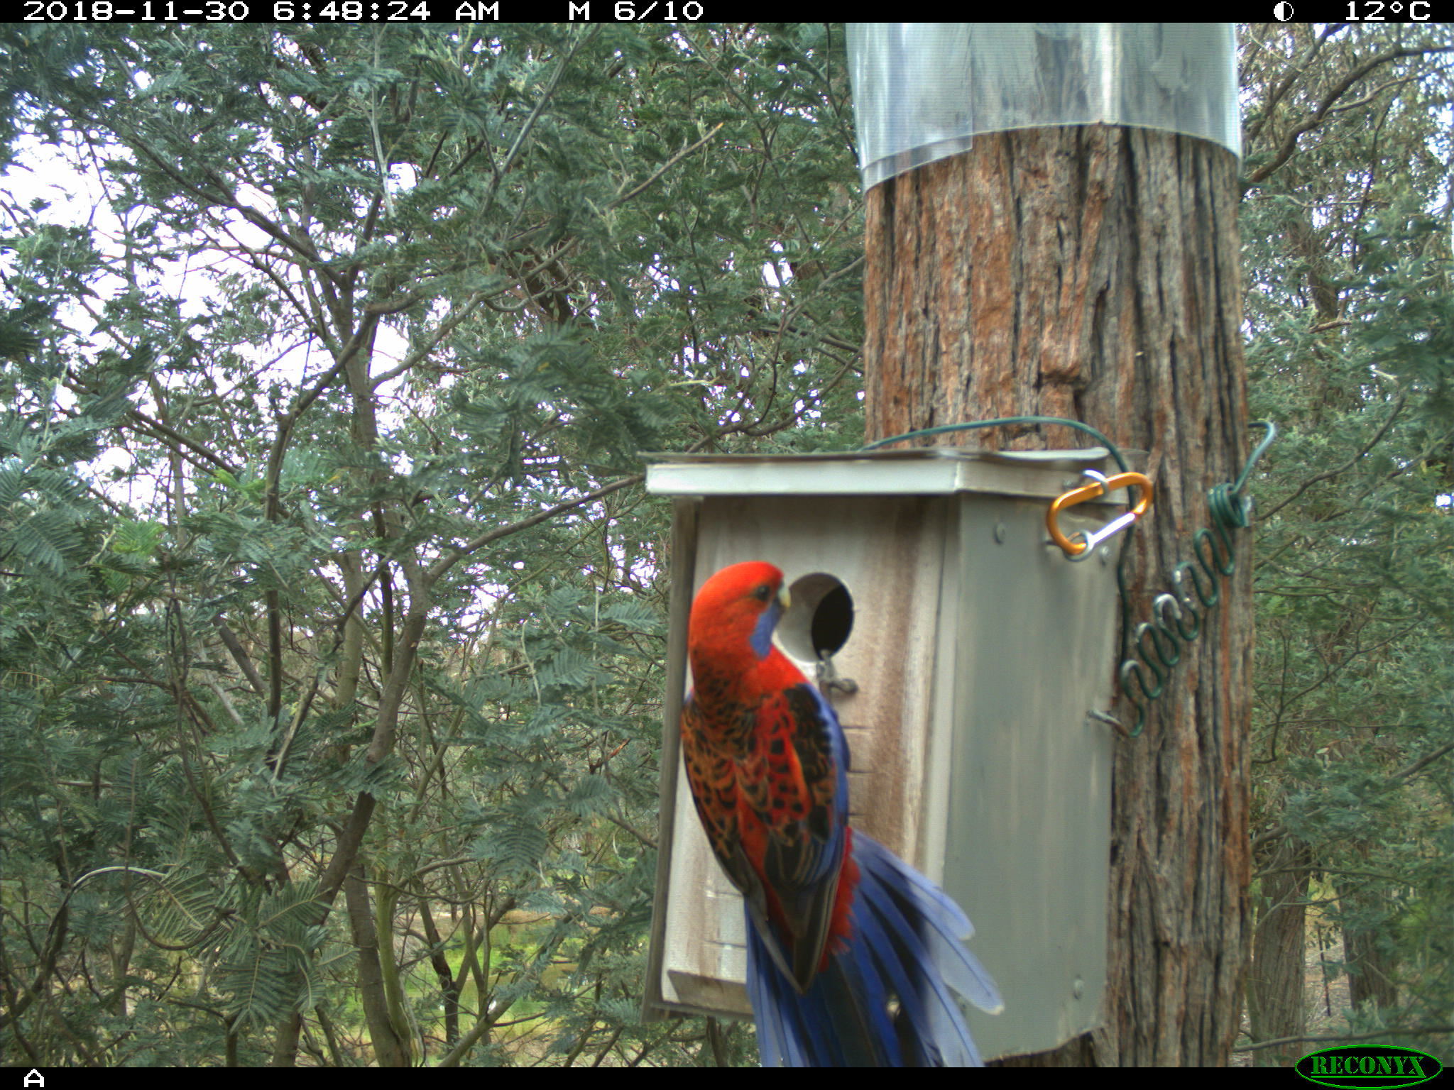
This entrance hole is too small for a Crimson Rosella, so the small occupants are safe from being evicted.

There are also a number of very small mammals – antechinus, pygmy possums and gliders that need tree hollows with tiny to small entrance diameters to stay safe from owls and brushtail possums.

There is pretty much a complete overlap between the small bird and mammal nest box dimensions and entrance sizes, such that a nest box of a treecreeper design is just as likely to be occupied by a sugar or squirrel glider – as I have found on my property.

Medium entrance diameters (60-90mm)

Medium sized birds such as the many different parrot species including lorikeets and rosellas, will only nest in tree hollows. They are also very susceptible to predation – mother birds sitting on nests, eggs and chicks.

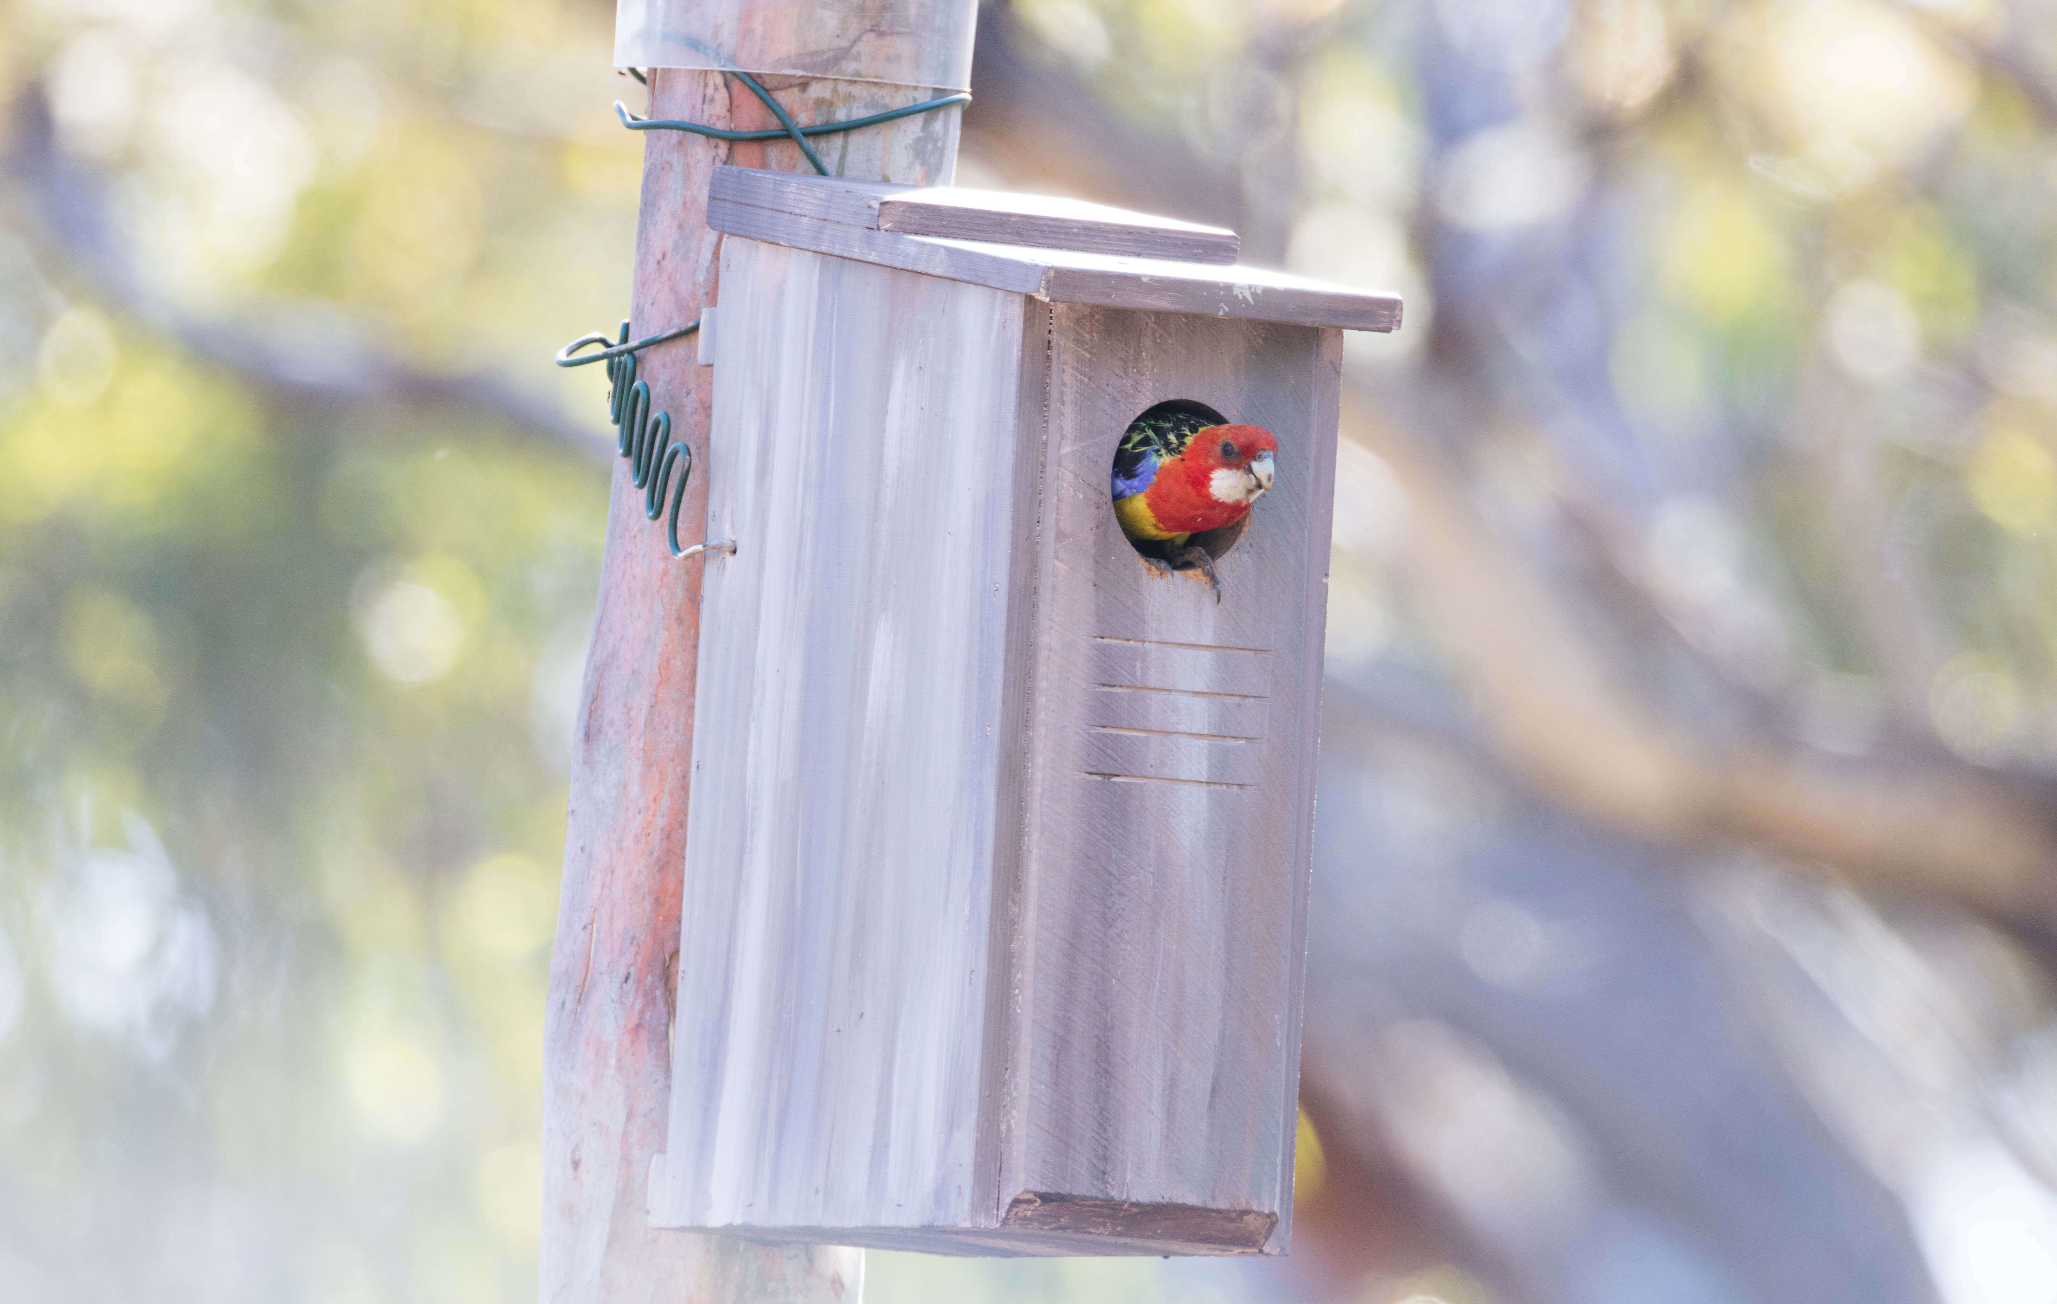
A perfect fit for this eastern rosella. This entrance size prevents raids by kookaburras, currawongs, and brushtail possums. She successfully raised three chicks in this nest box last year.

The different parrot species compete with each other also for nesting hollows, often with the larger species winning over a smaller species. Installing nest boxes with the exact recommended diameter for each species will assist each of the locally occurring species to secure a safe place to nest (60mm, 65mm, 70mm, 75mm, 80mm, 85mm).

Ringtail possums will use the same entrance size as for Crimson Rosellas but can’t fit into slightly smaller entrances for Eastern Rosellas and lorikeets.

Large entrance diameters (100mm +)

Larger tree hollows are occupied by owls, brushtail possums, ducks, larger parrots, Kookaburras and larger glider species. However within an ecosystem, these are fewer in number than are the medium to smaller species.

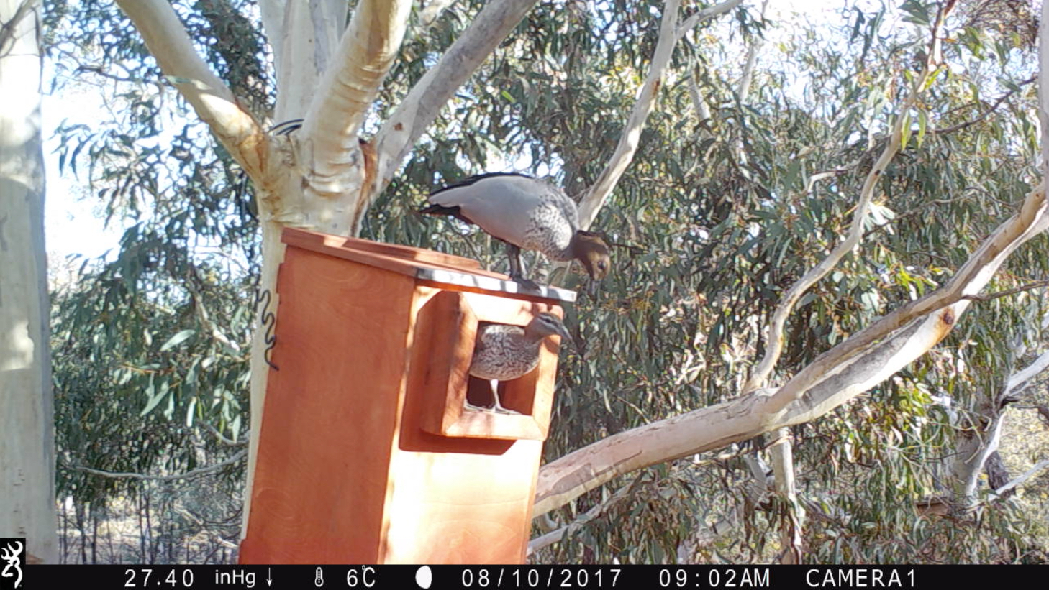

This nest box is designed for Black Cockatoos, however my resident Wood Ducks, and Brushtail Possums also like this size.

Tree installation materials

Now, there are a few different options for attaching a nest box to a tree. My preferred option is the Habisure system (and variations) by Hollow Log Homes, as this does no harm to the tree, is very durable, and makes installation a cinch. However the materials for this and similar variations are more expensive than alternatives, and so may be not an option for some seeking to install nest boxes. That’s understandable!

The Habisure System (Nest Boxes for Wildlife, by Alan and Stacey Franks)

The Habisure system is a single piece of plastic coated 3.15-3.5mm galvanised wire (fencing wire is an alternative option), that goes through holes right at the back of the two side panels of the nest box. The wire is bent to a zigzag shape for the first 20-30cm, and then runs straight after. One end has a loop, the other is longer with a straight end that goes around the tree and through the loop.

One variation has a piece of garden hose on the part that hangs off the tree – this would be a good option if plain fencing wire (not plastic coated) were to be used.

The zig-zag shape allows for the growth of the tree, so the nest box stays secure, but prevents the wire from strangling the tree as it grows.

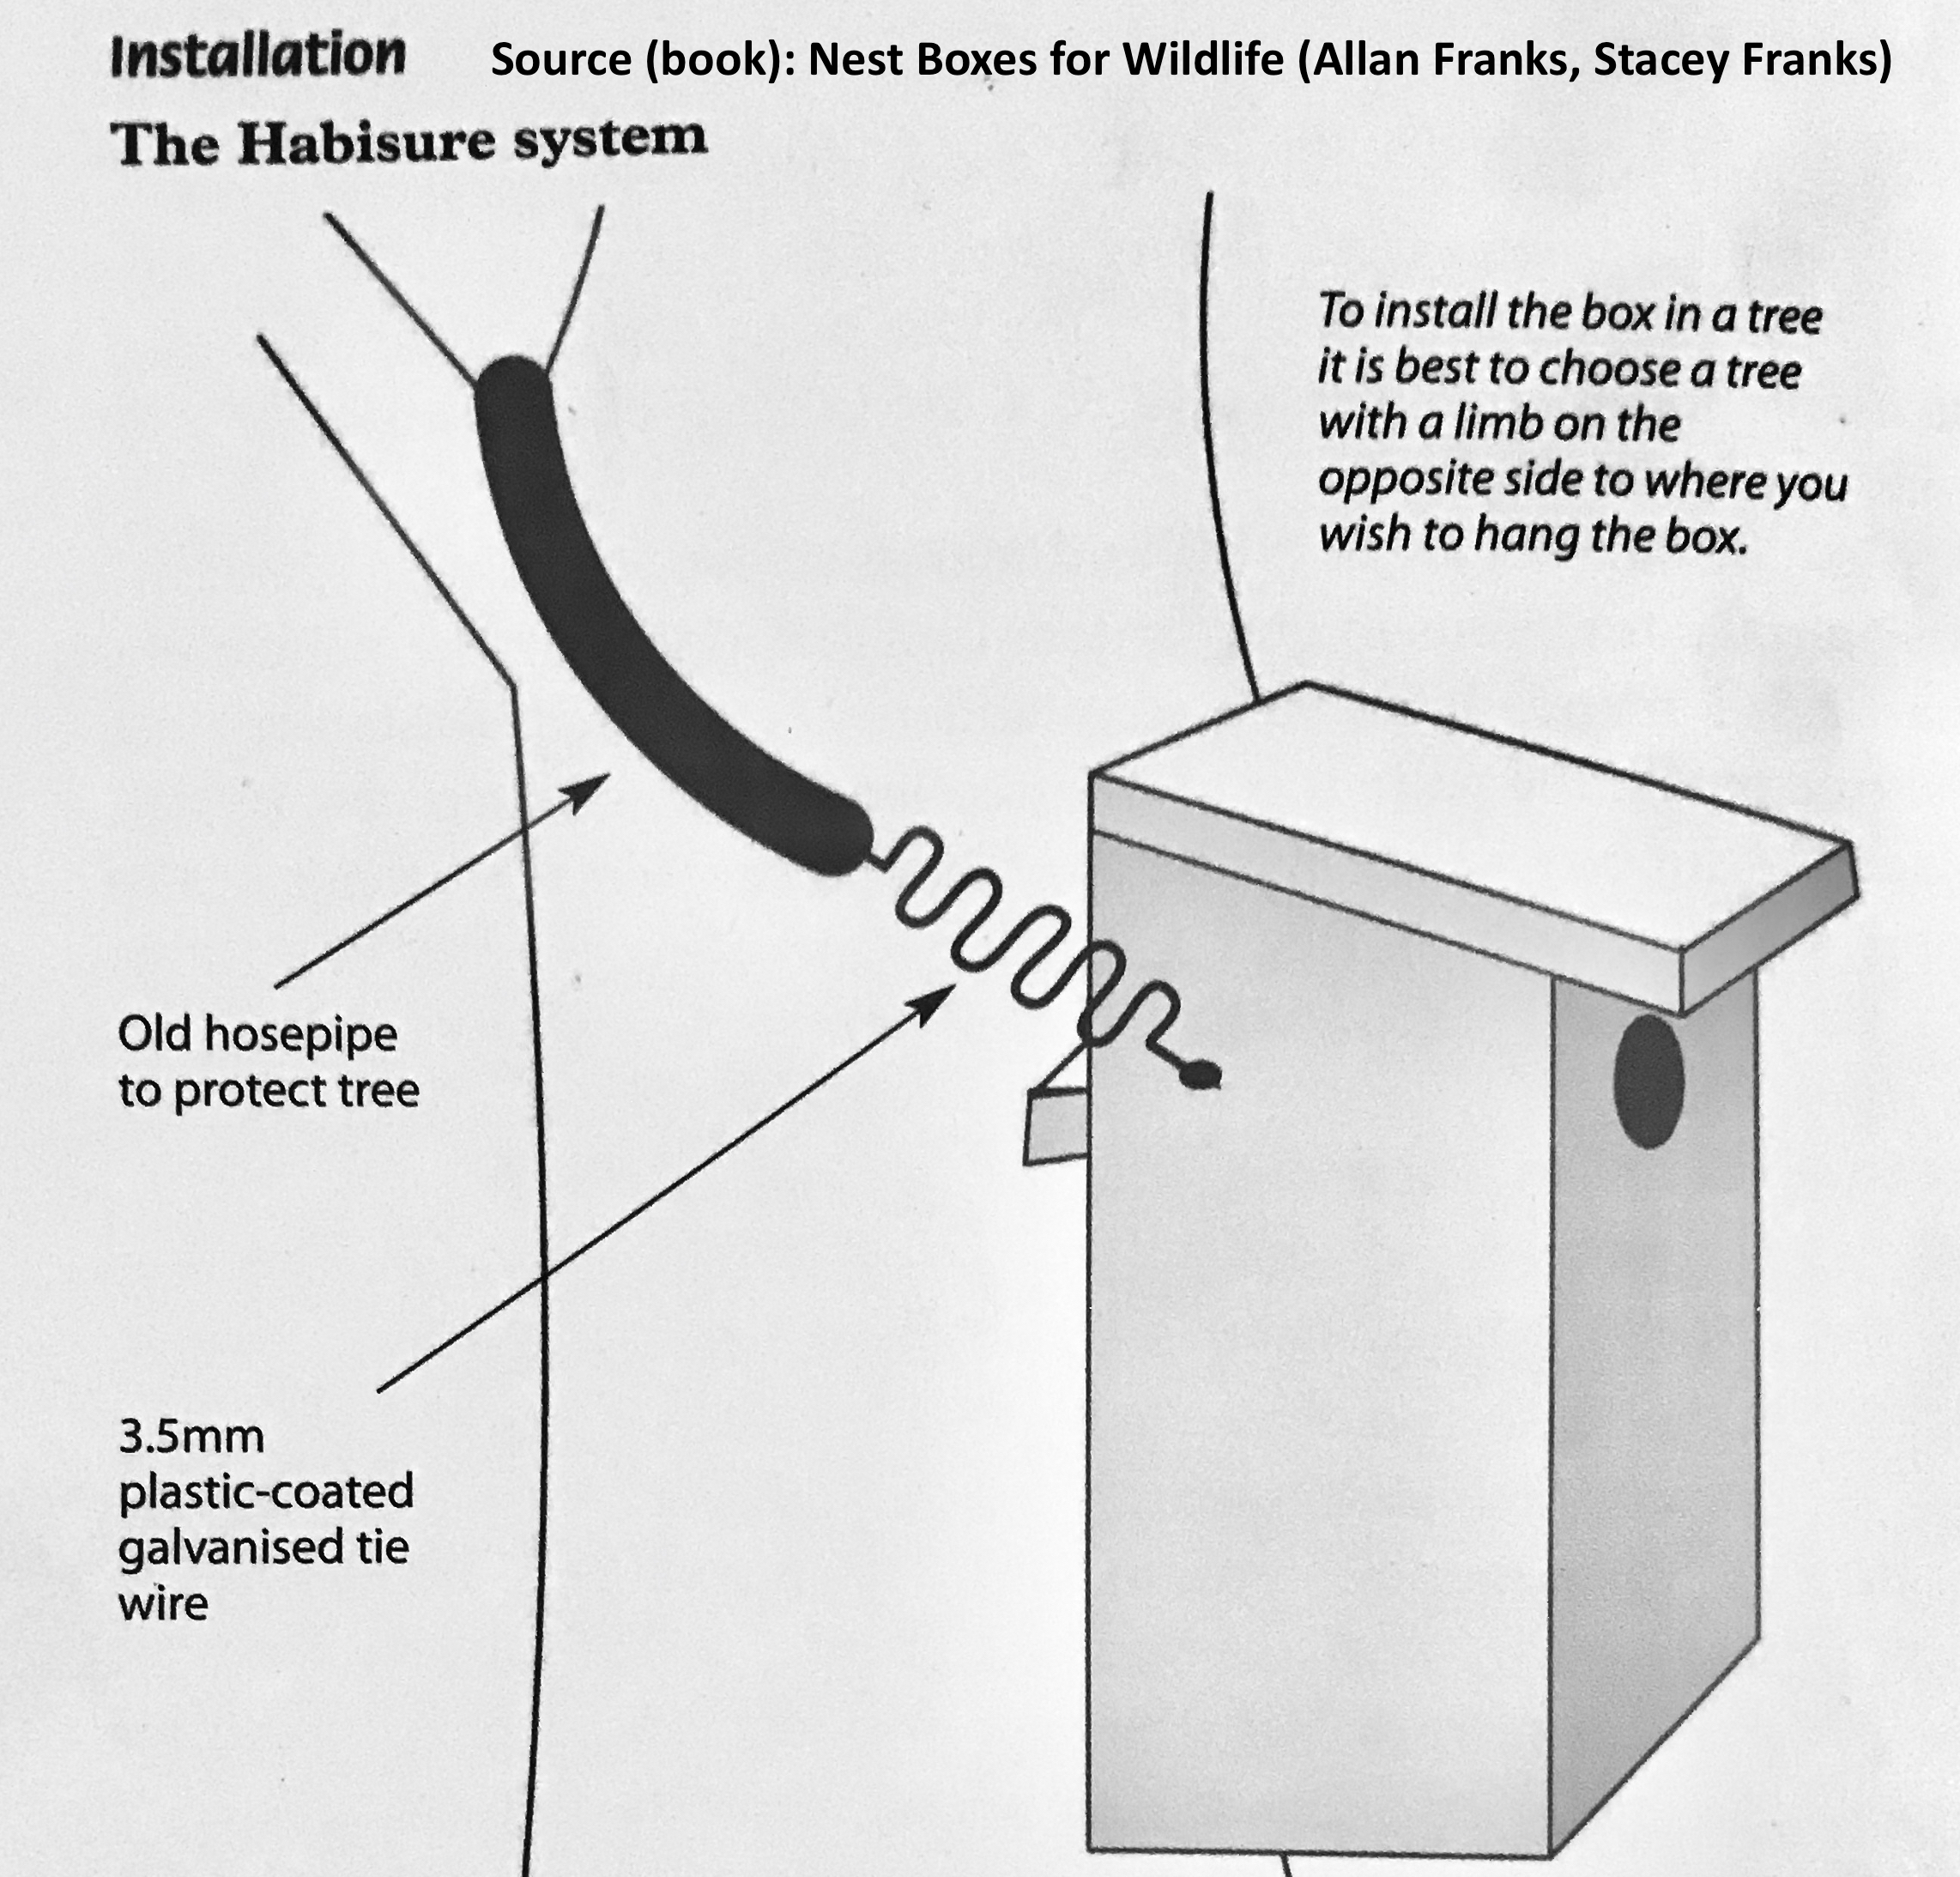
Nest Box Bedding

Although you may be making a nest box for a ringtail possum – according to the label on your design sheet – you are also making a nest box for different Rosella species (parrots), Dollarbirds, Australian Owlet-nightjars, and also perhaps a number of smaller bird species willing to brave the risk of these larger competitors chasing them out mid-nesting season.

The same is the case for most nest box designs. Native animals won’t read your label on the outside!

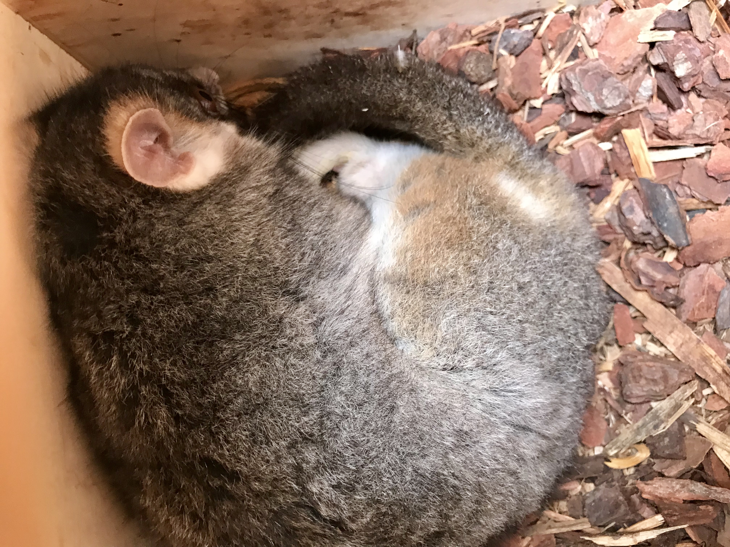
One of my resident ringtail possums enjoying this deep layer of pine bark.

Because of the high chance of multiple species using a single nest box, I strongly recommend adding bedding.

But don’t they add their own bedding?

While animals such as ringtail possums (curled bark pieces), sugar gliders (eucalypt leaf nests), galahs (eucalypt leaves), tree creepers (woven bark nests) will add their own bedding, many animals do not, and may refuse to use a hard wooden floored nest box with no bedding.

Birds that don’t bring bedding and lay their eggs on a bare, hard wooden floor risk their eggs being broken while they are being laid, or when mother bird is sitting on them. Although Wood ducks add a thick layer of down to a nest once all eggs are laid, the eggs risk being broken each day while mother duck lays her collection of eggs.

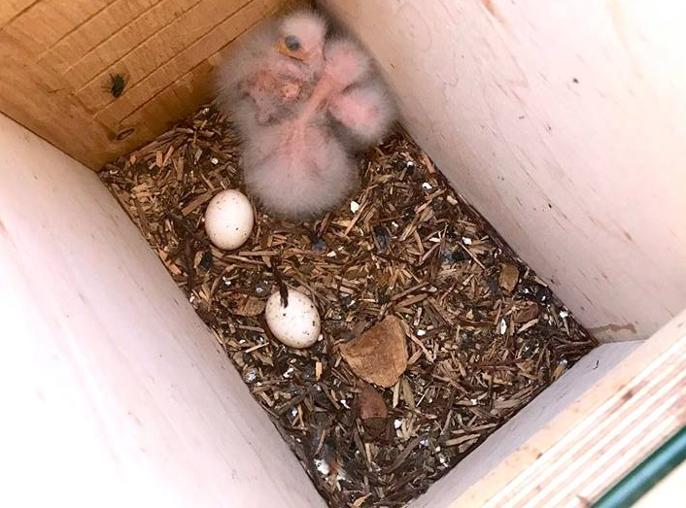
Crimson Rosella chicks on their bedding of shredded (by mum) wood shavings.

Natural tree hollows generally have a nice, cushioned layer of decomposing wood, which parrots will add to by shredding the wood inside hollows to make their bedding.

Do use: Sawdust, wood shavings, untreated fine wood or bark chip

Nesting boxes however provide no such benefits, and have a very hard, wooden floor. Bedding of sawdust, wood shavings (e.g. for pets), untreated fine wood chip or pine bark make fantastic bedding for nest boxes.

For depth, about 5 cm, or two inches is appreciated by some species, and will be reduced to suit preferences if too deep by other species.

Don’t use: Straw, sugar cane mulch

Please don’t use bedding such as straw or sugar cane mulch, as these provide very good homes for parasites such as lice, mites and various blood sucking critters – as poultry breeders such as myself well know.

Sugar cane mulch and straw become mouldy and fowl if exposed to moisture, including from precipitation, or accumulation of chick droppings. Chemical free wood products such as wood shavings, fine pine bark or wood chip do not have these issues.

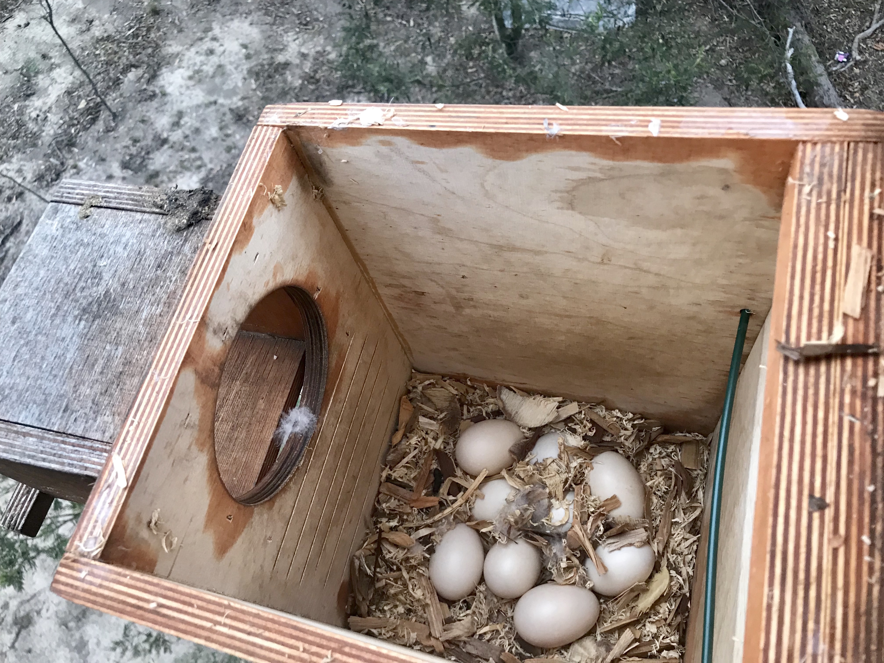
Wood Duck eggs on a bedding of wood shavings, mother duck has not yet begun to sit.

Feral pest exclusion methods

European bee exclusion

Urban and peri urban locations are at a greater risk of nest boxes being invaded by feral bees than within areas of native habitat. If you are worried about bees, or there are stories circulating about feral bees invading nest boxes installed in the area, the following method may be worth applying to nest boxes before they are installed.
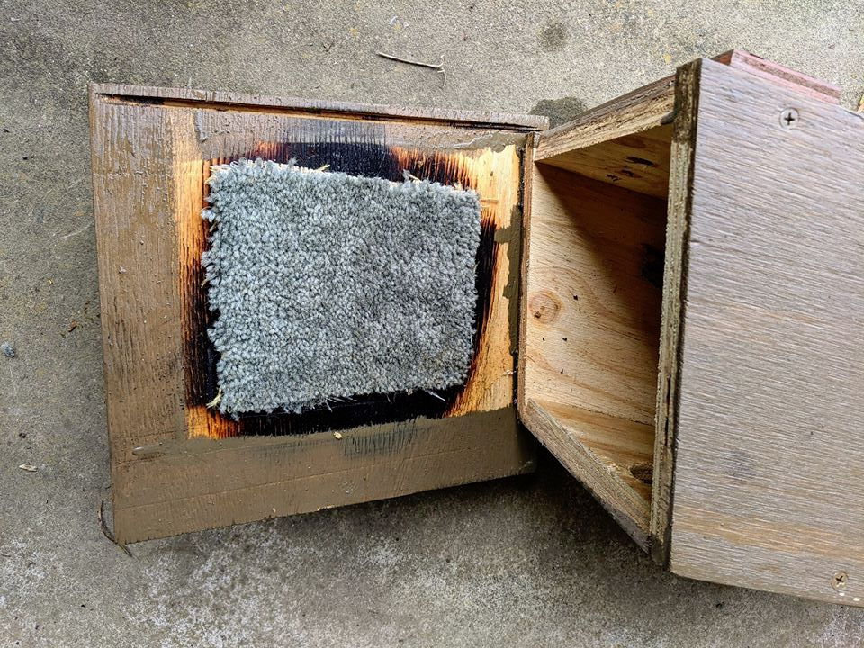
Image by Sharon Gwynne – added to a nest box after a nearby nest box was invaded by bees. Two weeks later, a Crimson Rosella family moved in!

Cut and attach a piece of carpet to the inside of the nest box lid – so that the lid still closes completely. The carpet needs to have unlooped pile, and not be marine grade. Bees can’t attach their wax to the carpet, and so won’t bother to invade the nest box. Simple!

Anti-myna baffle

Indian mynas are a pest bird species that lives in urban and peri urban environments. If you are aware of there being a large Indian myna population in the area where nest boxes are to be installed, you may wish to add an anti-myna baffle to prevent them from using the nest box. Alternatively, you could monitor the nest box, and install the anti-myna baffle if the nest box is invaded by mynas.
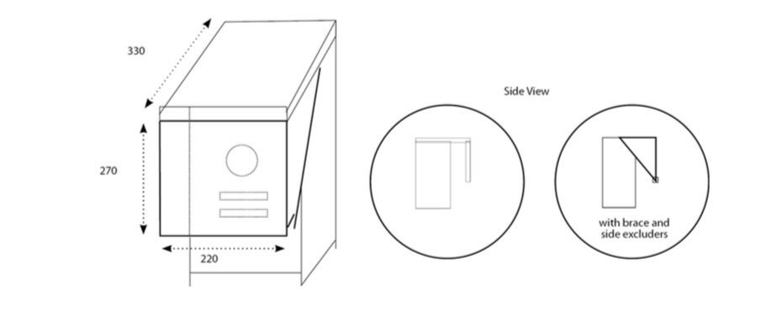

The distance that the baffle is placed in front of the nest box should be the same as the diameter of the entrance hole. This design is by BirdLife Australia.

Written and compiled by Alice McGlashan
Facebook: https://www.facebook.com/groups/nestboxtales/
Website: www.nestboxtales.com
Sharing stories and knowledge about nest boxes for Australian native animals to encourage everyone to improve habitat for wildlife.

